EXERCISES FOR ANCLIM SOFTWARE

PETR ŠTĚPÁNEK
PAVEL ZAHRADNÍČEK

(petr.stepanek@chmi.cz; zahradnicek@chmi.cz)

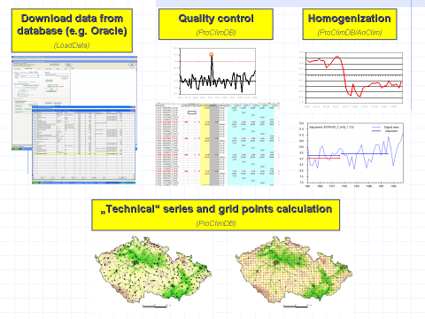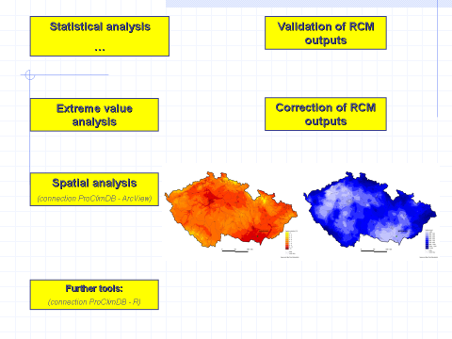

http://www.climahom.eu

Exercise 1.
1. load the file „precip bohemia“
2. View - 3 types of the display
3. Plot the graph
4. change the limit of the iqr coefficient – set number 1.5
5. display only period 1916-1956
6. display again whole period
7. switch to the season mode
8. change average to the sum
9. define your own season = vegetation season (apríl-september) and plot again the graph
10. change plot graph to the histogram
11. display the black/white histogram and thickness of the column = 1

Add. 1. load the file „precip bohemia“
- \Data\Analysis\precip_bohemia.txt
- possibility: speed button or menu file-open; right click; series controller
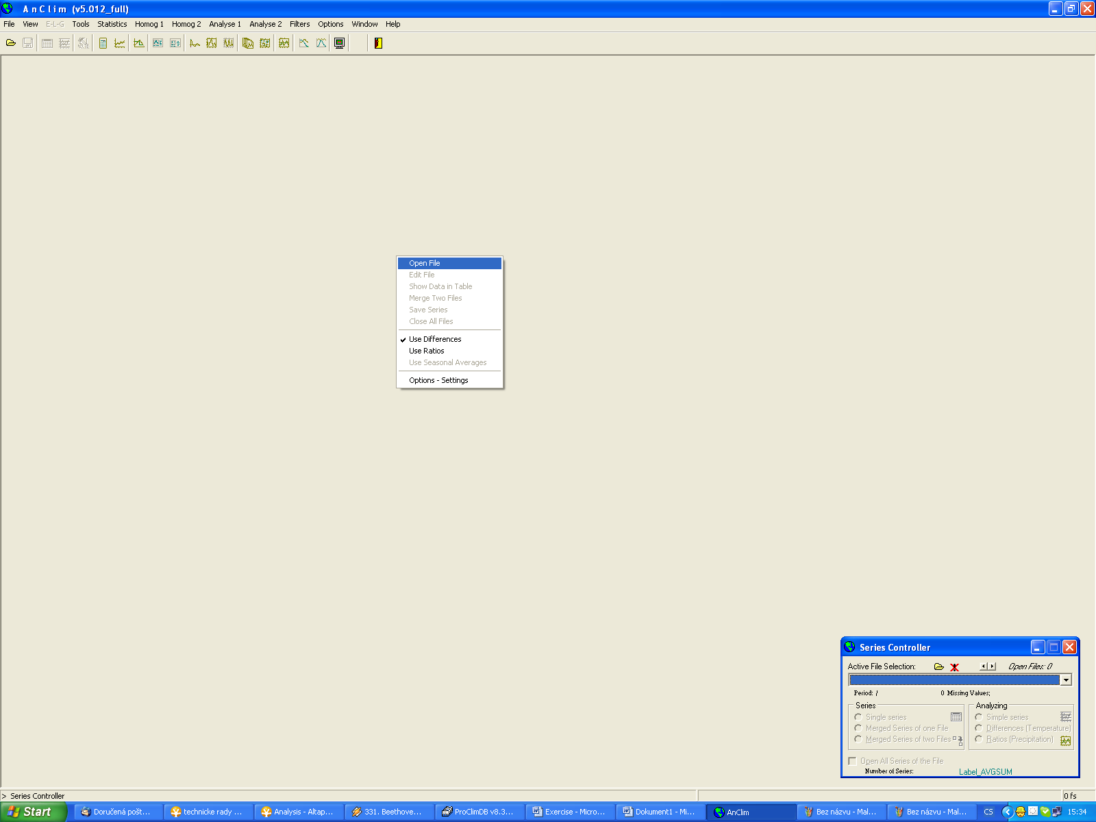
Right click
Speed button
Series Controller

Add. 2. View - 3 types of the display
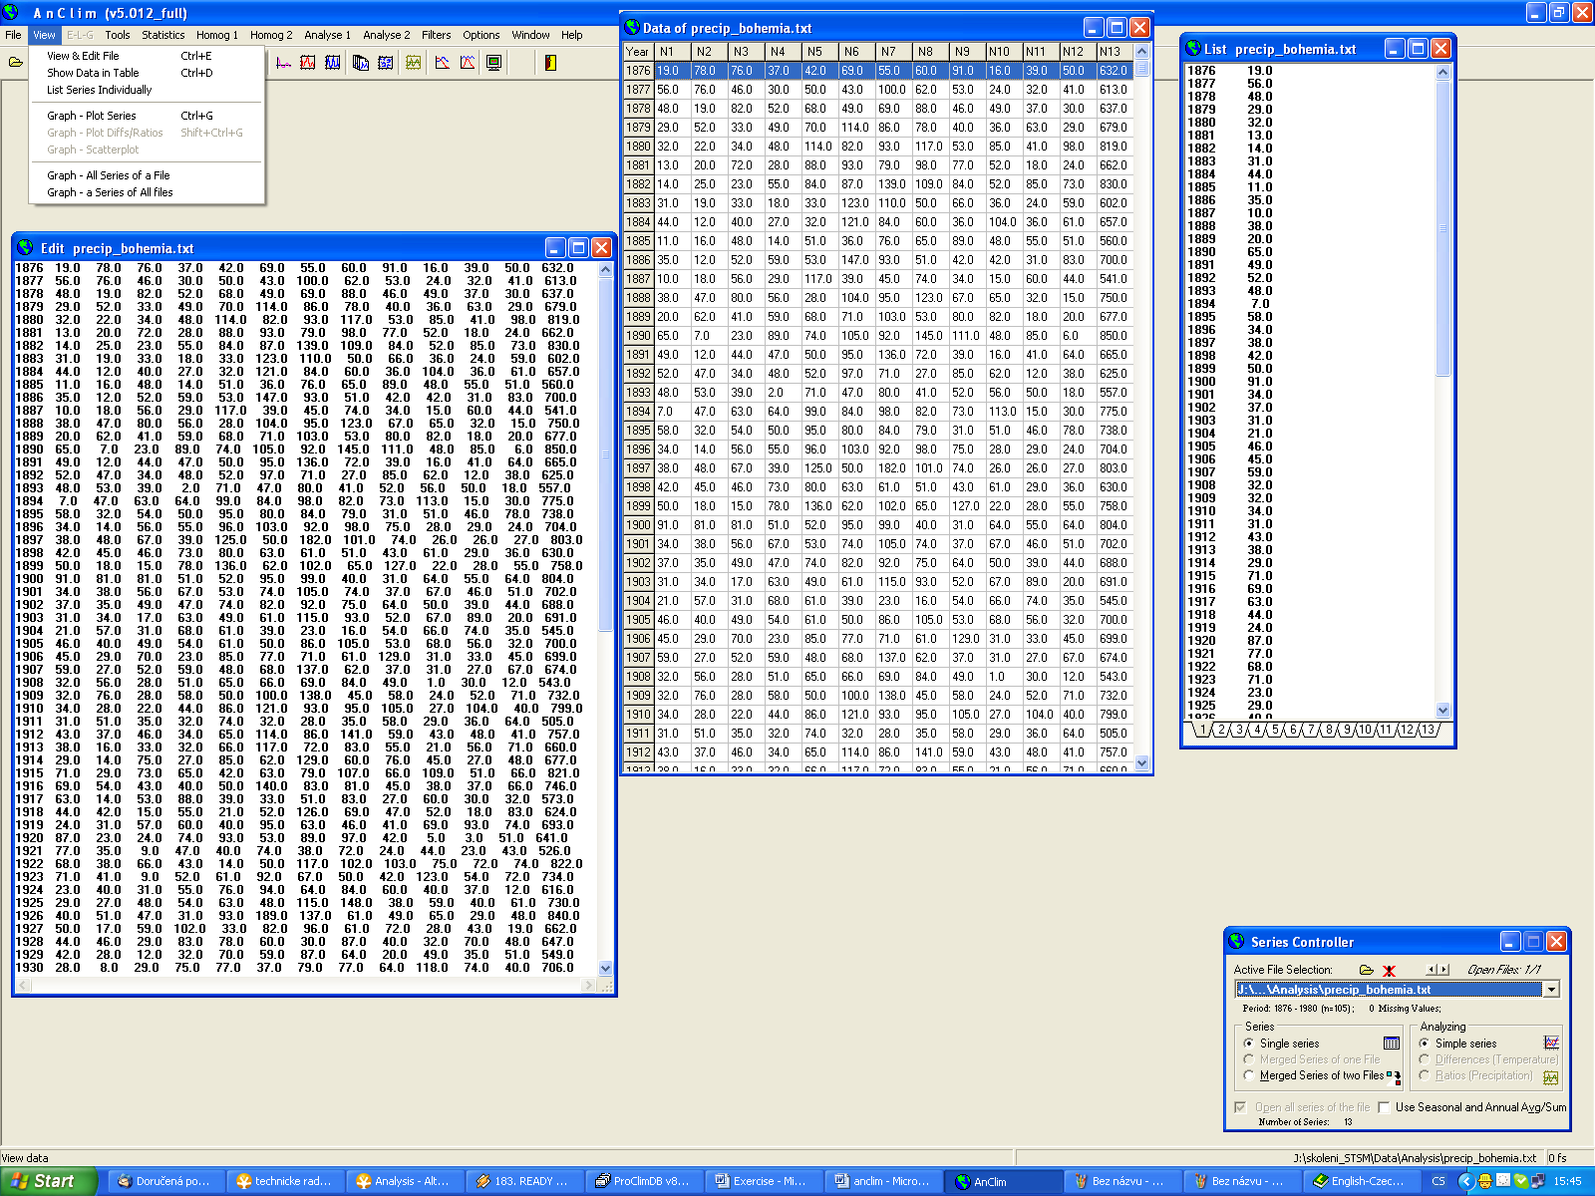
Each month individually

Add. 3. Plot the graph
- possibility: speed button or menu graph; right click; series controller
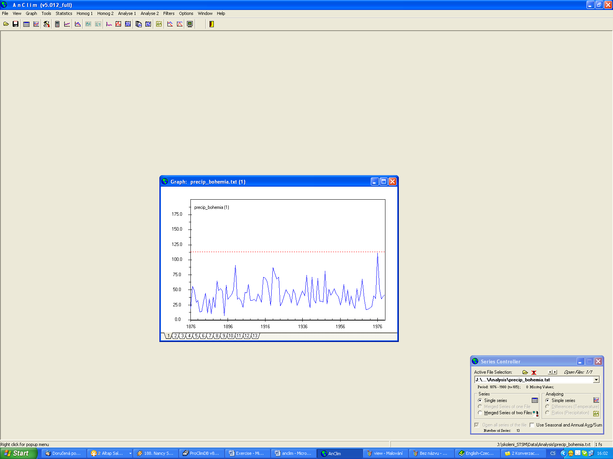
Information about series

Add. 4. change the limit of the iqr coefficient – set number 1.5
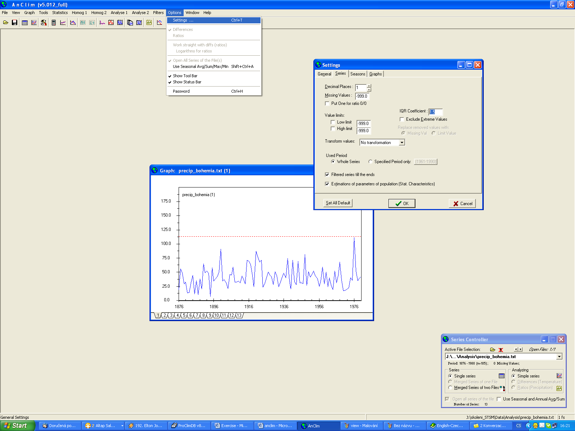

Add. 5. display only period 1916-1956
Add. 6. display again whole period
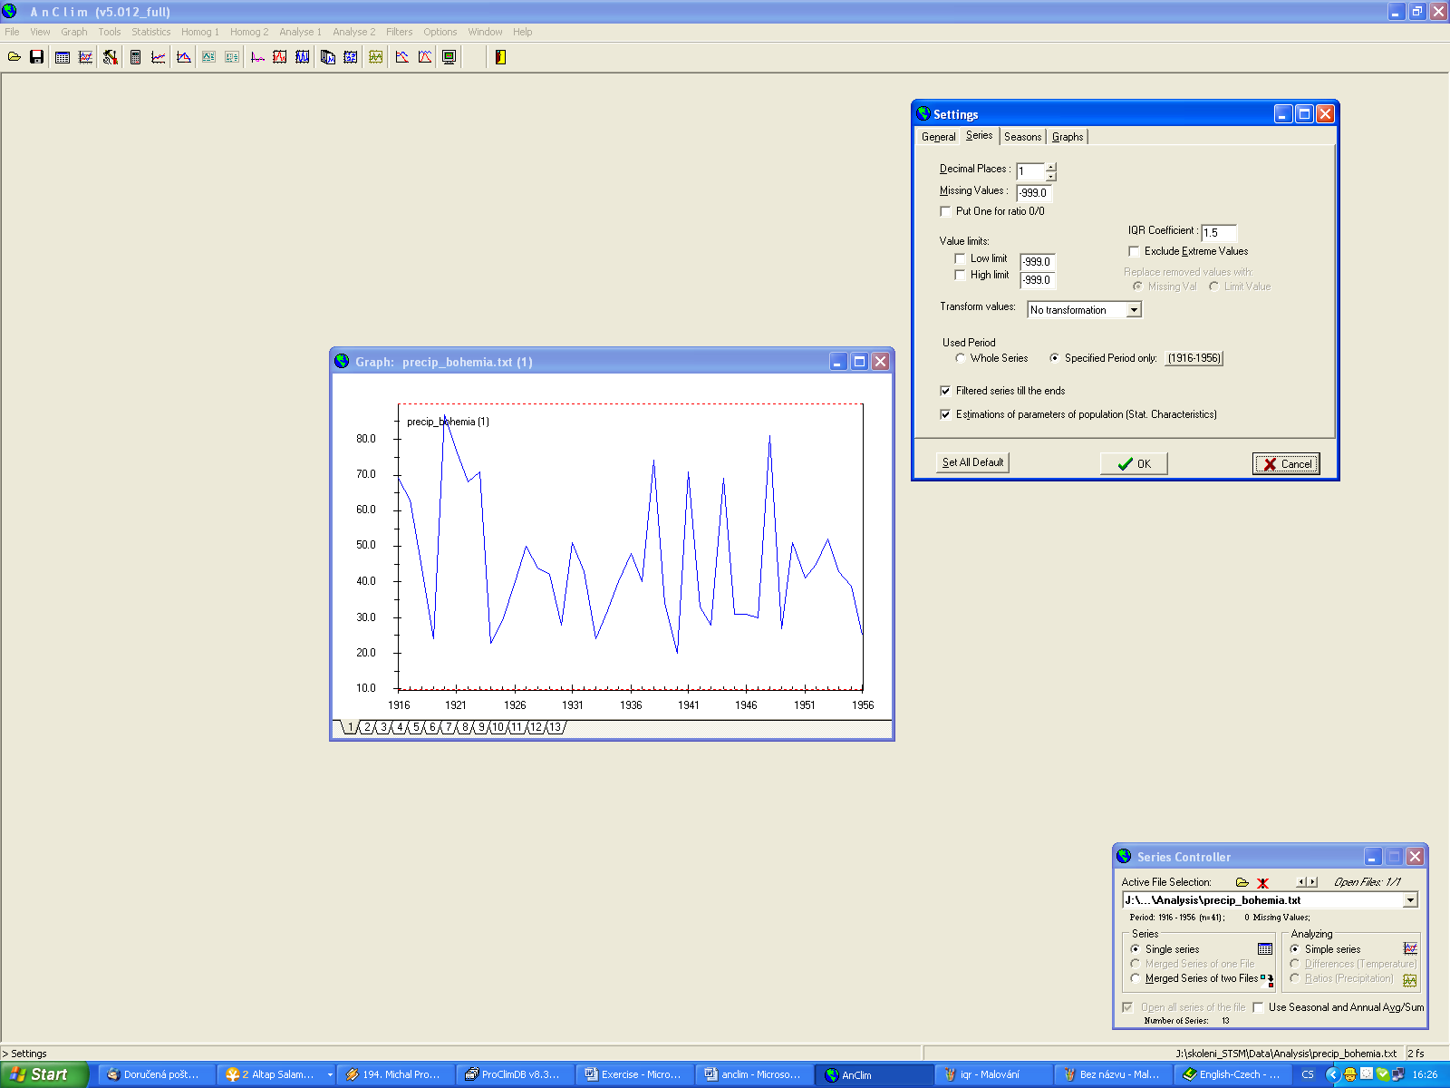

Add. 7. switch to the season mode
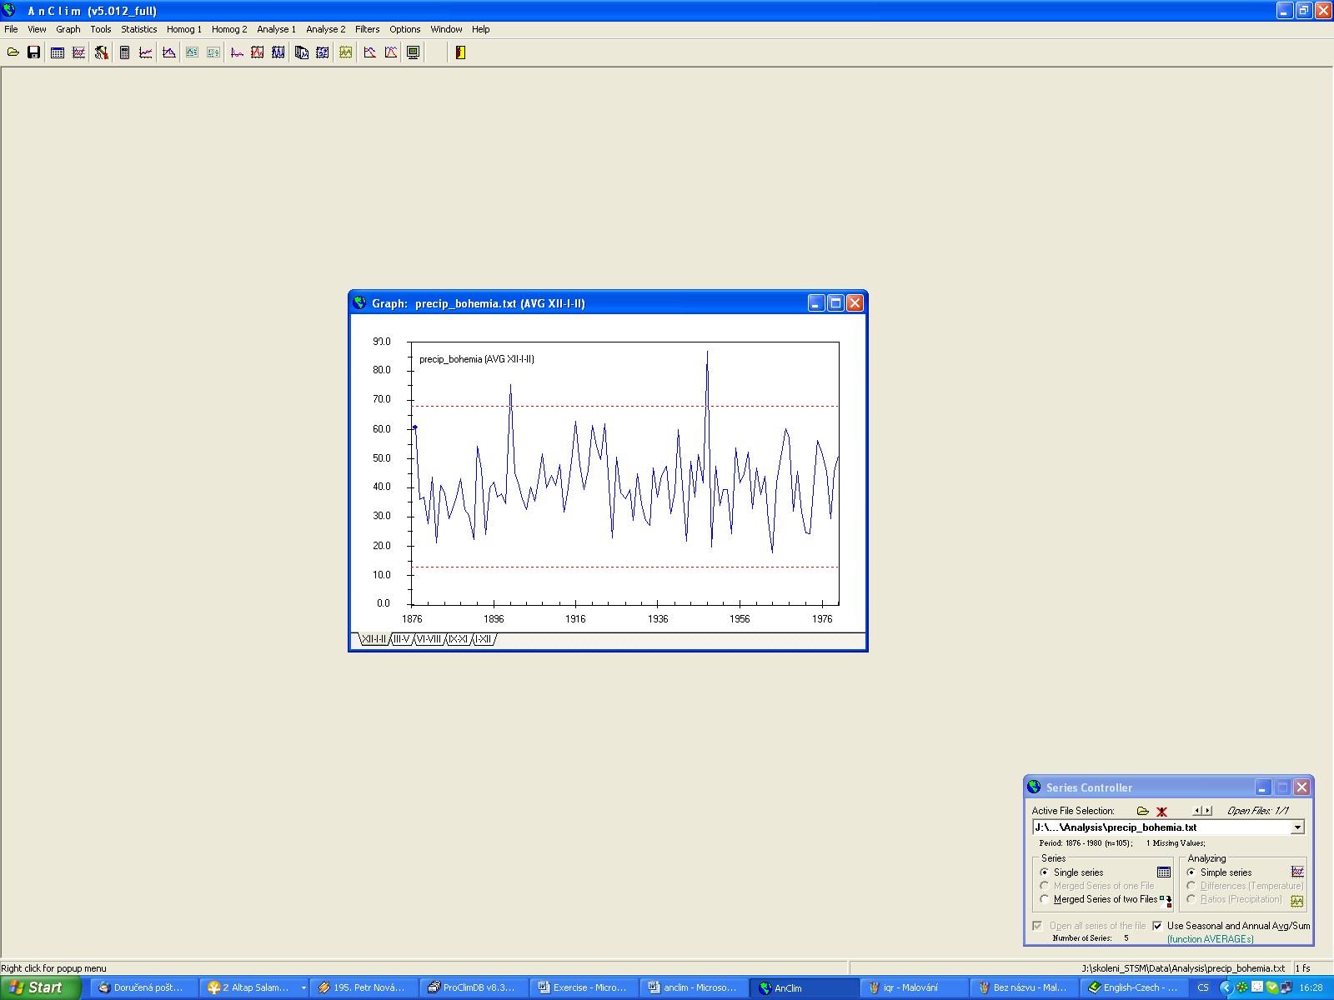

8. change average to the sum
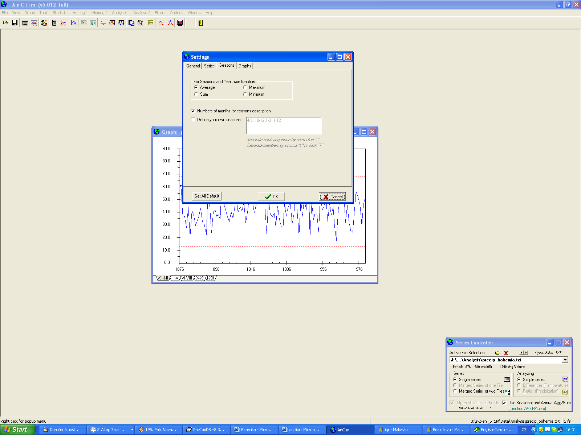

Add. 9. define your own season = vegetation season (apríl-september) and plot again the graph
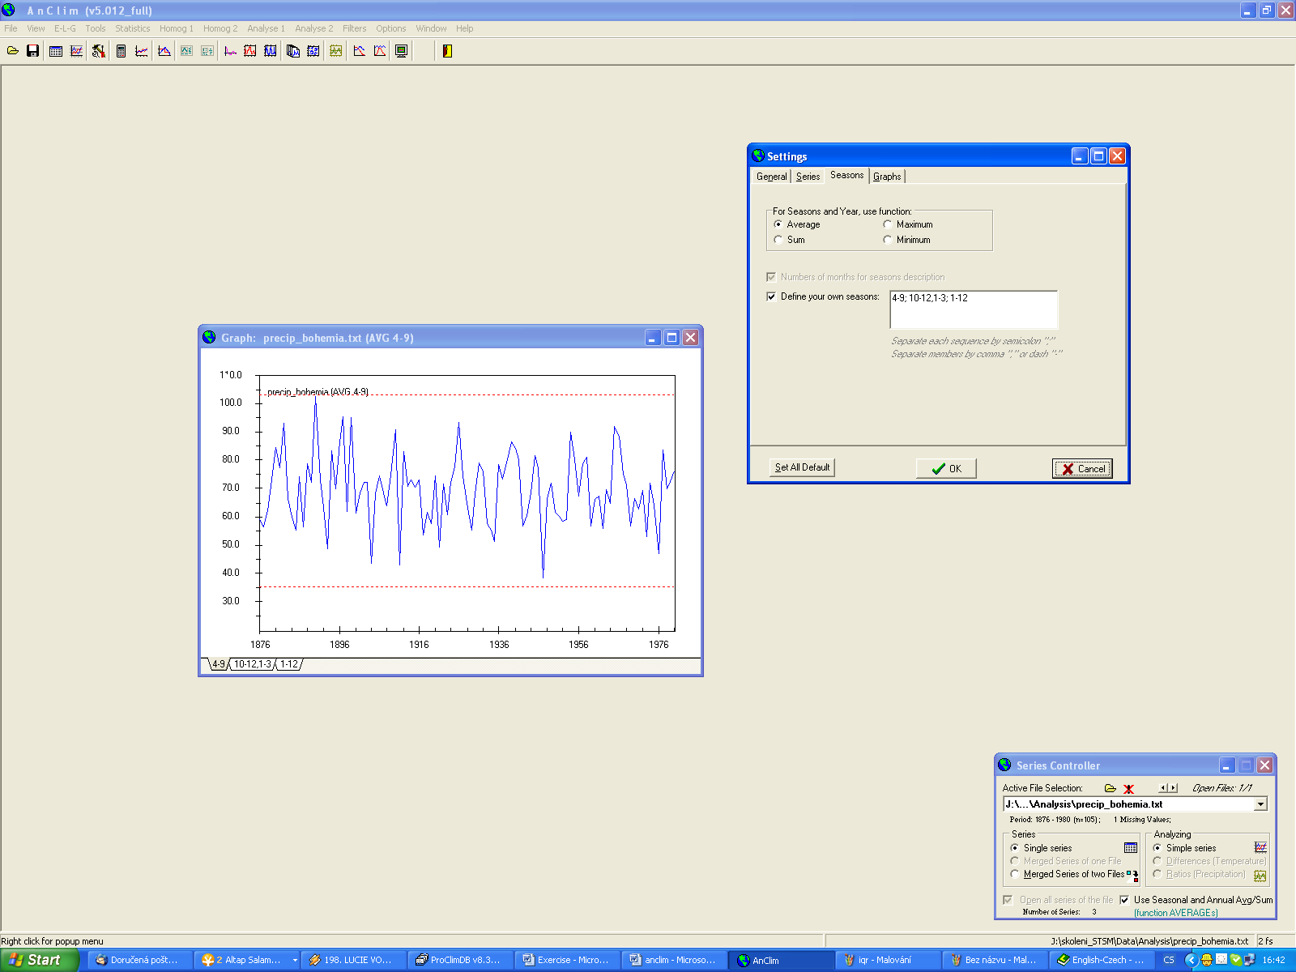

Add. 10. change plot graph to the histogram
Add. 11. display the black/white histogram and thickness of the column = 1
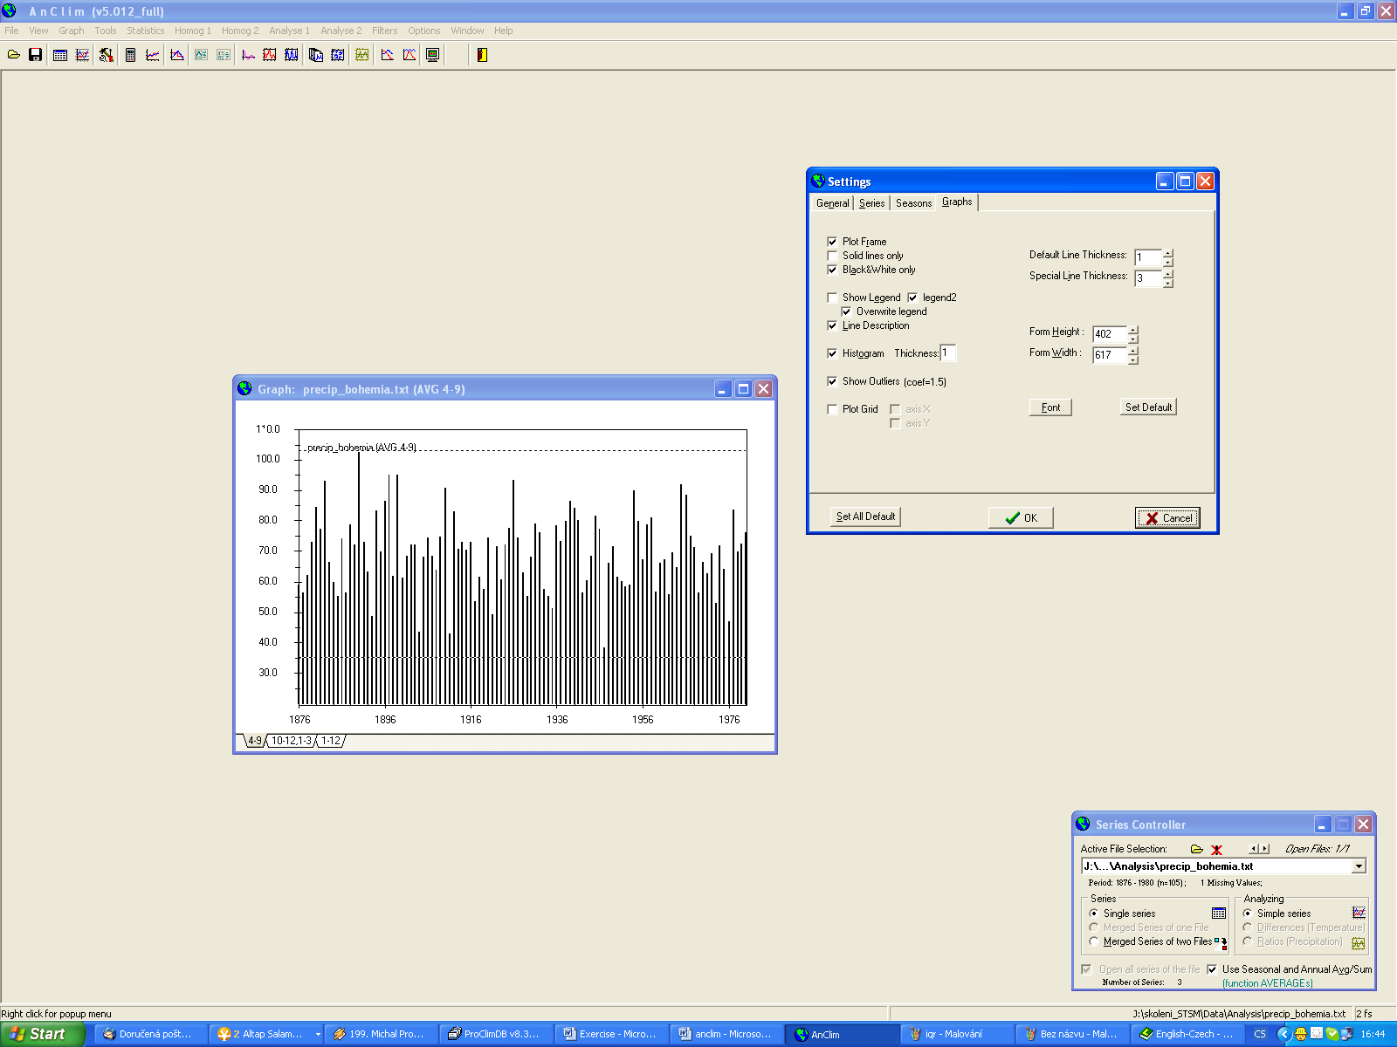

Exercise 2
1. calculate statistical characteristic for all months and transfer to the excel
2. display histogram for normal distribution of the annual sum.
3. plot the graph with linear trend

Add. 1. calculate statistical characteristic for all months and transfer to the excel
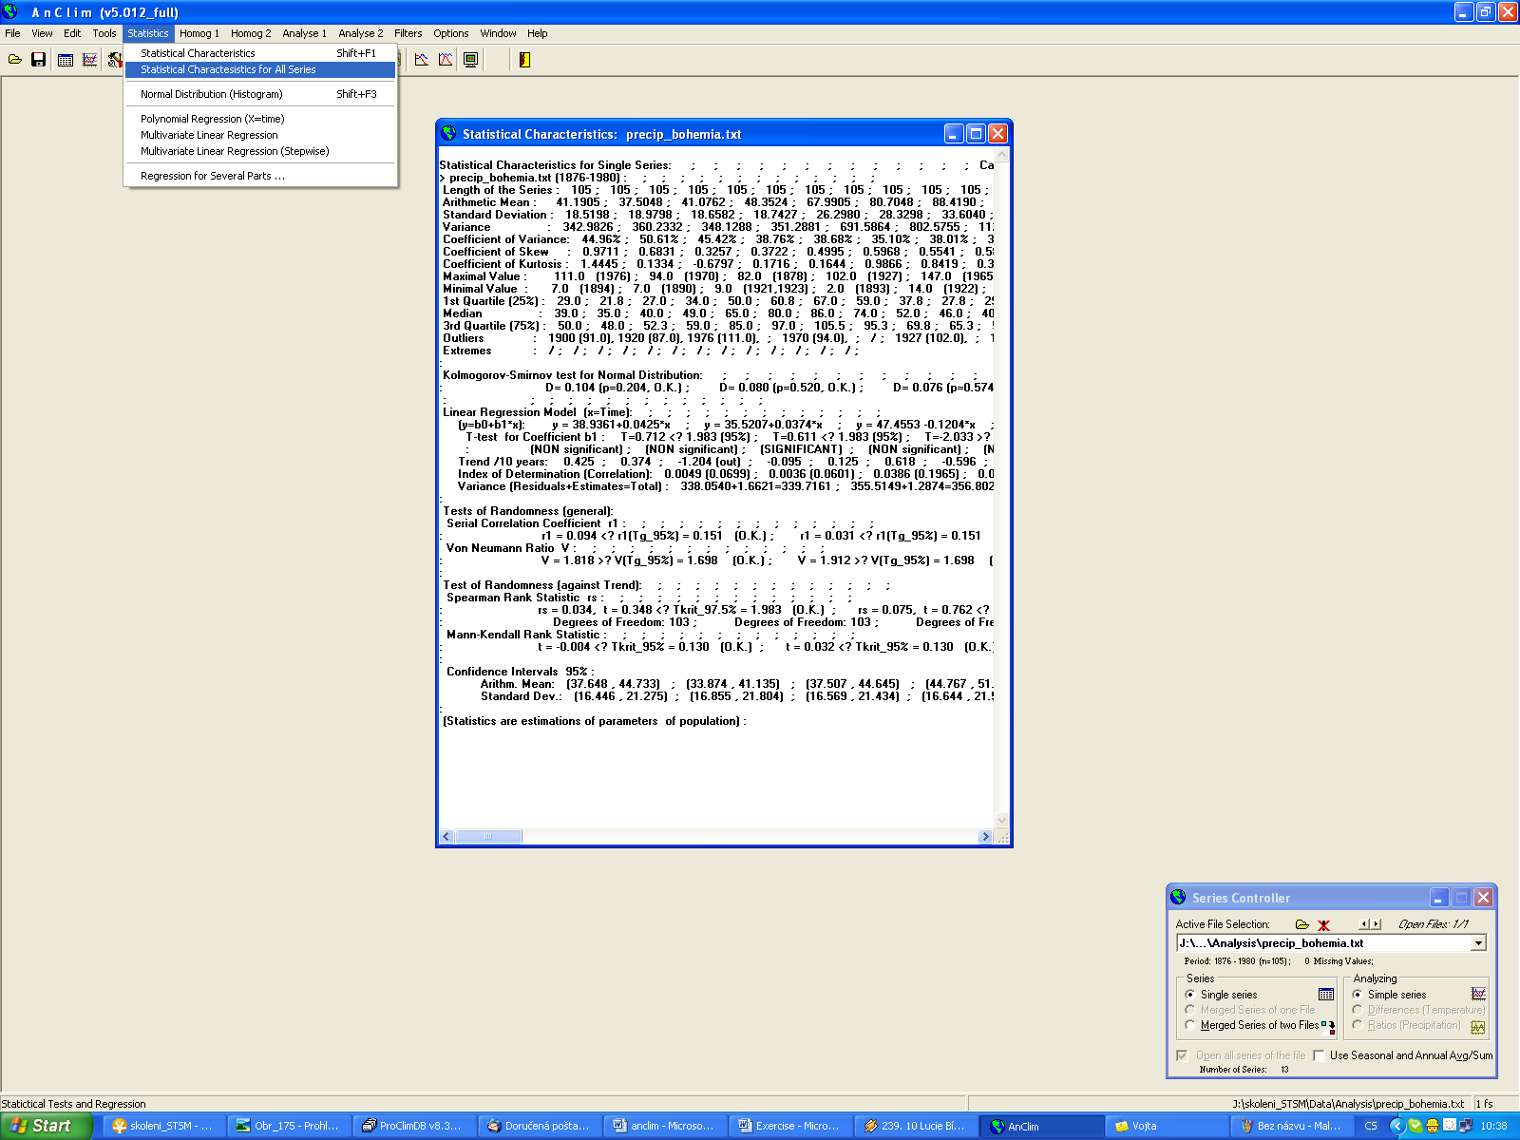

- copy text in the Anclim window statistical characteristics
- open excel – paste the text
- menu data – text to the column – delimiter – by tabulator, semicolon, others: colon
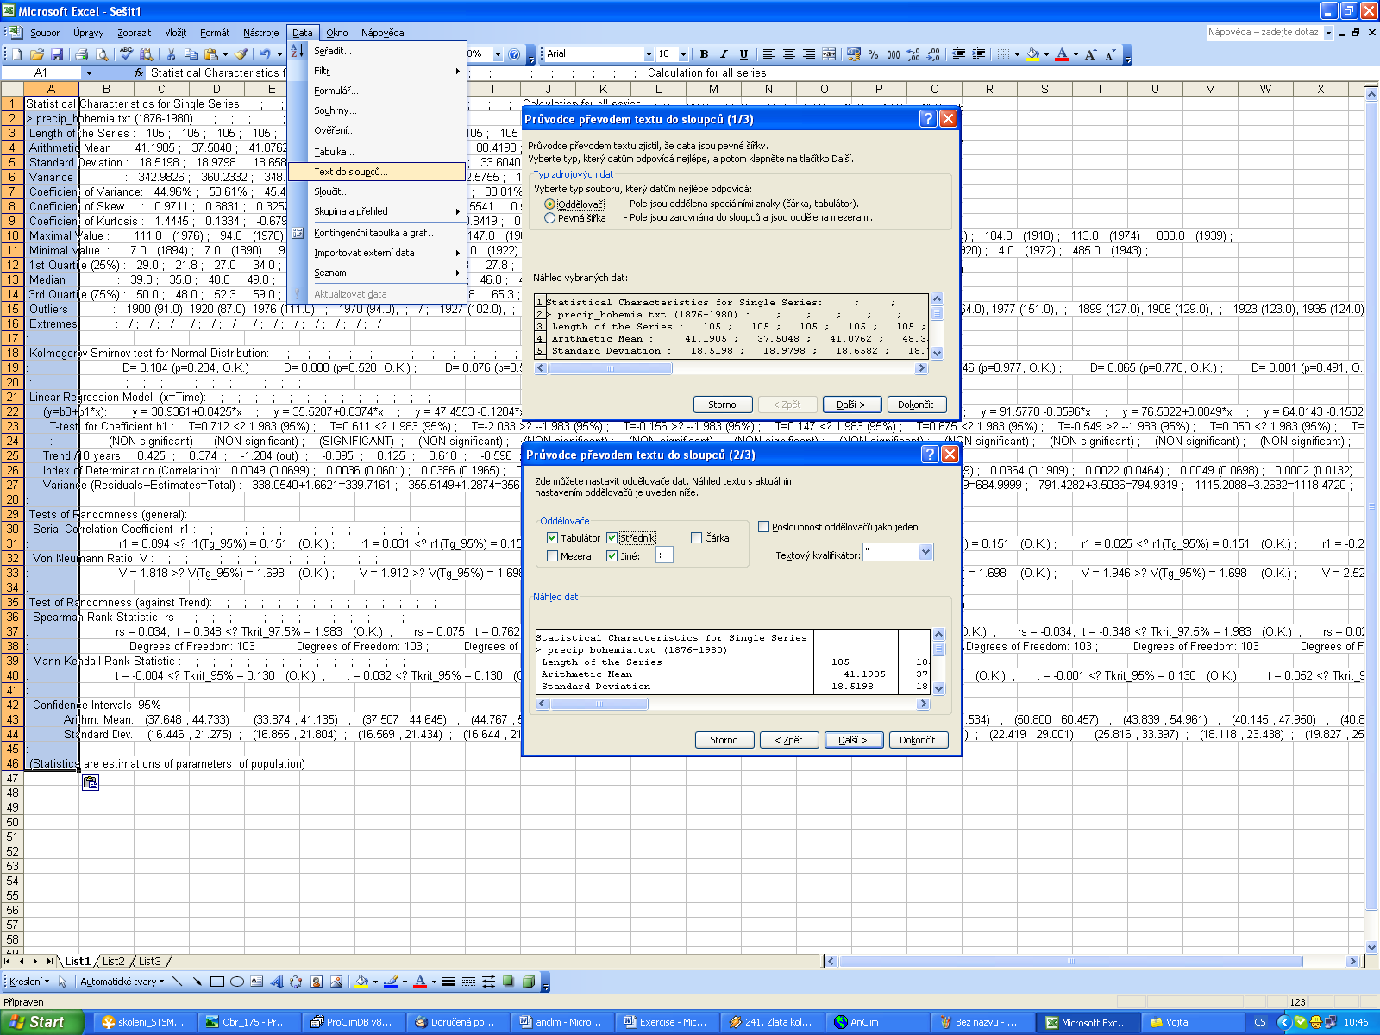

Add 2. display histogram for normal distribution of the annual sum.
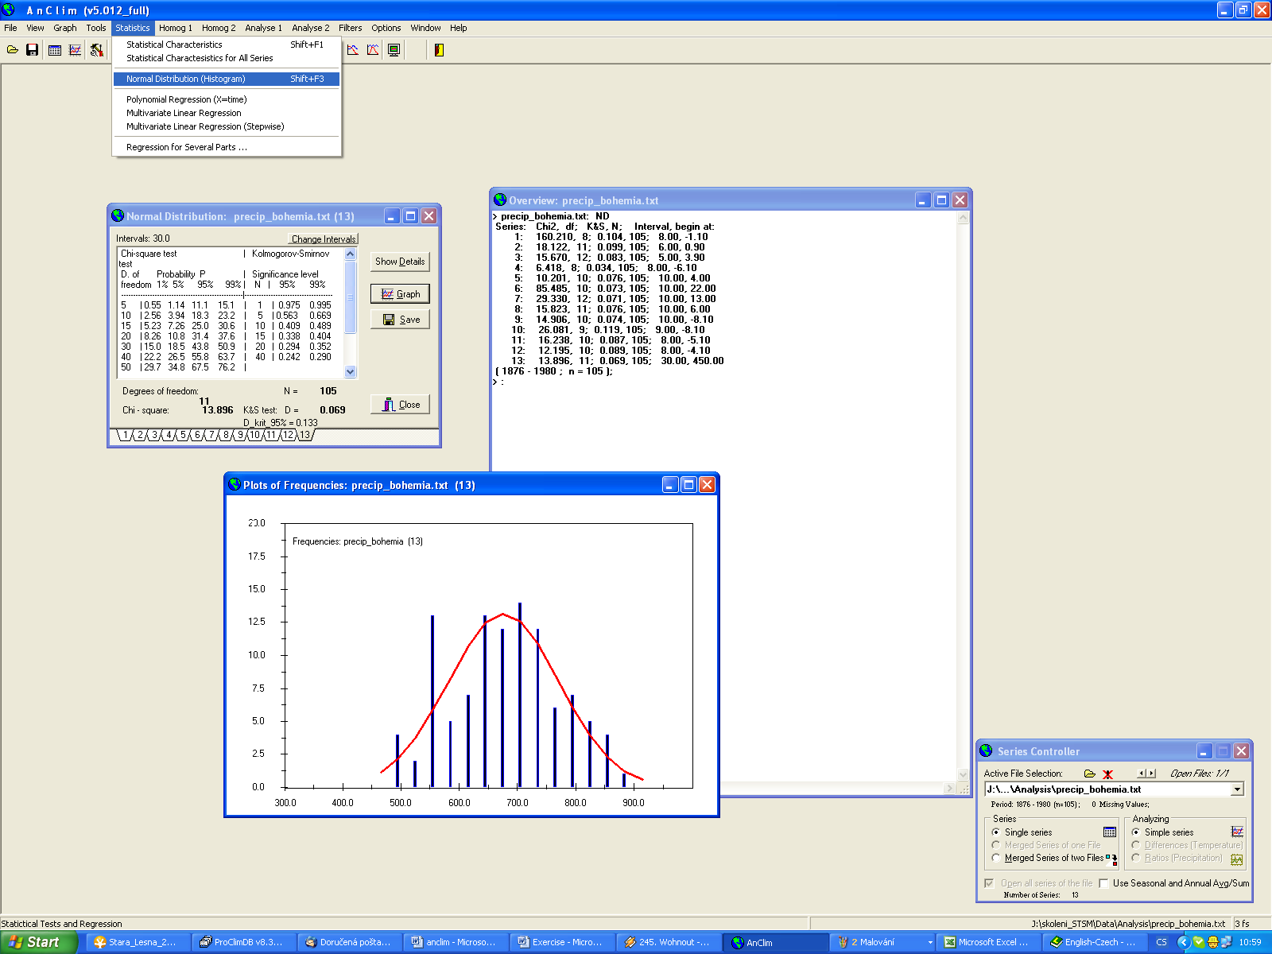

Add 3. plot the graph with linear trend
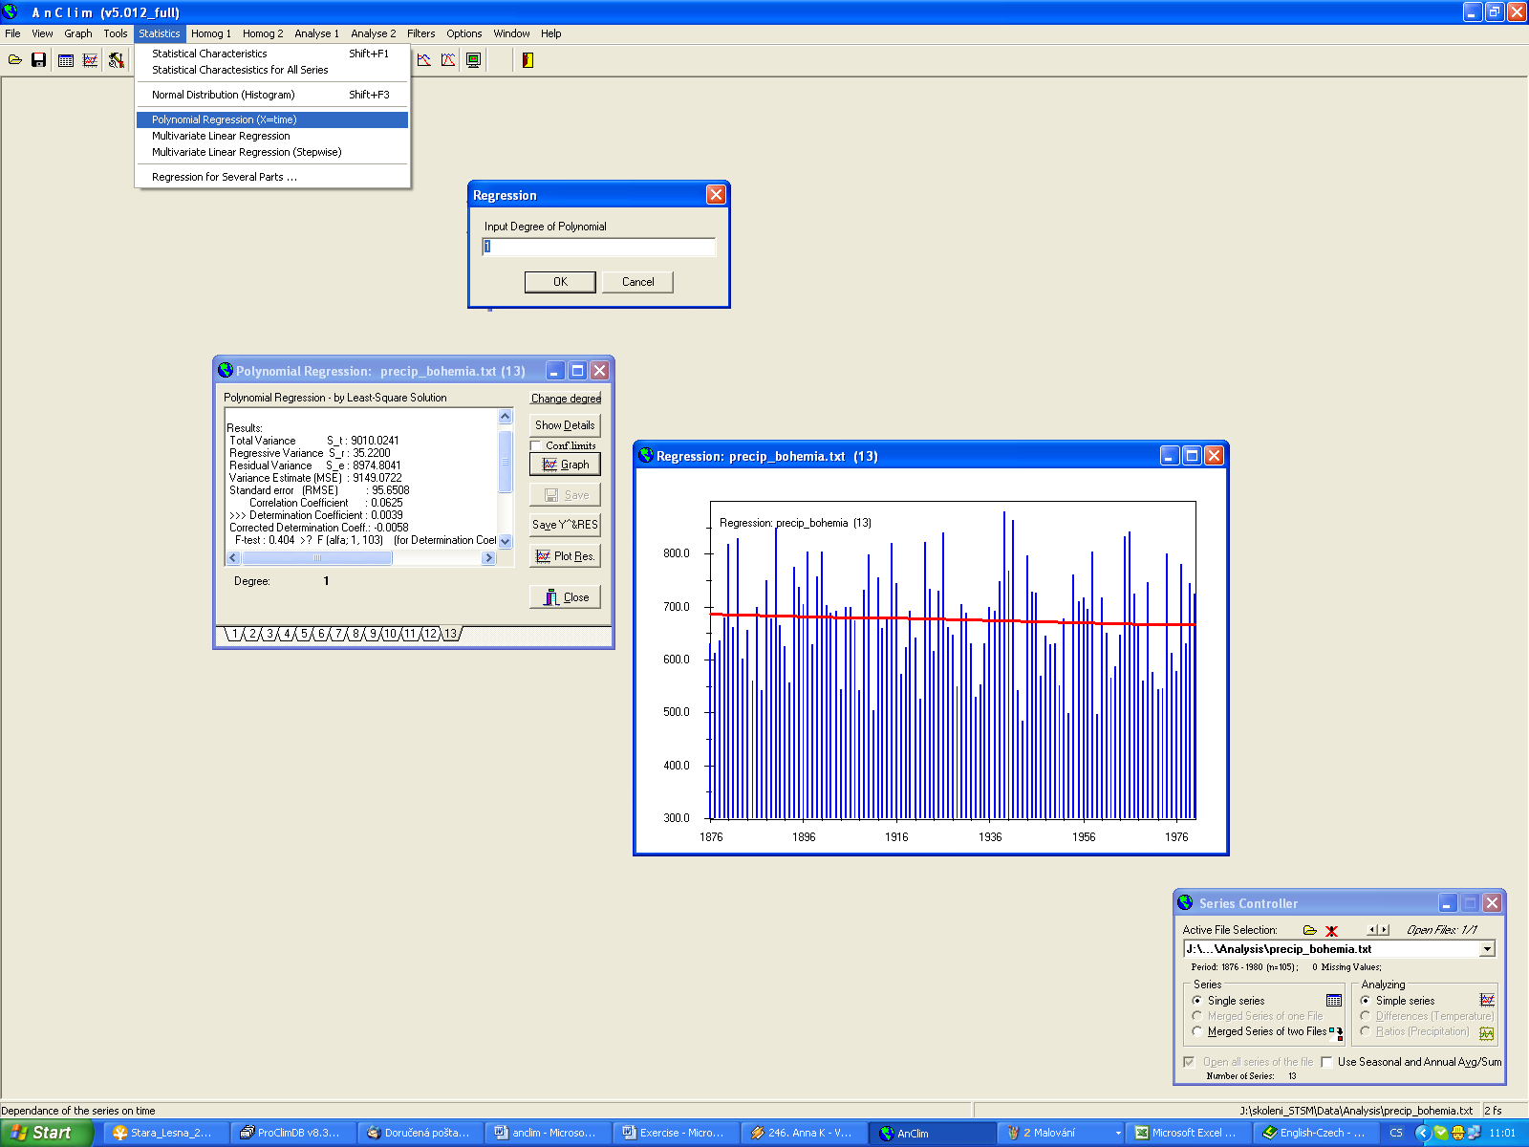

Exercise 3
1. load the file c_Casl_3.txt (directory homog)
2. calculate absolute homogeneity test SNHT
3. load reference series c_casl_O_3_REF.TXT
4. plot the both series
5. plot the differences
6. calculate the relative homogeneity test

Add. 1. load the file c_Casl_3.txt (directory homog)
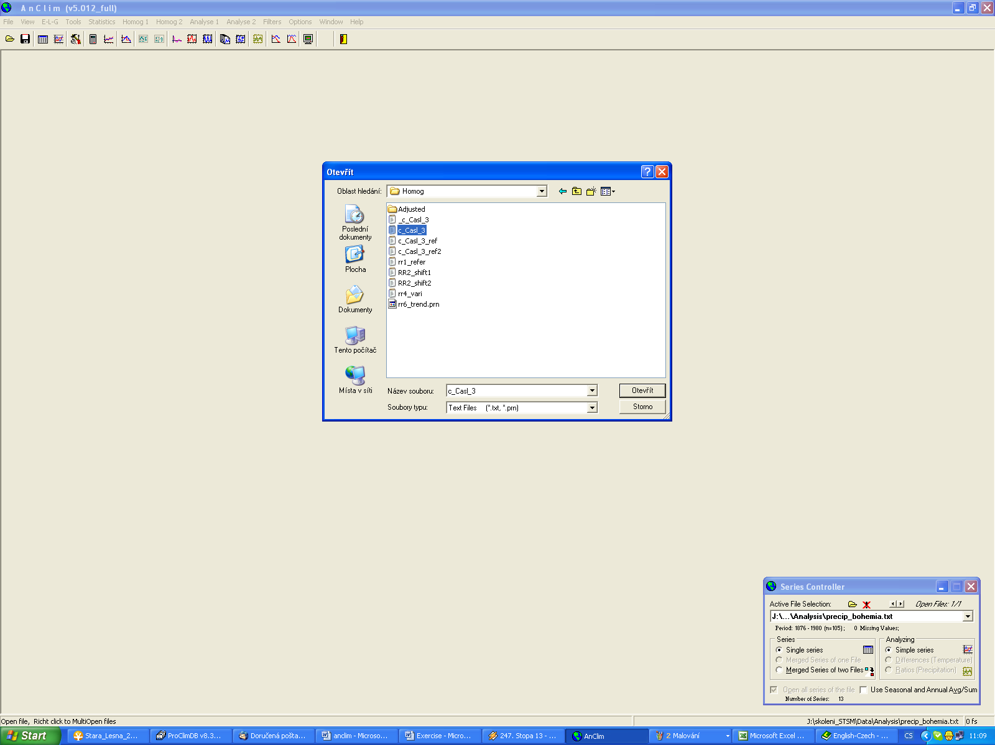

Add. 2. calculate absolute homogeneity test SNHT
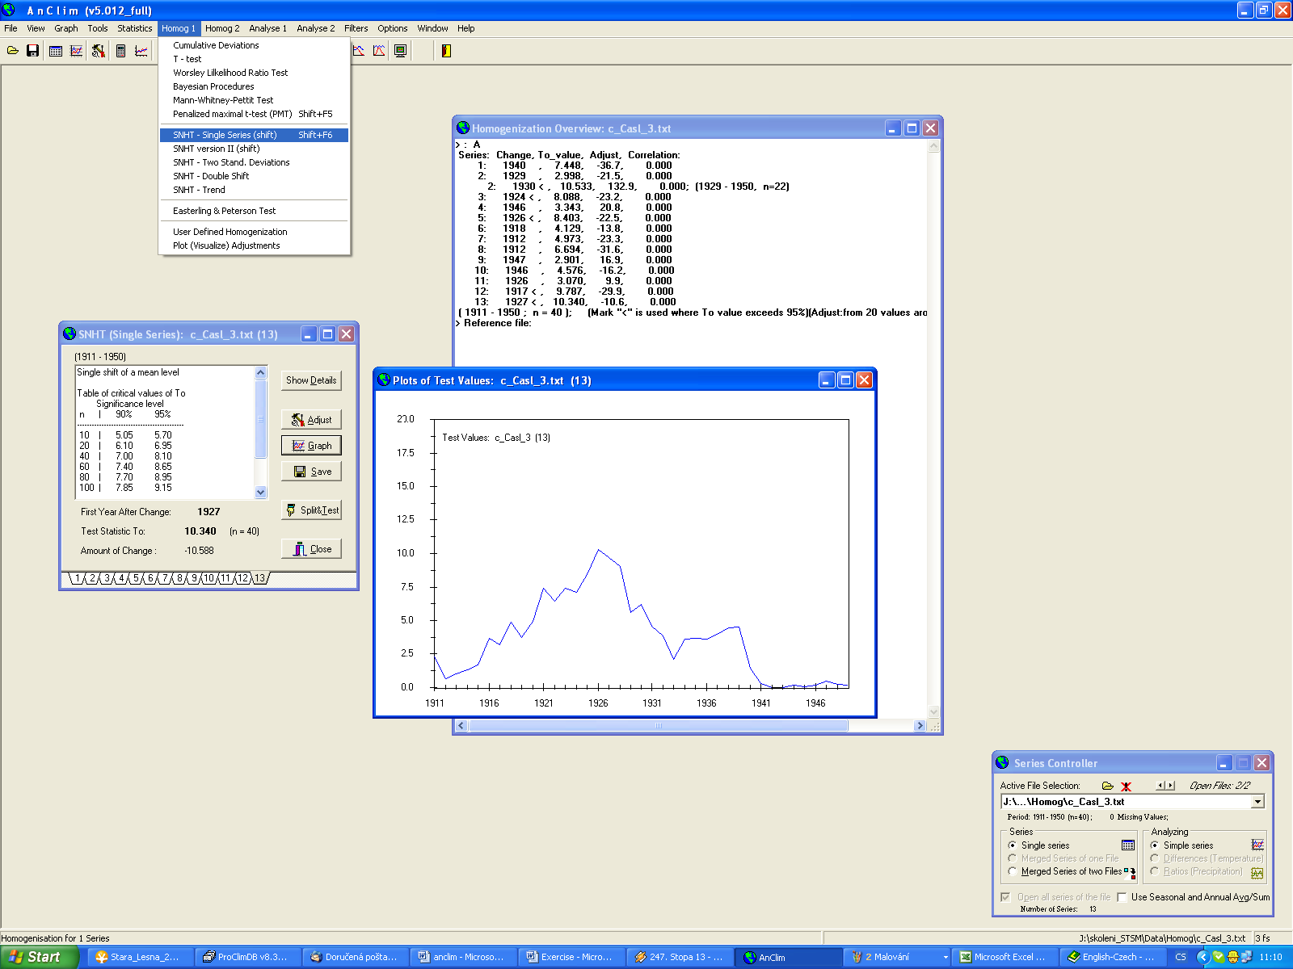

Add. 3. load reference series c_casl_O_3_REF.TXT
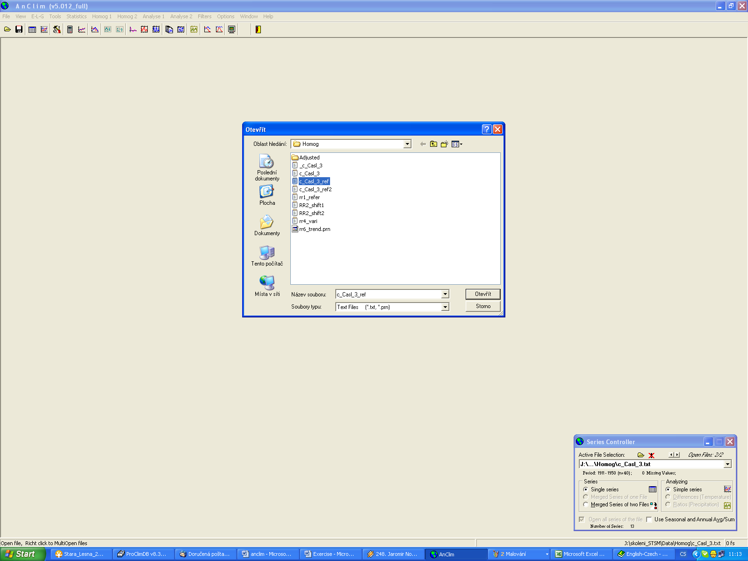

Add. 4. plot the both series
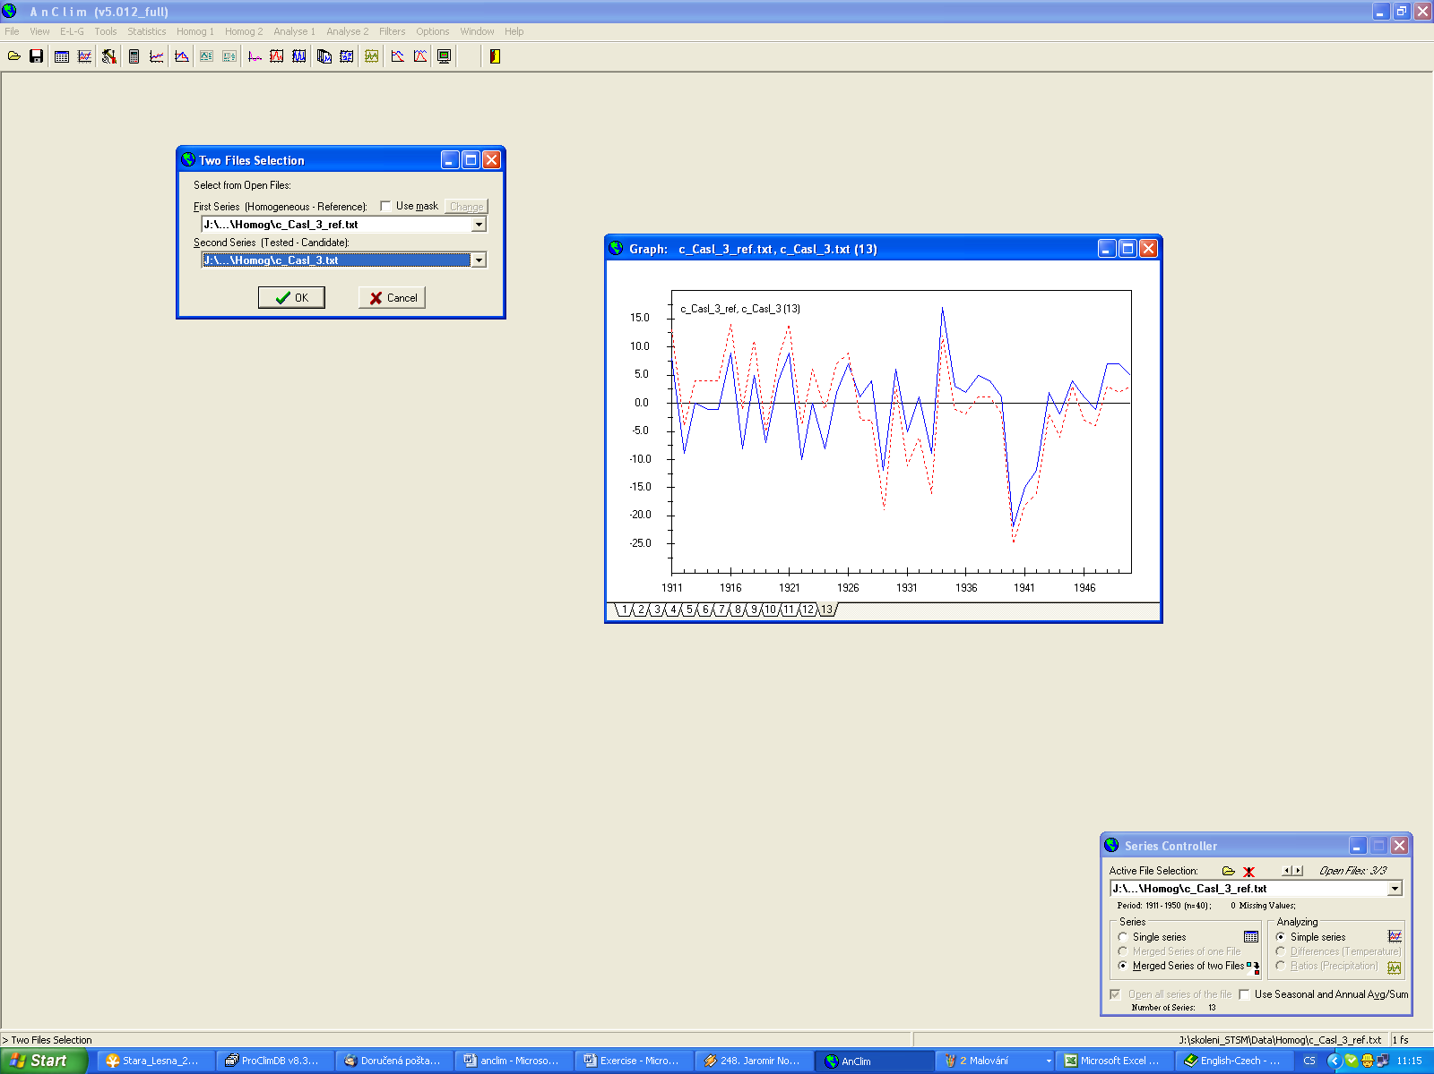
1.
2.
3.
Reference series
Test series

Add. 5 . plot the differences
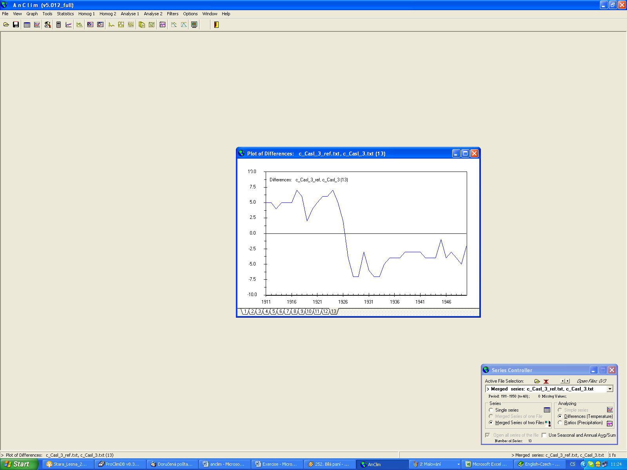

Add. 6. calculate the relative homogeneity test
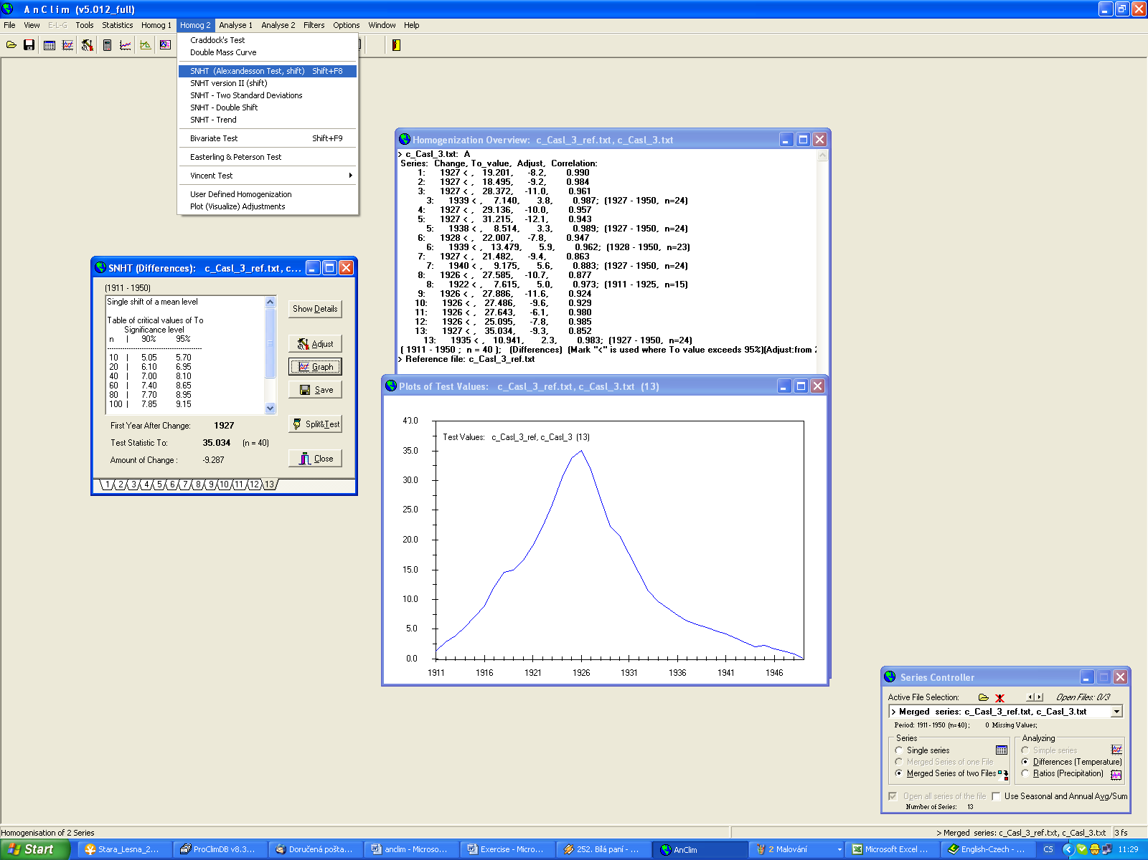

Exercise 4
1. load the file precip_bohemia.txt
2. Analyse 1 and 2
3. plot the 10 years low and high pass filter

Add. 2. Analyse 1 and 2
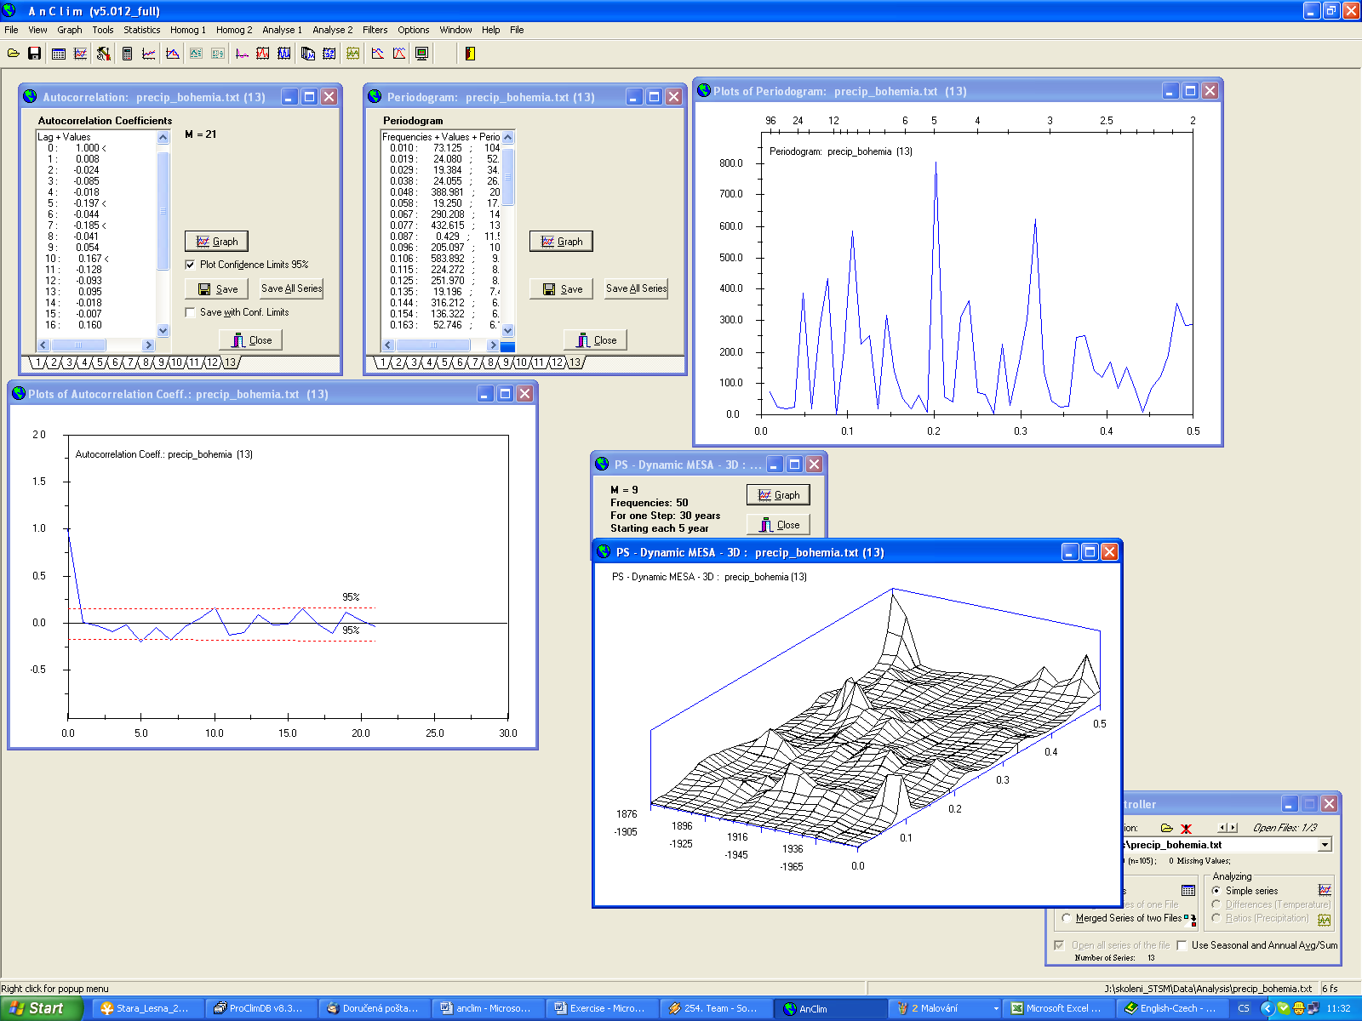

Add. 3. plot the 10 years low and high pass filter
