AnClim software documentation

Table of contents:
1. Introduction 1
2. Working with the AnClim software 2
2.1 General issues 2
2.2 Working with two files 4
2.3 Visualizing data 4
2.4 Adjusted series 4
3. Setting the software 4
4. Menu items in detail 6
4.1 View 6
4.2 Tools 6
4.3 Statistics 9
4.4 Homog 1 10
4.5 Homog 2 10
4.6 Analyse 1 11
4.7 Analyse 2 11
4.8 Filters 11
5. Troubleshooting 12

Introduction

AnClim is software for time series analysis. It has been specially created for climatologic purposes. The software was created by Petr Stepanek, a student of Masaryk University, Faculty of Sciences, Department of Geography and Cartography (1995–2000)). A general description of the software is given here: http://www.climahom.eu/AnClim.html

Be aware that this version of the software is freeware and can only be used for non-commercial activities. Any other use of the software (commercial activities, projects, etc.) must fulfil specified conditions as set under an agreement between Petr Štěpánek and the user of the software.
Usage of the software is, further, conditioned by referring to the author in works whose results were gained by means of this software. A reference to be used in publications: Štěpánek, P. (2008): AnClim - software for time series analysis: Dept. of Geography, Fac. of Natural Sciences, MU, Brno. 1.47 MB. http://www.climahom.eu/AnClim.html

The AnClim software can be adapted according to the demands of the user. Do not hesitate to contact me when you want to add some new functionality or in case of troubles with using the software. I would be grateful for any comments regarding this software and also problems pertinent to the processing of data (my approach is indicated here: http://www.climahom.eu/ToolForHom.html).

After some time, the software will become a DEMO version. You can then download the newest (freeware) version from the technical support website.

Software support page: http://www.climahom.eu
Contact: Petr Stepanek: petrstep@email.cz

Working with the AnClim software

General issues

AnClim accepts text files. Each station is stored in its own file. The ASCI files (*.TXT, *.PRN) for input should be formatted in the following way:

<year> <value1> [<value2> [<values3> ... ] ]

i.e. years are in the first column, followed by the monthly values. No header is required; file can start straight from the first row with data (in case a header is present, you can omit the first rows, see Settings). Text should be delimited by tab or space.

Example of monthly data:
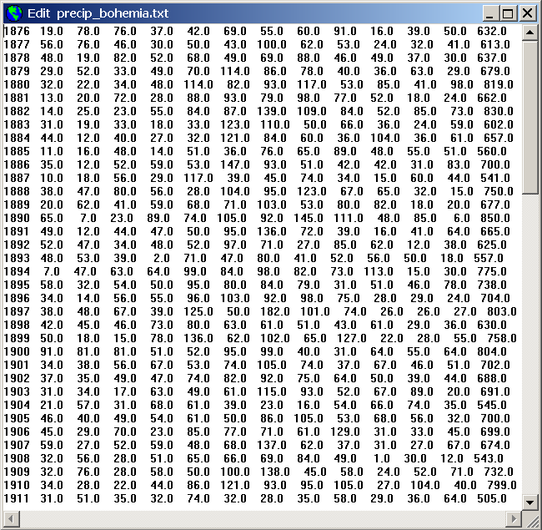

Example of daily data, months in columns (can be created in ProClimDB or LoadData software):
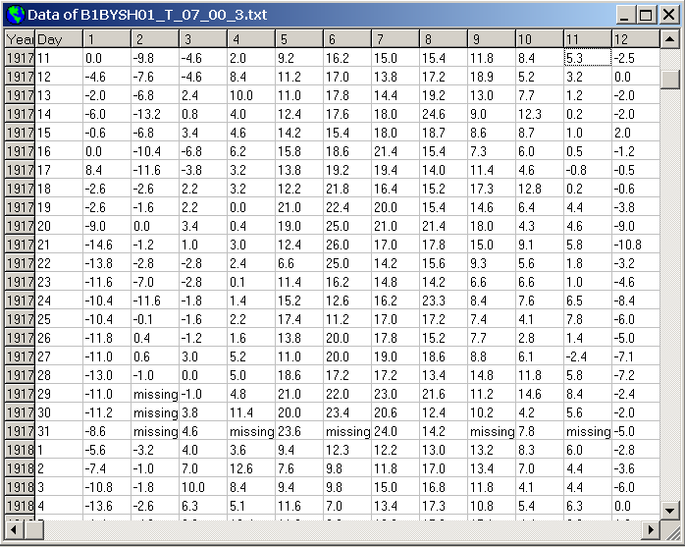

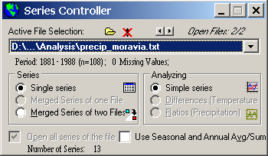
Software controls:

All open files are listed in the ComboBox in the Series Controller (see the picture above). The window of the Series Controller displays information about the number of the series of an active file, the time period of the series and the number of missing values.
If an open file contains 12 series (months), it is possible to switch the option for calculation of seasonal and annual averages from the monthly values. All the functions are then executed with respect to these seasonal and annual values. Seasons are defined as follows: months D-J-F for winter (note that December belongs to the previous year), months M-A-M for spring, months J-J-A for summer and S-O-N for autumn. Annual mean (or sum) is defined as J-F-M-A-M-J-J-A-S-O-N-D, i.e. all the months of the same year. Seasons can be custom defined in Options- Settings, see later. Work can be done with either seasonal averages, sums, maxima or minima.
The open file can be edited(View | View&Edit File), or the series simply listed (View | List Series Individually or View | Show Data in Table), visualized (for graphs see 2.3), adjusted (see 2.4).
As for the calculations of tests, the commands (functions) are performed for all the series of a selected file. Output for each series is displayed in a form according to the chosen TabSet at the bottom of the Form.
Right click on the main window (canvas) for quick access to the functions.
Files can be opened by being dragged from Windows Explorer e.g. and being dropped into the main window.

Working with two files

For testing relative homogeneity or for an analysis of two files, it is first necessary to merge the two files.
To do this - open the two files (all open files are inserted into ComboBox in the Series Controller), then change the option for merging two files (in the Series Controller, or select from the menu File | Merge two Files …). In the pop-up dialog box, select the proper homogeneous (reference) and tested (candidate) series (files). Data of the two files will be merged during their common period for all the series.
Finally, choose a proper option for applying differences (2nd-1st) or ratios (2nd/1st) upon the merged series.

Visualizing data

The software uses many graphs to support the output of functions. There are general rules for all of these graphs.
To change the parameters of the graph - just double click on the displayed graph and then input the desired options (or use menu Graph | Options). The diagram with plotted series will be replaced by a menu where it is possible to change the graph options. When finished - click O.K.
The graph can be saved as bitmaps or copied into (or from) the clipboard.

Adjusted series

When series have been changed (e.g. by running ”Adjust Series” or after adjustment during homogenization) the software works further with these adjusted series. To save these series, select the proper action from the menu (File | Save Series). To use the original date again,–reopen the file (by selecting it in the ComboBox and not opting to save the changes).

Setting the software

Use menu Options | Settings for changing various options of the software.

Software Settings
- Save actual Dir on exit. Saves the directory that is set when exiting from the software. This directory will be set when the software is next run.
- Allow sound. Makes it possible for some functions to be accompanied by sounds (opening and closing the software, Tools | Extract from files, Analyse1 | PS - Dynamic MESA).
- Close all forms on FOpen. When a new file is opened, all the forms (graphs, calculations) belonging to the previous file will be closed. Attention: in case the forms are not closed and you start using another file –the background data (of the previous file) are not no longer valid – if you will use the “old” forms you can get unexpected results.
- Allow output in Memo. Some functions have vast outputs and diplaying the results slow down the processing. Use the Uncheck option to hasten the results of such functions.
- Show All Info in the Stat Characteristics All Series: if not checked, only basic statistical characteristics will be used when using Statistics | Stat Characteristics All Series option.

Series Settings
- Decimal places. The number of decimal places for outputs of functions can be defined.
- Missing values. Define format of missing values.
- Value limits can be set by using the Low limit and High limit option: values outside these limit(s) will be either removed (replaced with missing value) or replaced with the limit value. For instance, when working without 0 values (daily precipitation), set the Low limit as 0.001, then 0 values will not be used in calculations (while 0.001 will be accepted)
- IQR coefficient: coefficient for interquartile ranges (coef – see above), to be used as a limit (for outliers) and to be plotted in the graphs (red dashed curve)
- Exclude extreme values. Replaces extreme values (outliers) with missing values or limit values. The threshold for extreme values is given as: q0.25-coef*(q0.75-q0.25), q0.75+coef*(q0.75-q0.25) (where q0.25 and q0.75 are quantiles). Value of coef is a coefficient defined by user. Usually coef=1.5 is used for outliers and 3.0 is used for extremes.
- Transform values: the series can be apriori transformed, before processing in the software (the other possibility is to use menu Tools - Adjust series functions with more possibilities).
- Values exclusion works in this way: first of all, outside limit values are excluded; then IQR is calculated and values exceeding the coefficient are excluded, the values are transformed at the end.
- Whole series, Certain period only. Series can be used for a whole period, or a specific period can be selected to work with (the series will be shortened with regard to this period).
- Put One for ratio 0/0. Takes ratio equal to one if values of both series are zero.
- Estimations of parameters of population. Sets what kind of standard deviation (and other orders of statistical moments) to use for calculation of statistical characteristics.

Settings for Seasons
- Averages / Sums / Maximum / Minimum for seasons and year. When using seasonal and annual series, whether to use averages (temperature) or sums (precipitation). Averages (sums) are calculated as: months XII – II (Dec-Feb) = Winter, III-V = Spring, VI-VIII = Summer, IX- XI = Autumn, I-XII = year.
- Define your own season. Seasons can be custom defined. Separate each season by a semicolon (;). The numbered months of each season are separated by a the comma (,) or dash (-) when defining interval (e.g. 1–4 means 1,2,3,4). Using 10–12,1–3 will use three months of the previous year and then the successive three months of the present year. Example: 4-9; 10-12,1-3; 1-12 (i.e. summer half year, winter half year and the whole year)

Settings for the graph
- Plot frame. Setting for inserting a frame around a graph.
- Show legend. Setting to show a legend for the graph – to distinguish between the lines.
- Legend2: description of the series (name, month/season)
- Line description. A graph with specific lines is the output of some functions. A description of these lines can be either hidden of shown.
- Histogram. Data can be displayed as lines or as columns (histogram). The width of the columns can be assigned.
- Show outliers. Shows a line which marks a threshold for outliers (extreme values). Outliers are values outside the interval: q0.25-coef*(q0.75-q0.25), q0.75+ coef *(q0.75-q0.25) (where q0.25 and q0.75 are quantiles).
- Black and white only. Option for having the entire the graph (lines, description...) displayed only in black and white.
- Plot grid. Plots grid across a canvas. Either for axis X or for axis Y, or for both.
- Default line thickness. Defines the thickness of a line.
- Special line thickness. Some special lines are thicker than the default. Select the thickness for these lines.
- Form Height, Width. To set the parameters of a form with a graph.

Menu items in detail

View

View and Edit File
Serves for editing an active file. The file will be updated when the changes are saved.

List Series Individually
Displays the series of a file. Switch between individual series by means of TabSet.

Graph
Plots the individual series of an active file. Switch between individual series by means of TabSet. See 2.3 for more details.

Plot all series.
Plots all series of a file together in one graph.

Tools
Serves for processing data before they are analyzed by means of a further function.

Adjust Series
Serves for adjusting series before they are further processed by other functions. Choose the proper action to run and then press either Adjust (adjusts only active series) or Adjust all series (adjusts all the series of an active file). When adjustingseries henceforth, all the functions will be run upon these newly calculated series. It is important to remember to save the series into a file in order to preserve the changes made.

- Add value. Adds required value to all the values of series.
- Multiply value. Multiplies all the values of series by required value.
- Value. Enter required value (for adding or multiplying).
- Average(s). Puts an average of a given period as value (required value for adding or multiplying). When the Adjust all series button is pressed, an average will be calculated for each series individually. Remark: this option is suitable for calculating deviations or ratios with respect to normal periods.
- Set years. Input period used for calculating averages of series (normal period).

Functions for single series
- Normalize series. Normalizes series in a way that an average of series equals zero and standard deviation equals one. Click Certain period option to use only a certain period for calculating average and standard deviation used for the standardization. The proposed average and standard deviation can be changed in the Value field (average is first, followed by a semicolon and the standard deviation).
- Calculate logarithms. Calculates logarithms of the values of a series. Default – calculates decadal logarithms, to calculate natural logarithms, check the proper option
- Square Root. Transformation of values in the form of square roots.
- Logit transformation: log((p+C)/(1-p+C)), where p=(x -min)/(max-min) (i.e. the values are between 0 and 1, constant C is used to avoid zero values for logarithms).
- Angular transformation: ArcSin( Sqrt(p) ), where p=(x -min)/(max-min) (i.e. the values are between 0 and 1). The aim is to spread the distribution near the ends of the range.
- Differencing. Differences adjacent values of the series. Differencing can be either absolute or relative. Lag of differencing can also be entered (first differences, second.. etc).

Functions for merged series
- Calculate differences. Calculates differences of merged series.
- Calculate ratios. Calculates ratios of merged series.

(Multi)Open files
It is possible to open all the files needed at once by means of this command when working with multiple files

Extract from files
Serves for extracting certain information from all open files (use Open files – see 4.2.2 for opening more files at once). In the opened form, the following information can be seen:
- Number of files. Number of open files (all the open files are contained in the ComboBox of Series Controller).
- Number of series. The number of the series from each file used for extracting information. This is the least number of the series that occurs in all the files. The second number (after a dash – ) means maximal number of series occurring in all the files.
- Common period. Period in common for all the files (years that occur in all the files).
- Whole period. The earliest and the latest year that occurs in all the files.
- Merge files. Check this option if information from differences or ratios of two files are to be extracted. The reference file is an active file (last file chosen in the ComboBox of Series Controller). Whether the differences or the ratios of the values of the two files are being used can be seen beside the CheckBox. To change the differences to ratios and vice versa – click on the label (differences or ratios). In case of ratios –either ratios or logarithm of ratios can be selected for use (check the CheckBox “log”).
- One to one. Check this option in case a reference file is unique for each candidate file. Click Choose button to select a name for reference files: affix 1 (letters before candidate filename), affix 2 (letters behind candidate filename) and suffix. An example: candidate series have this name xxx.txt. Its reference series is located in subdirectory “Refer” and has suffix “_r” – i.e. Refer\xxx_r.txt. The mask then looks like this: affix1=’Refer\’, affix2=’_r’, suffix is ‘txt’.

The following characteristics can be extracted (or calculated) from all the open files:
- Certain year. Selects certain year (rows). from all the open files.
- Certain series. Selects certain series (columns) from all the open files. The output can be transposed – this means that a row will contain the name of the file and then all the values (years) of the selected series (month).
- For 1 series. Calculates statistical characteristics for all the open files. In output, every row corresponds to one file. The characteristics are calculated for all the series. The characteristics are: arithmetic mean, standard deviation, minimal and maximal values, trends, outliers and extremes and others. For further details see 4.3.
- For Merged Series. Runs homogenization tests for all the open files. Check the “merge files” option before checking this option (and choose the reference file(s) ). The tests are: SNHT (various modifications), Easterling and Peterson, Vincent method and others. For further details see chapters 4.4, 4.5.
Note: running tests For 1 series when the Merge files option is checked gives results for differences (of ratios) of the tested and reference series.

Create reference series
Serves for calculating one reference series by means of all the open files.
- Simple average. The values of a reference file are calculated as a simple average from the values of all the open files.
- Simple average – deviations. The values of a reference file are calculated as a simple average from the values of all the open files. Before calculating of an average – all the series are converted to anomalies – i.e. arithmetic mean is zero.
- Weighted average – Differences. Reference series is calculated according to Alexandersson (SNHT). The weights are correlations (squared) between the candidate file and reference files ... (i.e: ( ( neigh_stnd 1 * wieght coef) + (neigh_ stnd 2 * weigh coef...) …) / (sum of weights) , where neigh_stnd are neighbor values standardized to average of reference station, it means (neigh_val – neigh_avg + refer_avg) for differences)
- Weighted average – Ratios. Reference series is calculated according to Alexandersson (SNHT). The weights are correlations (squared) between the candidate file and reference files ... (i.e: ( ( neigh_stnd 1 * wieght coef) + (neigh_ stnd 2 * weigh coef...) …) / (sum of weights) , where neigh_stnd are neighbor values standardized to average of reference station, it means (neigh_val * refer_avg / neigh_avg) for ratios)

Complete missing values
Before running this command (to complete the candidate series values), it is necessary to merge the candidate series file with the reference series file. The values of the candidate file are completed by means of a reference file. The average for the reference and candidate series for a given period are calculated. The missing value is then replaced by a value which is obtained as the value of the reference station (for the same year as the missing value), added to an average of the candidate series and subtracted from the average of the reference series. For precipitations (if using ratios instead of differences), replacement is done with the reference station value multiplied by the average of the candidate series and divided by the average of the reference series.
For calculation of an average, use:
- Whole period of series. Calculates averages for all the common period of the two series (candidate and reference).
- Certain period only. A custom defined period can be entered for calculating the averages used for the calculation of missing values.
- X years before and after a missing value. The length of period before and after a missing value can be entered. This period will be used for calculating the averages used for the calculation of missing values. THIS OPTION IS NOT YET AVAILABLE AT THIS TIME – IN CASE OF INTEREST – PLEASE CONTACT ME BY E-MAIL AND I WILL MAKE IT RUNNABLE (currently, ProClimDB software functions, which are more sophisticated, are recommended, e.g. in its menu 7-4).

One series of monthly values
In the case of a file with monthly series –one series can be created in which the monthly values are put one by the other – i.e. there are twelve monthly values for one year.

One series of monthly deviations
The same case as previous one – but all the monthly values are converted to anomalies (each month has zero average).

Generate random series
Generates a new series. Enter the number of values of a new series and maximal value of the series (values of the newly created series will range between zero and the maximal value). Save the series into a file. To use this series – open the saved file.

Statistics
Calculates various statistics.

Statistical characteristics
Calculates basic statistical characteristics for every series. Switch between individual series by means of TabSet.

Statistical characteristics for all series
Displays statistical characteristics for all the series of a file at once – using one form. Results for individual series are separated by a semicolon.

Normal distribution
Evaluates tests for normal distribution – chi-square test and Kolmogorov-Smirnov test. Enter the length of the interval and starting point for a series to be tested. To change the intervals for actual series – double click on a form and input new values. Click the “Show details” button to see the number of values within individual intervals and the theoretical values of normal distribution. Click the “Graph” button to view the distribution.

Polynomial regression
Calculates polynomial regression for a series. First input degree of polynomial. To see details of calculation – click the “Show Details” button (for instant solving of matrix by means of the method of least squares, etc.) You can view the original data and the calculated regression line (click button “Graph”), view the residuals (click “Plot Res.”) or you can save the values of the calculated regression line and residuals (the “Save Y^&Res” button). When working with one series, the independent variable is time, when working with merged files, the independent variable is the reference series.

Multivariate regression
Calculates polynomial regression. Note that the format of input data (file) is different from the “standard” one. The input file should be formatted in this way: the first column is the year, the second contains the values for variable Y, further columns contain the values for variables X₁, X₂, ... X_{n} . Click the “Use edit form” button – for a clearer display of results. Other buttons have the same functionality as in previous case (4.3.4 – Polynomial regression).

Multivariate regression – More
Same as in the above case (4.3.5), but in more details. Output is given in several tabs. First tab – displays results calculated for all the X variables, follows results for multivariate regression calculated without X₁, then without X₂, etc. – this first tab is an overview. Further tabs display results for regression without proper X variable (e.g. tab 2 – results without X_{1,} tab 3 – results without X₂ , ...). All this serves for judging whether or not the proper X variable is significant in a model.

Regression for several parts
Calculates regression (for given degree of polynom) for several parts of the series. Finds the best solution (a position of division) using minimum squares (squares of difference of regression values and original values). A polynom degree of 0 gives the average of a particular series.

Homog 1
Homogenization tests for a single series – i.e. absolute homogenization tests.
References for used tests:
Buishand, T.A. (1982): Some Methods for Testing the Homogeneity of Rainfall Records. J. Hydrol., 58, 11-27.
Mann-Whitney-Pettit test: Pettit A.N. 1979. A non-parametric approach to the change-point problem. App. Statist., 28, no. 2: 126-135.
PMT: Wang, X. L., Q. H. Wen, and Y. Wu, 2007: Penalized maximal t test for detecting undocumented mean change in climate data series. J. Appl. Meteor. Climatol., 46 (No. 6), 916-931. DOI:10.1175/JAM2504.1
For the others (test and User defined homogenisation) see: 4.5 Homog 2

Homog 2
Relative homogenization testing – means that you need reference and candidate station data, merge these files, select whether to use differences or ratios and then run the tests.
References for used tests:
Alexandersson, A. (1986): A Homogeneity Test Applied to Precipitation Data. J. Climatol., 6, 661-675.
Alexandersson, A. (1995): Homogeneity Testing, Multiple Breaks and Trends. In: Proc. 6th Int. Meeting on Stat. Climatology, Galway, Ireland, 439-441.
Craddock, J.M. (1979): Methods of Comparing Annual Rainfall Records for Climatic Purposes. Weather, 34, 332-346.
Easterling, D. R., Peterson, T. C., Karl, T. R. (1996): On the development and use of homogenized climate data sets. J. Climate, 9, 1429-1434.
Maronna, T., Yohai, V. J. (1978): A bivariate test for the detection of a systematic change in mean. J. Amer. Statist. Assoc., 73, 640-645.
Vincent, L. A. (1996): A technique for the identification of inhomogeneities in Canadian temperature series. J. Climate, 11, 1094-1104.
Vincent, L. A. (1998): A technique for the identification of inhomogeneities in Canadian temperature series. J. Climate, 11, No. 5, 1094-1104.

User defined homogenisation

Adjusts a series according to user specified information. The adjustment method is indicated e.g. in Alexandersson (1986). The method is quite simple: there are calculated averages (in case of two series from their differences or ratios) before and after the defined breakpoint and the difference (ratio) of the two parts is used as an adjustment factor. The length of periods taken for calculation of the averages needs to be defined.
The software suggests some values for correction but the suggested values can be changed and user-defined adjustments can be made. If the inhomogeneity started within a year is known and correction of previous months for one year later are wanted, select the particular month (using Tab). Graphs can be plotted in such a way so as to show the original averages of tested series before and after a breakpoint and the suggested adjustment (average of adjusted tested series).

Plot (visualize) adjustments

Shows averages (of differences/ratios) before and after a change (plots lines) to help users have an idea of how adjustments are obtained.

Analyse 1
Analysis for a single series.
References:
Brázdil R. (1986): Variation of atmospheric precipitation in the C.S.S.R. with respect to precipitation changes in the European region. Universita J. E. Purkyně, Brno, 169 s.
Mitchell J. M., ed. (1966): Climatic change. WMO, T. N. 79, Geneva, 80 s.
Olberg M., Rákóczi F. (1983): Informationstheorie in Meteorologie und Geophysik. Akademie Verlag Berlin, 184 s.
Schönwiese C.-D. (1985): Praktische Statistik für Meteorologen und Geowissenschaftler. Gebrüder Borntraeger, Berlin – Stuttgart, 231 s.

Analyse 2
Analysis for two series – the proper files should be merged before this is run.
Reference:
Brázdil R. (1986): Variation of atmospheric precipitation in the C.S.S.R. with respect to precipitation changes in the European region. Universita J. E. Purkyně, Brno, 169 s.
Mitchell J. M., ed. (1966): Climatic change. WMO, T. N. 79, Geneva, 80 s.

Cross-correlations
The second series is shifted forwards or backwards while the first series remains in its original position. Lag 1 means that the second series is taken one year later, e.g. the first series, 1950–1990; the second, 1951–1991. Lag -1 means that the second series is taken one year earlier, e.g. the first series, 1950–1990; the second, 1949–1989. These periods are than used for calculating the correlations.

Filters
Filtering series.
Reference:
Mitchell J. M., ed. (1966): Climatic change. WMO, T. N. 79, Geneva, 80 s.
Brázdil R. (1986): Variation of atmospheric precipitation in the C.S.S.R. with respect to precipitation changes in the European region. Universita J. E. Purkyně, Brno, 169 s.

Troubleshooting

* 1) Reading only a few columns of the input file:
Possible cause 1: the last row does not contain all the values, e.g.
2008 27.7 28.2 27.6 26.8 26.5 25.4 24.9 25.0 26.1 26.7 27.3 27.8
2009 27.7 27.5 27.7 27.3 26.8 25.8 25.4
Possible cause 2: If one of the column has letters (not only numbers), then the software stops and will not calculate any further columns

Reference:
Štěpánek, P. (2008): AnClim - software for time series analysis. Dept. of Geography, Fac. of Natural Sciences, MU, Brno. 1.47 MB.

Contact the author: Petr Štěpánek (petrstep@email.cz)
Homepage http://www.climahom.eu

