DOCUMENTATION FOR ProClimDB SOFTWARE

Table of contents:
DOCUMENTATION FOR ProClimDB SOFTWARE 1
1. Introduction 1
2. General scheme of data processing 2
3. Data and Data Info file structure 5
3.1. Structure of the data file for the monthly version 5
3.2. Structure of the data file for the daily version 6
3.3. Structure of Data Info file 8
4. Brief description of how to work with the software Chyba! Záložka není definována.
5. Description of how to handle the software 9
5.1. Functionality description 9
5.2. Functions that can be used during Viewing / Editing files 10
5.3. Setting the software 12
5.4. Keyboard shortcuts 14
6. Example of data processing 15
7. Individual function descriptions 16
7.1. Get info menu 16
7.2. Tools menu 19
7.3. Transf menu 24
7.4. Calculate menu 26
7.5. Calculations II menu 27
7.6. Number of days (daily version only) 30
7.7. Neighbours menu 33
7.8. Anomalies menu (monthly version only) 39
7.9. Reference menu 40
7.10. Homog menu 43
7.11. Adjust menu 45
7.12. Fill Missing menu 48
8. Examples of Visual FoxPro commands (that can be used during file viewing/editing) 49
9. Batch mode 51
10. Connection with R software 53
11. Final remarks 54
12. Troubleshootings when working with DBF files in Excel 54

Introduction

This is the documentation for the ProClimDB software (http://www.climahom.eu/ProcData.html). The software is for processing climatological data (monthly means, sums, extremes), as well as daily (or even sub-daily) data and is aimed at complementing AnClim software (http://www.climahom.eu/AnClim.html), which is a software developed for time series homogenization testing and analysis (correlations, trends, cycles, etc.) In this latest version, some new tools for time series analysis were added (SPI, extreme value analysis, regression, etc.) Both the ProClimDB software and the AnClim software were developed by Petr Štěpánek (petrstep@email.cz).

Be aware that this version of the software is freeware and can only be used for non-commercial activities. Any other use of the software (commercial activities, projects, etc.) must fulfil specified conditions set by agreement between Petr Štěpánek and the user of the software.
Furthermore, any work whose results were gained by means of the usage of this software must refer to the developer of this software. The reference to be used in publications: Štěpánek, P. (2008): ProClimDB – software for processing climatological datasets. CHMI, regional office Brno. http://www.climahom.eu/ProcData.html

The software can be adapted according to the demands of the user. Do not hesitate to contact me should you wish to have any new functionality added or in case of problems using the software. I would be grateful for any comments regarding this software and also for being alerted to any problems pertinent to the processing of data (my approach is indicated here: http://www.climahom.eu/ToolForHom.html).

For technical support, visit the webpage http://www.climahom.eu where, among other things, FAQs and steps describing how to proceed (how_to_proceed.doc) can also be found.

General scheme of data processing

Various functions can be found in the software. The original aim was to cover functions from data quality control, through homogenization to time series analysis (after consideration, implementation of the connection to R- software for multivariate analysis, etc. started in 2010).
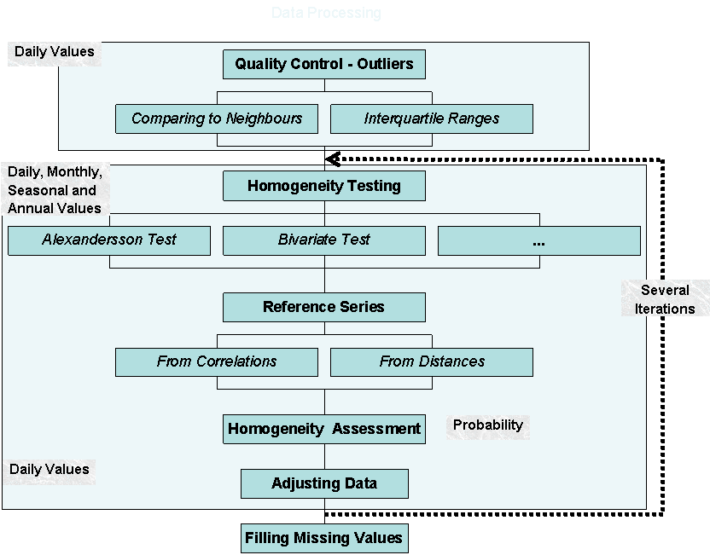
Fig. 0a. Scheme of usual data processing during data quality control and homogenization (preparing data for time series analysis) prior to data analysis

Brief description of how to work with the software (Quick start)

- The software works with all source data included in one file (“Data_file“). Another important file is the file with information containing data (“Data_info_file”), such as beginning, end of measurement, coordinates and so on. It is advisable to put coordinates of the stations into this Data_info_file for later use (e.g. selecting stations by means of distances, see below how to import such information). When running functions in the software, only stations listed in the Data_info_file are processed. This way, there is no need to adjust or change the Data_file each time another set of stations is processed, simply change the list of stations in the Data_info_file. Thus, Data_file and Data_info_file are the most important files used in the software. Once created, the other functions can be run to get the desired results very quickly and easily. Remark: for some functions, the Data_info_file is not required (files not required for processing are given in brackets).
- Each month is processed individually.
- The software uses different files stored in the Data (Data_day) subdirectory (folder). When working with data, your own (new) subdirectory (folder) should be created first of all. Original (example) files should serve only as templates and should not be modified. It works like this: load a template file from the Data subdirectory according to your needs (his function can be accessed by right clicking the mouse button) and use the “Save as” command to save the template file to a new file with which to work. Or, better, write any name (e.g. copy filename of input data file and rename it, e.g. refer_info_xxx.dbf); in this case, the program loads the template file and copies it into this new file automatically.
- Use different profiles (settings of files) to preserve the file settings for later use. Leave the Default profile with the loaded template data unchanged and work with a new profile.
- To view files and results, either functions in the software can be used (View/Edit table) or to display information in MS-Excel (in the case of using MS-Excel, see the Troubleshooting chapter at the end of this document).

Fig. 0. The appearance and functions of the main window.

Data and Data Info file structure

The software works with all source data included in one file (“Data_file“). The accompanying file with information about the data (“Data_info_file”), such as ID, begin, end (years) of measurement, coordinates and so on is another important file. Data (stations) are processed according to information fed into the Data_info_file. However, if information about station locations (e.g. not working with neighbours) is not needed, it is possible to proceed even without this Data Info file (files not required for the processing are given in brackets).
The software works with files in the DBF format. MS-Excel (up to the 2003 version), for example, can be used for exporting data into the DBF format required by the software.
Data can also be easily downloaded from the central database and prepared by means of LoadData software (by means of automatically generated SQL commands) – straight into the format needed by ProClimDB software, without further need of data structure–format modification.
Should the original data of individual stations be stored in TXT files (or XLS format), use menu Tools – Import from TXT/DBF files in this software or use the same function in LoadData software (tab Output). Another option for preparing TXT files is macro, in MS-Excel, which was developed to import all TXT (XLS) files stored in a given directory into one Data_file (DBF). The macro can be found in the GetStations_xls.xls file in the root directory of the software. When the file is opened, a form will appear where functions for loading the data, managing sheets, and finally creating one DBF Data_file, etc. can be selected (note: in MS-Excel, you have to allow macros)
Important: the code for missing values is: -999 (can be changed in Settings).

Structure of the data file for the monthly version

Switching between the monthly and daily version is done via menu Options – Change Mode of data processing, or directly via the button on the main form (Mon or Day buttons).
All source (measured) data are included in one file (“Data_file“). Monthly data are distinguished by their ID, each row contains one year (Year column), and individual months are marked as N1-N12. Alternative acceptable formats are: Ids in individual columns (with names of 10 characters at most). A final station ID can also be composed from several columns (e.g. ID+Element+Time) – check Auto_multi_ID option on the main form or in Settings – Values & IDs handling.

Examples of supported data formats:

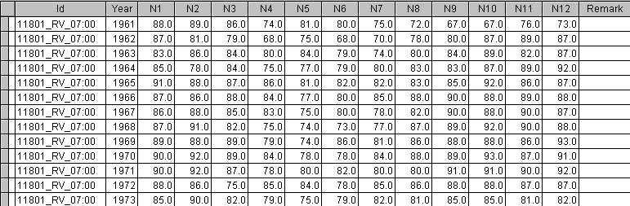
Fig. 0b. (ID, Year, Months in columns: very useful format: easy processing of individual months)

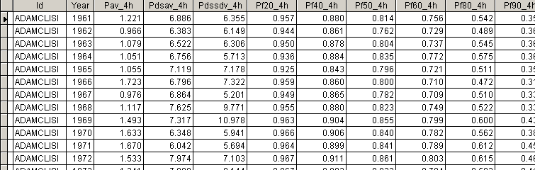
Fig. 0c. (ID, Year, Annual data (e.g. various indexes) in columns: easy processing of individual columns. All the columns after the Year column are considered until a column with the character data type is found)

…
Fig. 0d. (Year, Month, IDs – stations in individual columns: suitable in cases where the same measurement periods are used)

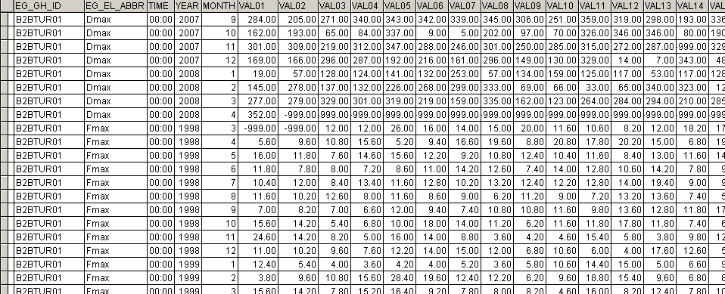
Fig. 0e. Example of final ID composed from several columns (EG_GH_ID+EG_EL_ABBR+TIME).

Structure of the data file for the daily version

Data are distinguished by their ID. Each row usually contains one day (the date is given by combining the Year, Month, Day columns), followed by values given in Value2 column, but such a file structure requires a lot of disk space and the data processing is also slow. Alternative acceptable formats are: months in individual columns (N1–N12), or days in individual columns (D1–D31), or IDs in individual columns (with names of 10 characters at most).

Examples of supported data formats:
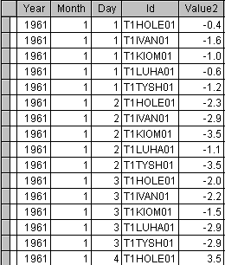
Fig. 0f. (ID, Year, Month, Day, Value: very space consuming long calculation times …)

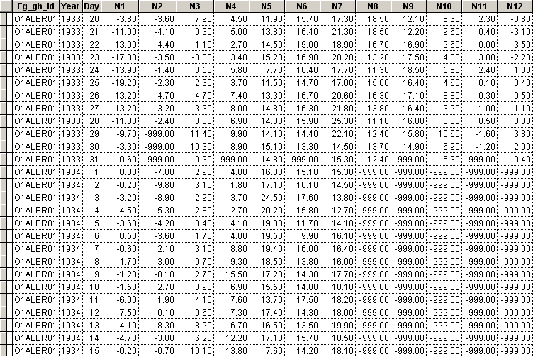
Fig. 0g. (ID, Year, Day, Months in columns: very useful format easy processing of individual months)

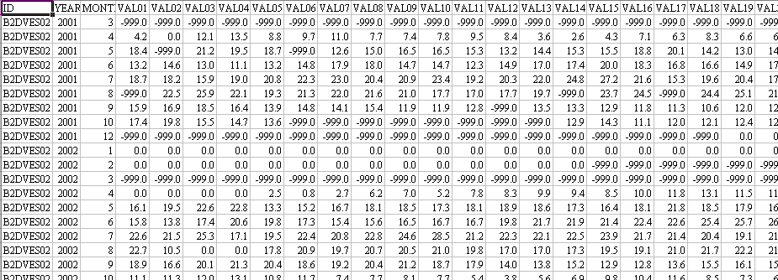
Fig. 0h. (ID, Year, Month, Days in columns)

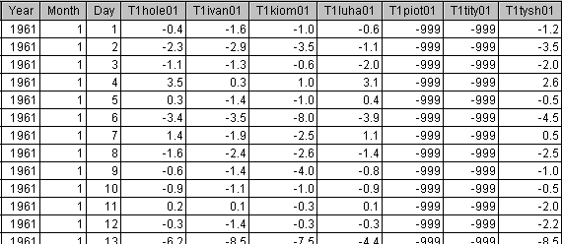
Fig. 0i. (Year, Month, Day, IDs – stations in individual columns suitable in cases where the same measurement periods are used)

Structure of Data Info file

Data Info file contains these columns:
Id – the final ID of a station can be composed of: station ID+element+time+… (i.e. several elements, observation times or anything else can be processed separately but be in one file). If automatically created “multi ID” is not wanted, uncheck “Compose ID from several columns” option in Settings – Values & ID handling.
Id_orig - original station ID – needed for the function Get info - Import Geography (1–5)
Region – can, for example, be a geographical region, but generally anything that distinguishes groups of stations for processing (e.g. remainder of composed ID – like element and observation time). In functions like correlations, neighbours, reference series – neighbouring stations are sought only within the same “region”
Miss_cnt – number of missing values for a station
Miss_max – maximum number of consecutive missing values for a station
Period_mis – standardized number of missing values so that stations with different lengths of measurements can be compared
Length – length of measurement of a station (end - begin)
Remark: the above mentioned columns are filled by running the function Get Info - Create Info file (1-1).

Further columns:
Name (station name), Latitude, Longitude, Altitude (or any other columns found in the input file) – can be filled by running the function Get info – Import Geography (1–5).
ANOM, ANOM_BEG, ANOM_END, ANOM_CNT – serves for menu Anomalies
DIST_MIN, DIST_MAX, DIST_MEAN, DIST_STD – function Get info – Get min. distances (1–7) fills information about the distance to the nearest or farthest station and average distances to all stations, together with standard deviation of the distances.

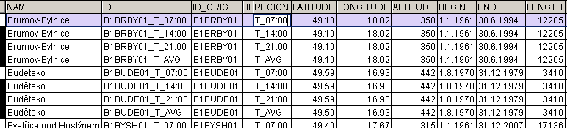
Fig. 0i. Example of Data Info file.

Description of how to handle the software

Functionality description

The proper function to be processed can be selected from either the menu of the main window (the window is called ProClimDB…), or by switching pages on the accompanying window (Processing Window).
Before data processing, files have to be inputted into EditBoxes (by right clicking on a given EditBox and selecting the Attach (Open) File option). Generally: the input (Source) files are on the left side and the output (Destination) files are on the right side (note: the content of the output files will be overwritten; if the file does not exist, it will be created).
Individual files can be managed by right clicking upon a given EditBox (see diagram below). There are several commands to select from:
by selecting “View / Edit Table…” a file can be viewed (in Show_DBF.exe application distributed with the software) and the desired changes, such as inserting new rows/columns, deleting them, modifying the structure of a file, running FoxPro commands, etc. (see below for more details) can be made.
Attach (Open) file option opens a file (the name can also be pasted from the clipboard). The Load from template option (valid only for the input files) creates a new temporary file from a template file (overwriting a template file itself can lead to later problems in the software). The Load output file option: puts a default name for the output file. Destination files are backed-up into *.bak files before processing (see Settings – General settings).
The Save as … (Copy) option can be useful for copying a template file to a new location. With Save as dbf IV, files can be saved in DBF IV format (for use in other applications).
Click the Undo option to undo the most recent process (in output files).
The Open files in external viewer (e.g. MS-Excel, Statistica, R) is self-explanatory; in these cases the file is saved into DBF IV format automatically, the external viewer is defined in Settings – General settings. In MS Excel, you filters can be used for better viewing of the content of the file, use colours, graphs, etc. Note that there are some limitations when using files in MS-Excel (see Troubleshooting at the end of this document), e.g. rows marked for deleting are not displayed, if new rows are added in MS-Excel in the end, they are not accepted in DBF file, etc.

Working with filenames: filenames can be dragged from Explorer and dropped into the proper EditBox, or by right clicking on the EditBox (e.g. output file, or data file), copying the filename onto the Clipboard, going into further function, right clicking and pasting the name into another EditBox (input file). Or the filenames of all EditBoxes of a given function can be propagated into another function: 1) after calculation is finished, 2) after saving filenames and options into a batchjob file – using right click upon Run button, or 3) right click on any EditBox and select Propagate All Names …; Note: 1) and 2) are available only if the proper option has been chosen in Settings – Control Options).
If the font of an EditBox is in Italics, more than one file (list of files) or a mask (e.g. data\data*.dbf) can be inputted; the full pathname is only needed for the first filename, the other files in the list can be input without it. Red coloured font indicatess that a file does not exist but is required (this does not matter in “Destination files” since it will be automatically created from the template files). Blue coloured font is for output files (a file does not need to exist before running the function, it is created from scratch).

Fig. 1. Example of right clicking on an EditBox.

After selecting (opening) all the needed files in EditBoxes and choosing the proper options, press the “Run” button to start computation. Press the ESC key to stop the computation. During computation, the processing information is displayed in the Process Info window.
When working with a large amount of data, some functions can take a lot of time on some machines. It is possible to interrupt the calculating (by pressing ESC) and to re-start it later from a selected position. In this case, the starting position must be typed into the appropriate EditBox in Settings – Starting positions); the new start position of the calculation should be the last number shown in the Process info window (in the screen) of the previous calculation. Previous output files should be preserved (make a copy) as in some cases (functions) previous and posterior output files will need to be combined; output files are sometimes overwritten. It is easy to merge files (previous results and new ones) by Viewing the file, pressing the Command button and typing this command: append from <file_name> ), or by using the function in menu Misc – Append another file when Viewing the file, or by using 2-1 function with the DBF option in ProClimDB.
The software remembers the last file settings for a given profile. If, e.g. more climatological elements are processed, different profiles for each element should be used so that file settings for a particular element are preserved. Change the profiles in menu Options - Change profile - where a profile can be selected or a new one created (note: when creating a new profile, all settings of the current profile are loaded - copied).
Contrary to file settings, option settings are stored only once (the most recent), for all profiles altogether. To save it for later use, use batchjob file (right click on the Run button), set the batchjob file in Settings – Control options.

Remarks: in some cases, the input or output files are not required, the editbox label is then given in parenthesis “(Data Info file)”. E.g. Info File is then created “in situ” from the Data file (creating a simple list of stations with their begin and end estimated, no missing values or other characteristics, such as importing geography, are included. Cases marked for deletion (in Data file) are not processed. As a “(Data Info file)” a file with a simple list of IDs (of arbitrary field names) can also be used.

Functions that can be used during Viewing / Editing files

When View / Edit Table is selected … by right clicking on the selected file (EditBox), the file is displayed in a new application (Show_DBF.exe distributed with ProClimDB). .dbf extension can be registered to be opened via this application (asked upon first launch or found later in menu Options).
There are several buttons on the form:
No buttons: adds a column with row number (order). Click again to remove the column
Bottom/Top button: skips to the beginning or the end of the file.
Sort buttons: click to sort according to the next column, right click to cancel sorting and display the original view. To save the sorted view, click Ctrl+S and enter a new file name.
Delete button: deletes records marked for deletion. Records are marked for deletion by use of the far left (very thin) column with no name. Right click to remove the deletion marks (recall all). Important note: rows marked for deletion are not displayed when you open the dbf file in Excel
Insert button: inserts a new line (row) before the actual row. Right click to add a new row at the very end of the file (append blank).
Modi stru button: opens a form wherein the structure of a given file can be modified. New columns (fields) can be inserted, deleted;the order can be changed, the length of columns can be changed, the number of decimal places, etc.
Command button: type queries – Visual FoxPro command (compatible with previous versions of the software, e.g. DBF IV);a very useful and powerful function. Examples of commands that can be used: delete rest, recall all, delete all for year<1990, replace id with id+’_r’ all for substr(id,1,2)=’B1’, append blank (for other examples, see the end of this documentation file). Along with others, Select – SQL commands can also be used, e.g. Select * from thisfile where length>10 (i.e. the words ThisFile, This or File or DBF() can be used instead of the original file name). Another example: Select * from dbf() where Id in (Select Id from dbf() where Year=1950) into table output.dbf (selecting whole measurements for stations measuring in a certain year). For processing a longer command or several commands at a time, put the commands into the Settings\Run_commands.prg file (each command on each row; to continue on the next line, put “;” at the end of previous line) and then right click on this button to run the program file. Note: if this is going to change the contents of a file, save it to a new location first so that the original data is not lost.

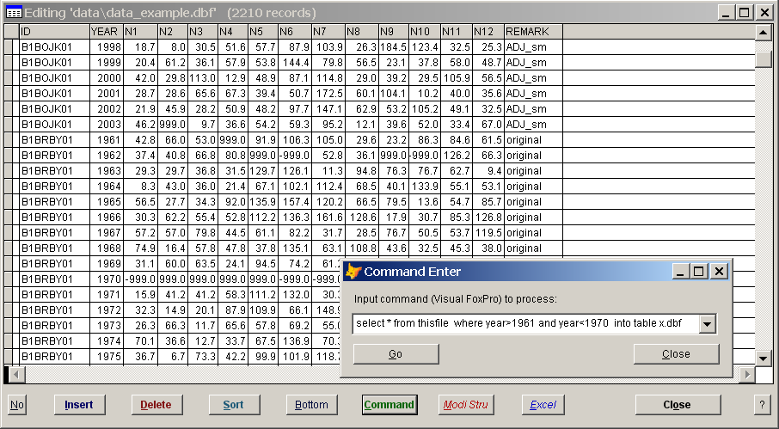
Fig. 2. Viewing a data file.

While viewing a file, use keyboard shortcuts. E.g. Ctrl+F to find a file; Ctrl+S to save into another file; Ctrl+D to mark a record for deletion; Ctrl+W to copy a whole row; Ctrl+E to paste a copied row. Press the button with the question mark for more details.

It is also possible to right click on a particular column name or upon a row and select a function from the context menu. For example:
List cases of this column will give a list of all cases that occur in the given column.
Filter (Show rows of a particular case) displays rows with the occurrence of an input value (works like Filters in MS-Excel), various expressions can be inputted:
- B* ,
- >20,<30 ,
- <20 or >30 and <>-999 ,
- >'C' and <'K' ,
- begin> 1894 and id='Average' .

Fig. 3a. Functionality available during Viewing a file (right click upon a row)

Right Clicking on the Column header brings up another context menu.

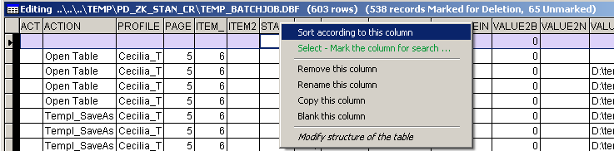
Fig. 3b. Functionality available during Viewing a file (right click upon a column name)

Setting the software

In menu Options – Settings, a number of options can be set.

General settings tab: Back-up output files option: check to back-up output files (destination files). Files are saved into *.bak files before processing. To restore the original files, right click on edit control of a proper file and select the Undo option. Wait time: wait time in hours, to automatic continuation after pressing ESC (e.g. 0.05 for 2 minutes, manually can be set in: SETTINGS\o_time_wait_esc.txt). There are further options for setting the default external viewer, the code page (for View), internal viewer fonts, sizes, etc.

Values, IDs handling tab: Missing value option: code for missing value. The value can be changed but it is not advisable because of the relation with AnClim and LoadData software. Further settings can be made in Allow missing Dec for the first DJF option behavior for calculating the first DJF (winter) value (e.g. in the 4-1 function).
Value limits can be set using the Low limit and High limit option: values outside these limit(s) will either be removed (replaced with the missing value) or replaced with the limit value. For instance, when working without 0 values (precipitation), set the Low limit as 0.001, then 0 values will not be used in the calculations (while 0.001 will be the lowest to be accepted).
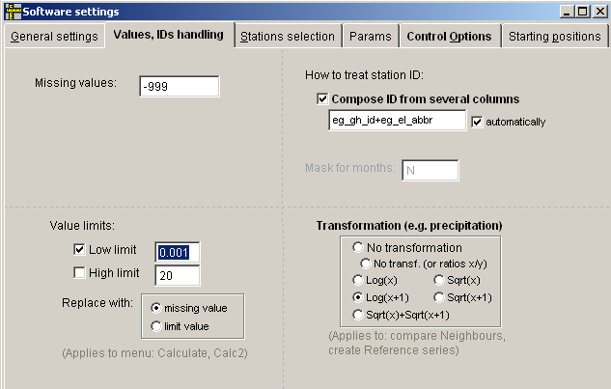

ID: ID can be created by combination of several columns. The columns can be specified in the Compose ID from several columns option, check the Automatically option to use all available columns automatically (all columns before Value column, except Year, Month, Day).
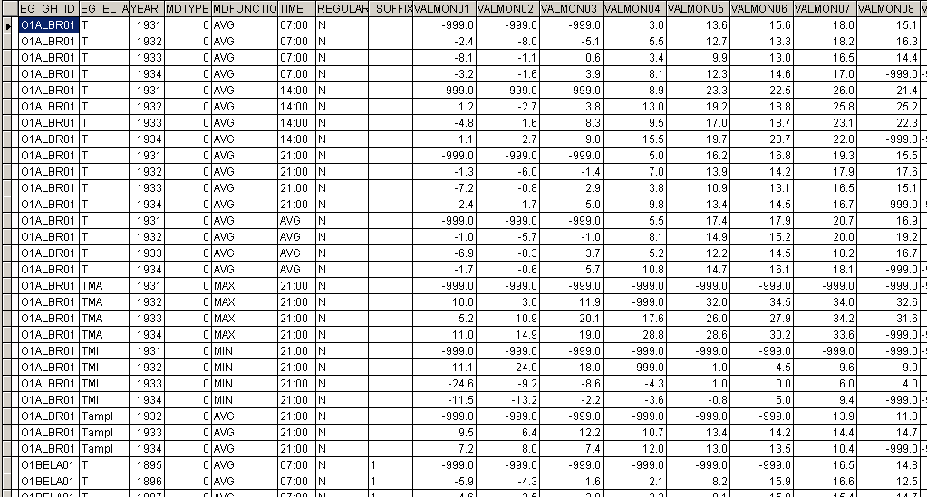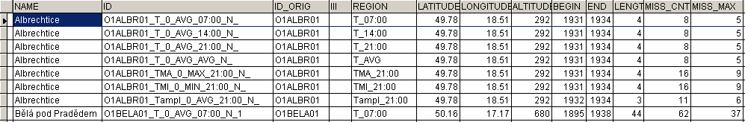
Data file
Data Info file
(Various cases of certain columns can be processed separately – by creating individual IDs in Info file, see Settings – Compose ID from several columns)

Transformation settings: in some functions (e.g. Neighbours, Refer menu), it is possible to choose between differences and differences of transformed values (for precipitation, instead of ratios, because e.g. log(x/y) = log(x)-log(y)). Transformations can be very useful. Here is where the choice of which transformation will be applied on data (when using the Differences of transformed values option in functions) can be made. In case of No transformation, ratios will be used (either Y/X or you can set using X/Y), otherwise the differences of two transformed series will be applied: Log(x), Sqrt(x), Log(x+1), Sqrt(x+1), Sqrt(x)+Sqrt(x+1). Equitable ratios are constructed in such a way so as to give comparable values for both X/Y and X/Y values. Remark: should there be a need to change the value when running in the Batchjob mode, the name of the variable is n_transformation (=0 for no transformation and Y/X, =-1 no transformation with ration X/Y, and value 15 for transformations: 1 log, 2 sqrt, 3 log(x+1), 4 sqrt(x+1), 5 sqrt(x)+sqrt(x+1), n_transformation=-10 equitable ratios).

Stations selection tab: Minimum station length option: minimum length of base station for calculating correlations and finding neighbours (shorter series will not be processed). Minimum neighbour length option: minimum length of selected neighbours (shorter series will not be accepted). For zero (or empty) values, no such condition is applied.

Params tab: when working with statistical distributions, it is possible to use your own distribution parameters to calculate CDF, return periods, etc. Generally, the first step is to calculate parameters (use Save distr. parameters option) for each station. Then the file is edited and a new file with the parameters to be used in processing is prepared. To do this, edit proper input file (e.g. in Excel) then check Import distr. parameters option and run proper function (distribution) again.
Minimum distance (km) for weights option: lower values are replaced with the limit, for weighting distance, 1 is the least minimum recommended.
Clever neighbours selection option: serves for selecting neighbours in a way so that the IQR (using ngb. altitudes) of the base station altitude is below 0.5 (recommended), the selection of the last 33% of neighbours (recommended) is changed to achieve this (i.e. taking further stations if needed). This option is good e.g. for functions using standardization to altitude. (Use negative values for values between median and a quartile, zero for values at a quartile) ( (recommended: 1.5 is sufficient for temperature, 0.5 is good for snow – when altitudes of neighbours should be around that of base station).

Control options tab:
No stop when error occurs: if checked and some error occurs, no error message will be displayed and processing will continue. Regardless, all errors are written into the controls\error*.log file.
No data files indexing: indexing files helps considerably in speeding up calculation (mainly for daily values processing). On the contrary, in some cases (when indexes are already created), creating indexes can slow down processing. Should this happen, check this option,but do not forget to uncheck it again later!
Batchjob processing: a list of actions to be taken can be defined (record it by right clicking on the Run button or record all using the Log all processing option) and then let the software process all of it. This is useful in the case of a lot of time-consuming processes. Simply define actions (in the proper dbf file), run it and then wait till all of it is finished.

Starting positions: data processing can be stopped for any reason by pressing the ESC button. To continue later from a given point, define the desired starting position in the proper edit box. Just find the proper menu name and fill in the desired starting position. Do not forget to delete this once the processing has been completed.

Keyboard shortcuts

Keyboard shortcuts:
- Ctrl+PageUp,PageDown, – changes menu items
- Ctrl+up Arrow, down Arrow – changes submenu items
- Ctrl+Q,W,E,R T,Y,U,I: context menu for editboxes 1–4 and 5–8…
- Ctrl+F4, Alt+F4, Ctrl+Q - closing a window (e.g. Viewing a file, Settings)

For shortcut keys that can be used during viewing/editing the file, see documentation for Show_DBF.exe application.

Example of data processing

Start with checking data file and creating info file – menu Get info – Create Info_file (1-1), then import coordinates and altitude into the Info_file – menu Get info – Import Geography (1-5). The data can be checked for outliers – menu Neighbors – Compare from … and then Compare User defined (7-1 or 7-2 and then 7-4). For homogenization – use Reference menu (8-2 or 8-3), then AnClim software for homogeneity testing (also available through the 8-4 function) and back ProClimDB Homog menu (9-x) for processing the results and Adjust menu (10-x) for adjustments. Grid points can be calculated using menu Transf – Calculate grids II (3-15 and 3-16). Filling missing data is available in menu Fill Miss or better in the Neighbours menu. Then the date can be analyzed– e.g. menu Calculate, Calc2.
Examples of processing can be found in the Help menu – Example …, or in the “how to *.doc” files in the root directory of this software.

Individual function descriptions

Get info menu
Item Create Info_file (1-1). This function goes through Data_file and puts information about stations contained in it (distinguished by their ID) into Data_info_file (ID, begin year, end year, length of measurement, etc.). Creating Data_info_file is essential for running functions pertinent to working with neighbour stations.
In case there exist several parts of measurements of some station (there is a gap in measurement), names - orders of these parts are put behind an ID of a station and original Ids are replaced (both in Data_info_file and backwards in Data_file if you will choose to save it in the end of processing). In other words, original series are divided into different periods, such divisions are made according to a maximum allowed length of missing years (see text below).
If the Without end missing option is checked and there are missing values in the beginning or in the end of the data, then the begin year, end year in the Data_info_file is given without these missing years. Delete whole missing years option: deletes all rows where all monthly data are missing. Fill_gaps-with missval option – fills gaps between parts of the same station (ID) with missing values (otherwise the station is divided into more parts – see above). You can specify a limit for maximum number of years to be filled in Max missing years option; separating stations into more parts with gaps less than one year if also possible: after semicolon put number of Days (for Days in Columns structure the number should be multiple of 31, for Months in columns structure the Days does not work, only whole years). Recommended length is 4-5 years. Note for daily version: Max missing years means complemented years. E.g. if zero, fills gap shorter than one year, if 1 till two years etc.. Snapshot to Info_file only option: takes only Snapshot of content of Data file and saves it to Info file (without searching for gaps). Remark: You can also get quick overview of Data file using this command: SELECT ID,MIN(year) as begin,MAX(year) as end FROM thisfile GROUP BY id INTO TABLE data_info .
Output: in Id_orig column of output Data_info_file, original Ids are preserved (for purpose of importing geography in the next step). In some cases, you can may need to use this command: replace id_orig with alltrim(substr(id,1,at('_',id)-1)) all for at('_',id)>0 . This will restore original Ids from new values to that Idxxx column. See Count missing values option for description of output regarding missing data.

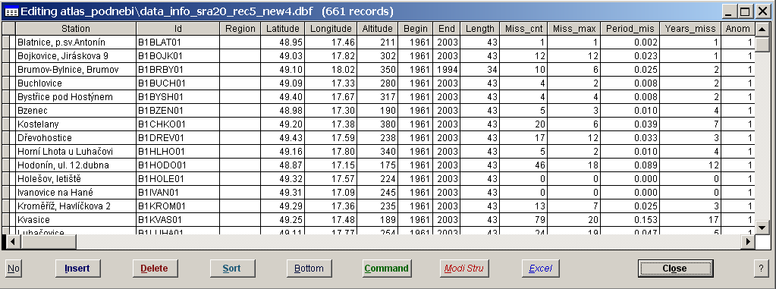
Fig. 2b. Viewing a data info file, monthly version (with imported geography – 1-5 function)

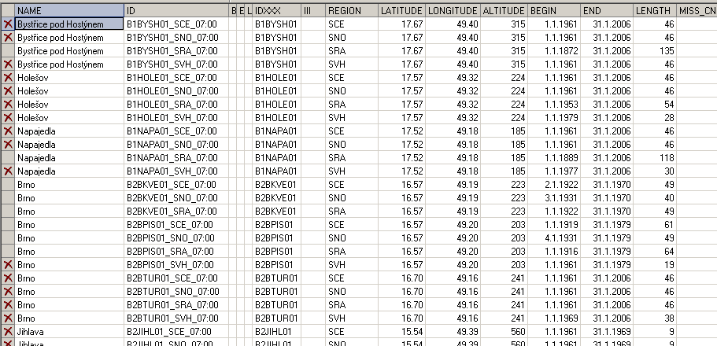
Fig. 2c. Viewing a data info file, daily version (with imported geography – 1-5 function, and shorter stations marked for deleting)

Follows three functions that can be used in a case that “Get stations info” was not able to adjust original data file so that it is suitable for the software:
Adjust data file (makes the data file suitable for the software, the first field has to contain station ID).
Adjust to unique ID (in data file, creates new IDs by combining names in available columns)
Fill gaps (fills gaps in measurements with missing data, applicable also for hourly data). You can set the maximum gap for filling missing values, the values filled can be either a missing value or a value specified, and you can also interpolate values between two records, for the smallest time step available in the series; for the first value: the length of the succeeding record - i.e. the first length available - is used.

Item Import geography (1-5). By comparing two common columns of the two files (columns to be specified in Column-source and Column-dest textboxes, e.g. name for ID in Geography file and ID in Data_info file) columns of a destination file are filled with columns values of a source file (only columns with the same names in both the source and destination file). Suitable e.g. for filling coordinates, names of stations etc into Data Info file. In case of more number of occurrence in the source file, finds the latest (date) value and takes appropriate values with regard to this latest date (important e.g. in case of importing coordinates). Note: in case you created different parts of series in previous step (Get stations info), original Ids are stored in Id_orig column. This should be used then here in Column – dest. option.
Item Count missing values. Calculates missing values for stations and periods listed in Data_info_file. (Remark: this is calculated in automatically by running “Get stations info” option). Column Miss_cnt contains number of missing values for a whole period of measurement, Miss_max - maximal number of successive missing values (individual monthly values), period_mis - number of missing values per one month (number Miss_cnt divided by length times 12). Calculated for months (n1-n12) only, not for n13 (annual values). Years_miss column contains number of years containing at least one missing values (month). Note: missing data are calculated automatically during running Get stations info menu.
Item Get min. distances (1-7). Calculates distances characteristics (in kilometers) for each station. First you have to input coordinates of stations (latitude, longitude) into Data_info_file (e.g. using Import geography menu, see above). Characteristics calculated for each station are: distance from the nearest station (dist_min), distance from the most distant station (dist_max), average distance from all the stations (dist_mean) and its standard deviation (dist_std). Check Not the same name option so that the minimal distances are not calculated for stations with the same first 4 letters in a name as the given station.
Item Distances (1-8): creates list of stations within a given distance from each station given in Info_file. If you specify Data_Info_file B, for each station in the Info_file, neighbours are found in the Info_file_B only. Set Max distance option to give the limit for selecting stations. You can set maximum number of neighbours given in the output. Leave empty for all neighbours, if you put 1, the neighbours are given in the same row as base station. If you check Add order statistics, in the end some statistics (min, max. avg) for individual orders of stations selection (the first nearest station, the second, etc.) are given. If you check Add interval statistics, numbers of stations within a given distance interval (set begin value and then step – interval length) are calculated, both numbers for a given interval and numbers of all stations till given distance. Note: all stations listed in Info_file are considered, regardless on period in which they measured. If you want to work with stations measuring within specified period only, you can proceed like this: while Viewing Info_file, use e.g. these two commands (selecting only stations measuring between 1961 and 1990): “delete all” and then “recall all for begin>=1961 and end<=1990”. To get list of stations available within given distance category (interval), check Give list of stations option. Distance and azimuth for base station (id_1) mean vector sum of all neighbour positions.
Remark: rows (stations) marked for deleting are not considered – no list of neighbours is given in the output for such stations, but these stations can still appear in the list of neighbours of other “base” undeleted stations (but marked for deleting so that you can easily erase them). As for numbers of stations in given intervals, only stations not marked for deleting are considered.
Item Number of stations (1-9). For each year, number of available stations is calculated. Output (Output-Count file) contains number of available station for a given year (no1 column), number of available stations for a given year that measure also between 1961-1990 (no61_90). Column MV contains number of stations with whole year (all months) of missing data. After it follows – if the option Give list of stations is checked - list of stations available for a given year (ID),.with begin and end of measurements of each station. Check Calculate min. distances option to get minimum distances for each station in a given year. In the end there are summed numbers of all available stations for intervals of a given length of measurements. Input into textboxes: “Interval begin” – start point for intervals of a length of measurements, “Interval length” – number of years for each step – interval length.
Item Group records - Count cases: Gives statistics (using values of a given column Statistics for column) for individual cases of a specified column(s). .You can specify several columns (separated by semicolon or space) for whose individual cases combination statistics (AVG,STD,MIN,MAX,CNT) will be calculated.
Item Find problems: Finds problems in data file, namely the same values. The same values can be searched for either in rows or in columns (or both, but then Blank the rest option does not work properly). You can set the least number of occurrence of the same values (option The least No of occur.) and then whether to search in rows or columns. Found cases will be unmarked for deleting in the output file. Remark: similar function, but more sophisticated (in sense of neighbours selection), can be found under 7-3.

Item Arcview: Read points in a grid (ASC): according to given coordintes and raster file (grid in ASC format, can be achieved through menu File – Export Data Source in ArcView), reads value in the grid (e.g. elevation).
Item Arcview: Read points in a SHP: estimates to which SHP (Shapefile) the input points belongs to.
Item Arcview: Read points in a grid (ASC): for the given Shapefile, gets middle of the area into the output.

Tools menu

Item Import from TXT/DBF files (2-1). You can use either GetStations.xls file distributed with this software (in root directory) with proper macros (see section 1.1. Data Format) or this function. Put filter for choosing given files (option Files (filter)) from specified directory. The TXT files to be loaded into a given Import_file: imported columns from TXT files has to have fixed positions (if the Delimited with option is checked) or can be delimited by the specified characters (you can specify several characters for delimitation if needed but do not use space between individual characters since the space would be regarded as another delimiter. Use 'COMMA','TAB','BLANK' words for delimitation with “,”, tabulator, space. The columns positions in output files are recognized according to a structure of the Import_file – if the option Create new file is not checked, or estimated from the structure of the imported TXT files – if checked (the names of columns are then read from the header which is specified in the Start row option – after semicolon or comma. For cases new output file is being created, you can check the option Recognize data type to recognize TXT files columns data types (according to specified Start row), if unchecked, Character data type is used solely (you can then apply function Tools – Adjust table structure to change the structure of View – Modify Structure).

In case your data are delimited with characters, the settings can look like:
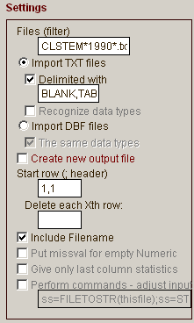

If you need to adjust input TXT files, check the option Run this command upon Input files … and specify a command. You can use these words: filename or DBF() if you want to operate with a file itself – this will overwrite original file, for example:
ss=FILETOSTR(thisfile);ss=STRTRAN(ss,'&','.');STRTOFILE(ss,thisfile)
will replace & with dots in the input file, or use file_string to work with content of a file – original file will stay unchanged, for example:
file_string=STRTRAN(file_string,'&','.')
will do the same but will preserve the original file.
You can also input a script file to process the input TXT files. Use “file_string” variable to manipulate with content of the files

To process the created DBF files (DBF file is created for each imported TXT file, then the DBF files are appended together), you can run a script (using Visual FoxPro commands). Some examples are given in Settings\run*.prg files). For running the scripts, use Run Script upon Output DBF option.

You can also create one data file by appending specified DBF files (check the option Import DBF files).

To import XLS files, use this option (filter can also be specified in edit box – not shown here – like data\*.xls):
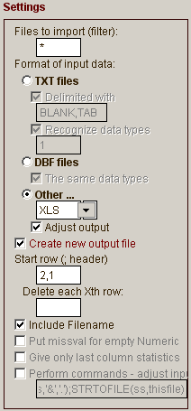Adjust output: makes various adjustments to the imported files, like converting to proper format, trimming, putting away missing columns. In case empty column is found (its name is empty, i.e. a cell in the first row, some value has to appear later otherwise such column is not taken into account at all), the first case is marked as “Column_end” (name of a column), to be suitable then for LoadData (insert functions), since all the columns begind such “Column_end” named column are not taken into database (during Insert, Update commands).

To find files also in subdirectories of a given folder, check Include subdirectories option.

Input files: if you want to select only certain filenames (and in your input directory you have many of them and filter condition is not possible to apply), you can input the list of the filenames in the Files List – add Filter input file. If you want to read columns names of the input files (e.g. you have TXT files without header), you can input the file with such header (TXT file with Header input file).

Item Export to TXT files (2-2). Creates TXT files for stations in Data file. If Stations individually option is checked, each station data are converted into individual TXT file, otherwise one TXT files with all data is created (you can also specify columns according to discriminate results into final file: By groups option, e.g. Remark; Region; id_2). You can delimit data with a given character (or TAB or BLANK) if you check Delimited with option (note: unchecked option results into fixed length of fields). For successive use in AnClim software, check the Suitable for AnClim option.
To put created TXT files into subdirectories (according to groups), check the Into directories option.
To create output TXT files with header (columns names), check the Add header option. If you need to include more sophisticated header (e.g. more lines), specify a TXT file with it in the TXT file with Header input file.

Item Get Differences / put together (2-4). Calculates differences between values of Data_file_1 and Data_file_2 for pairs of stations and periods specified in Diff_info_file (column ID_1 and ID_2). There are calculated either differences between neighbours and base station (if diffs of transf.Vals option is unchecked) or (if diffs of transf.Vals option is checked) differences of transformed values (e.g. logarithms – which means using ratios of values, square root, etc.; form of transformation is set in menu Options – Settings – Values, IDs handling. For using simple ratios, check the diffs of transf.Vals option and then in the Settings set NO transformation). (Transformation is good e.g. for guarantying normality of precipitation series). Check One for 0/0 ratio option to put "1" instead of missing value in case of 0/0 ratios. MissVal for “OR” option: if checked, evaluates missing value if one of the corresponding value is missing (in case of ratios: puts missing value for denomination equal to zero), otherwise evaluates differences (or ratios) regardless meaning of the cells. As Diff_info file you can put e.g. ref_ser_info file which is output of creating reference series files (see later). The settings then would be: 1. ref_ser_info file, 2. data file and 3. refer_series . Note: final (output) IDs are combination of IDs of the two data file; to get IDs of the first file, use this command: replace id with substr(id,1,at(' - ',id)-1) all (or: replace id with substr(id,1,at(' / ',id)-1) all ), or adjust length of the column (using Modify structure command).
Other possibilities of the function are putting data beside each other (i.e. joining) – option Put data aside or one after another (creating a new column distinguishing the source files) – option Put data after.
Note: Diff_info_file need not to be specified. In that case, similar ID from data B file will be searched for (if the same name as in A is not found). E.g. B1BRBY01 - B1BRBY01aa. Or, you can use only one Data_file 1, and specify which stations to combine in the Diff_info_file.

Monthly version only:
Item Get seasonal AVG/SUM/Extermes (2-5). For stations listed in Data_info_file averages (sums, extremes) for winter, spring, summer, autumn and year are calculated. Output in Season_file: n1 (winter, months XII of previous year, I, II), n2 (spring), n3 (summer), n4 (autumn), n5 (year, i.e. I-XII). If one of used months has missing value, seasonal (annual) value is then missing as well (if the Allow missing value option is unchecked). Check Add half year info option to get results for half years (e.g. months 4-9, 10-12+1-3, to be specified in settings\o_halfyear.txt file), results are saved into N8 and N9 columns.

Daily version only:
Option Get Monthly AVG/SUM/Extremes (2-5): gives maxima (or minima, average, sums) from days of each month. Check Give time option to get time of maxima/minima for the first occurrence of a given value. Check Allow missing values option to get AVG/SUM/MAX/MIN even in case of missing data in a given month. Into No_cases column saves number of available values.
Option Get Daily AVG/SUM/Extremes (2-6): gives maxima (or minima, average, sums) from available times of each day. Check Give time option to get time of maxima/minima for the first occurrence of a given value. . Check Allow missing values option to get AVG/SUM/MAX/MIN even in case of missing data in a given day. You can even specify if certain values should be shifted (their date): e.g. in case of precipitation and sum from 07:00 to 07:00 of next day, check “Apply date shift“ option and specify: <='07:00':DATE(-1)
Examples xamples:
SUM date shift condition: TIME<='07:00':DATE(-1)
In this function, you can also create aggregates like 15 minute data etc. (check Irregular and Get subdaily values option and specify number of minutes, it will be taken from the whole hour, values are written to the end of the time interval, e.g. values between 15:01-15:15 will be written to 15:15).
In case of Regular data, you can select maximum allowed gap in the input data.

Item Calculate new values from equation (2-8):. calculats new values from defined columns according to the given equation. You can calculate e.g. AVG from individual hours. Specify column which will be used to select proper rows (e.g. Time) and then the equation (e.g. ($07:00+$14:00+2*$21:00)/4 ). You can even specify if certain values should be shifted (their date): e.g. in case of precipitation and sum from 07:00 to 07:00 of next day, check “Apply date shift“ option and specify: <='07:00':DATE(-1)
Further examples:
Column Time… ($07:00+$14:00+2*$21:00)/4 …
Column Time… INT(($07:00+$14:00+1*$21:00)/3)
Column eg_el_abbr: 1013.25*( (($T+273.16-.0065* 241.00)/($T+273.16))^5.256 ) (calculating air pressure from temperature
Column eg_el_abbr: 1.276*($P/1000)*(1-0.00366*$T)*(1-0.378*$E/$P) (calculating air density from temperature, water vapor pressure and air pressure)

iif($TMI<0 and $TMA>0,$TMA-$TMI,0) ) (conditional calculation)
iif($SRA=-999, iif($T=-999,-999,0), $SRA)

You can use a date of o value by means of this::
(VAL(sys(11, DATE(year,month,day) ))-VAL(sys(11,DATE(year,1,1))))

Further useful functions (for more, refer to Visual FoxPro help)::
sin, cos, asin, acos (arc cosine), tan,
dtor (degrees to radians), rtod (radians to degrees),
pi(),

You can also input TXT file with equation:
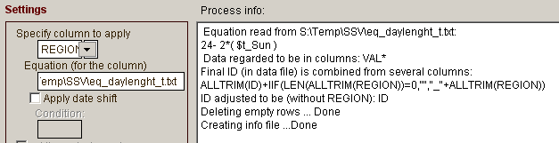

In the equations you can refer to another txt file with equation: ‘filename.txt’
0.4093*SIN(2*PI()*( 'eq_JD.txt' -81)/365)

You can refer to a value in the specified DBF file (to be found according to given station ID): $['filename]column_ID!Column_to_read
tan( dtor( $['S:\Temp\SSV\grids_model_ssv_repl0.dbf']ID!Latitude ) )
Some prepared equations are store in the SETTINGS\Calculate folder, e.g. calculating Extraterrestrial radiation (eq_extrater_rad.txt), time of sunrise (eq_t_sunrise.txt), Koeppen formula (eq_Koeppen.txt), relative humidity, etc.

Item Replace values. There are two modes for replacing values. Either replacement of values for specified times (in ReplVal file), or exchanging specified values (their all occurrences) with another values (ReplVal file has another structure then). The first case (time specification): replaces values in Data_file with values taken from ReplVal_File. You can create such a file e.g. in MS Excel and then to save as DBF IV. Check Prefere non-missing option to preserve original values in case Replacing values are missing values. A structure of the ReplVal_File can be given in two forms: either as a normal Data_file (i.e. ID, year and months n1-n12 in one row), or like this: ID, year, month, value (i.e. each monthly value in one row). This option is suitable e.g. for correcting outliers. You can put missing values in cases that cannot be found in metadata, in the end you can fill missing values (see the end of this document). The second case (exchanging all occurrences): specify a column with values to be found and a column with values to be set (in ReplVal file) and a column to be applied (searched) in input Data file. In ReplVal file you can also specify additional condition (column Add_cond)
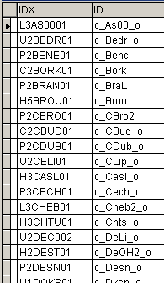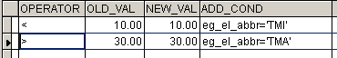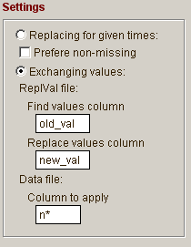
Fig. 3. Examples (Exchanging values) of input file (ReplVal File)

Item Get specified data. Takes information specified in Data_Info_file (ID, begin and end year) from Data_File and saves the output into new Output File. Input can be given into one file (Into one file option), or for separated files – according to individual rows of the Info_file (Into separated files option), or use Just modify the input file option, if you want to perform commands upon the certain files only. The commands can be given straight in the Edit, separated by semicolon, or you can specify .prg file with the commands (see e.g. SETTINGS\run_commands_appends_from_dirs.prg for appending files of the same name from the given subdirectory)

Item Combine Data Files. Copies data from Data_file_A and then adds data from Data_file_B for stations not included in Data_file_A. Check the Sort output option for sorting the output file according to ID and year. Normally, copies data of File A and, from File B, adds data of stations not included in the File A. Check the Include overlap B station option to combine the two files. Example: file_A contains “older” data that you want to prolong to the presence, file_B values to be added - updated. If data in these two files differ (e.g. they are converted to deviations from some period in one of the file), you can set period to calculate adjustments (Adjustment period option, number of years), whether to use differences or ratios of the two files (Differences option) and in case the overlap period is longer than Adjustment period, whether to take the values nearer to presence or to the past (Adjustment from presence option). You can select whether to adjust file A or file B (Adjust file A option). Check the Check consistency option to find values that, even after adjustment, differ (the differences stored into Overlap – diffs file), and also, finds missing values in file A in cases there are non-missing values in file B (new suggested rows are put into Combined file , original rows are marked for deleting). Option Delete "only in B" stations serves for deleting (in the output file) stations coming from file B that are not included in file A; thus you will get only stations coming from file A and update of the stations included in file B.
Note: Diff_info_file need not to be specified. In that case, similar ID from data B file will be searched for (if the same name as in A is not found). E.g. B1BRBY01 - B1BRBY01aa. Or, you can use only one Data_file 1, and specify which stations to combine in the Diff_info_file.

Item Adjust Table Structure: Merges structures of two tables (A+B) and/or adjusts output table structure. Table B need not to be specified at all(only to change structure of the table A). According to Input columns mask option you can rename columns (input either mask like N*, or name of the first column be applied), change data type (e.g. to N (number), C (char) , L (logical), D (date), T (datetime), columns width, number of decimal places. Check Drop_columns option to remove the specified columns. If you want to rename the columns, specify Output column mask (without ‘*’); for filling '0' before numbers – to get the same length of column names - 'put ?'s (e.g. ‘Val?’ for tens or ‘Val??’ for hundreds).

Item Cross Table: Creates individual columns for variants in the Distribute_Column and fills data from the Values_Column. The input is sorted before processing – beware that the order of the columns influence the latter distribution. Note: There are some limitations pertinent to names of columns to be redistributed, e.g. their name cannot begin with number. In such cases names of columns are adjusted so that the operation can be finished (for example in case of redistributing months from one column and the months are given by number, final columns will have “n” before the number of month).

Item One Data Column: Creates one data column from the columns fulfilling a specified condition given in the Column_filter option (you can set mask for columns to be redistributed – when using ‘*’ after the name, or input the begin column). Check Exclude_empty_cols for deleting empty columns. Use option Column-numbers to create a new column where names of redistributed columns are converted into numbers (filter name is excluded and the rest of name is converted). Remark: In the Data file, a column with Year must be included.

Item Join tables: joins two tables. You can specify more columns for the join condition. In case the same ID occurs in File_B (e.g. Geography file), you can specify to take only the last rows (option Only last rows in file_B). Sort according to needed column (e.g. end_date in this case).

Item Set values apart according to Cases (1…): in Transf – Encode values you can create categories, whose time can be used for discriminating another element (e.g. according to three categories of cloudiness you can select appropriate temperatures). …
After some processing (e.g. correction of values), you can put values of individual cases together again running item: Put Cases together (...2) - this function is not finished yet

Transf menu

Transforms data in a specified way.
Item To Anomalies: calculates anomalies (deviations) from a given period (resulting data have zero mean in the given period). The same as in menu Anomalies but not so sophisticated. Input begin and end year of reference period to be used for calculating averages. If zero, whole period of measurement is taken into account.
Item To Average: changes values of each month to have given average over given period (specified in Statistics file).
Item Put average: - replaces all data by an average calculated from a certain period. Again input begin and end year of reference period to be used for calculating averages. If zero, whole period of measurement is taken into account.
Item Standardize Period: standardizes data to have zero mean and standard deviation in a given reference period. Again, if the begin, end are not specified – uses periods specified in Data Info File.
Item Standardize Period: standardizes data to have zero mean and standard deviation within all the months of one year (each row).

Item Modify values: adds or multiplies a value to original data or uses some transformation.
Logarithms: are used when data are very strongly positively skewed, with a small number of values that are much larger than the mean or mode (constant C can be used to avoid zero or negative values). Square root transformation can be used to remove moderate skewness. Logit transformation: log((p+C)/(1-p+C)), where p=(x -min)/(max-min) (i.e. the values are between 0 and 1, constant C is used to avoid zero values for logarithms). Angular transformation: ArcSin( Sqrt(p) ), where p=(x -min)/(max-min) (i.e. the values are between 0 and 1). The aim is to spread the distribution near the ends of the range.
Remark: cases (stations) marked for deleting are not processed.
To “detransform” values, e.g. when you used logarithmus and you need to convert back return periods calculated in 4-6 function, you can use 2-8 function (Tools – Calculate new values from equation), and to input something like: exp($SRA), or 10^($SRA) for decadal logarithm .

Item Encode values, intervals:. Into the first output file encodes values (given in the input Intervals file), into the second output file calculates frequencies given by the intervals. In the input Intervals file you can leave interval_1 or interval_2 empty, it will be supplemented from the previous (next) interval (adding 10e-10 …). To blank the value in the file, right click for popup menu (while Viewing the file) or you can use this command: Blank fields interval_1,interval_2

Fig. 3. Example of input and output files during encoding values (getting frequencies)

Item First Differences: calculates first differenced series. In case you want to use differences, check the Differences/Ratios option, then new_val(i)=val(i)-val(i-1). For using ratios, uncheck the option, then this equation is applied: A1(ip+1)/A1(ip)-1, if A1(ip)=0, then new_val(i)=-1. Check Absolute values option to get absolute values of results, i.e. abs( new_val(i) ).
Item Filter: calculates filtered values (Gauss). Check option to get either low-pass filtered or high-pass filtered values, specify period in years to be taken for calculation. Check Till the ends option for calculating values till the end of series (note that this is not mathematically pure).

Item Create grid points: serves for creating list of grid points – regularly distributed (in space) points. You give some initial coordinates (the option Start long. and lat.) and from these coordinates further points are searched in all directions using Grid step option (in km). It gives you also list of stations given in the input Info_file (in Search distance option). Altitudes for the given grid point are calculated as weighted average (1/d) of surrounding stations.

Item Calculate grids: Calculates series-values of grid points according to previously created Column Data file. Check option weighted average for calculating weighted averages, uncheck for simple averages. As weights- reciprocal values of distances are used. Check the following option squared weights if you want to use squared reciprocal values, uncheck for normal reciprocal value as weights. Search dist;min.Stations option – input circle in km, where to get stations for a calculation, follow semicolon and then required minimal number of stations within this distance.. Start long. lat option - put starting coordinates for the first grid, use semicolon for separating values of longitude and latitude. Grid step;min.Stations option - distance of next grid, semicolon, required minimal number of stations within a grid.
Remarks:
Search diameter (in km) is a length (distance) of the investigated area, so that radius (search distance) from a given grid point is half of this value (to all the directions). Grid step means a distance between two grid points.
search distance should be at least: search_distance=sqrt( sqr (grid_step) + sqr(grid_step) ) = sqrt(2)*grid_step = cca 1,414 * grid_step. It is because there is used circle for searching stations, while value grid step is given for a square (the same values of search distance and a grid step would lead to "blank" spaces – some stations could not be used for calculation).
search distance, minimum number of stations: if this condition is not fulfilled, the grids are not calculated. Then in output Grid_info file – such grids are marked for deleting, and in column (&stan_h1) there is a "x " before the rest of the name of a station.
grid_step, minimum number of stations: the least number of stations that has to be available to calculated grid values. Note: there is searched a distance of the grid step, so that corners of the grids are not covered!!!
Output: first row – 0 distance – a position of a given grid, altitude – averaged altitude for a grid (average from all available stations – listed below).
Power for weights: after semicolon, you can put function, for example ‘1;log(x)‘ will use weights 1/(log(d) …
THIS PART STILL BEING UNDER REVISION, SORRY

Item Calculate Grids II: … see Item used within Neighbours menu – option User defined – Quality control,

Calculate menu

Item Basic Statistics. Calculates all basic statistics for stations specified in Data_info_file. For further processing, it is smart to open output file in MS-Excel (right click upon EditBox), then you can use filters and to get very easily e.g. only averages, STD, etc. Check Sample STD option to calculate standard deviations for a sample. Fill Begin and End Year textboxes to specify a period for which the statistics are calculated, leave it empty for using whole period of measurements. In SubPeriod option you can specify that calculation will be performed only for periods of these lengths. E.g. 10 years would lead to calculating statistics for individual decades, starting from the Begin date (note: only whole periods of stations are performed with regard the to particular subperiod). – You can also input more begin years (if subperiod - timestep - is specified), periods are then adjusted to fit the set of begins (e.g. 1961, 2021, 2071, for 30years periods in CECILIA project). In case you input individual years, finish it with 0 or x not to continue with SubPeriods time step.
Daily version: option “each day individually”: takes a given month and for each day of it calculates, from selected years, statistical characteristics. To put individual months into one column, use menu Tools – One Data Column, with filter “K*”. …
There are a lot of information for all the stations and for their analyzed subperiods. My approach is like this: I open the file in MS Excel (right click upon the EditBox and select "Open in Excel"). Adjust the width of the cells if needed. Then I select some cell of the first row, and click Menu - Data|Filter|Automatic filter. Then, in column "ID_2", I select e.g. RDI, and you see rows with RDI values only. I select the column (e.g. all months) with RDI values, copy and past them to a new location (new sheet e.g.). Then you can plot the values.
If you will process a lot of stations, maybe using Contingency tables and graphs (in menu Data of MS Excel) would be more suitable. Write me if you want a description how to use it.

Item Normal Distribution Test. Calculates D and p-values of the Kolmogorov-Smirnov test, for normal distribution. Again specify a period for calculation (begin and end year), if empty, whole period of measurement of a given station is taken.
Daily version: check Real_Precision_Index to calculate RPI values … . Numbers for individual digits are expressed relatively to number of all values. … The RDI (ReDistribution index) calculation makes sense when you calculated the RPI for parts of a period of measurements for a given station (e.g. annually - set "SubPeriod" option to be 1 year). See menu Calculate – Dynamic RPI to claculated RPI for moving window.

Item Correlations. Calculates correlation coefficients between stations. Check “First Differences” option for calculating correlation coefficients from the first-difference series (good for time series with inhomogeneities). In option “Minimum length” specify minimum length of common period for calculating correlation coefficients. Series with shorter period in common are not accepted for computation. After semicolon you can input minimum number of values for the calculation Check Run K&S test option to add testing of normality (Kolmogorov-Smirnov test, note that normality is one of the basic presumptions when calculating correlations). Z and p-values (of K&S test) of the 2nd series (ID_2) are calculated and then stored in Correlations file (see Remark column for finding given rows). Check Exclude 0-0 cases option to calculate correlations only for cases when there are not zero values in both of the series at the same time (suitable for precipitation, the reason for this option is normality of the series). Specify Filter for ID1 option (mask by means of "*") to calculated correlations only for certain stations. Check Within Region Only option to calculate correlations only between stations of the same region (region is specified in Data_info_file - column Region). Set Limit distance option to calculate correlations only for stations that are within this distance (in km).
Output file: All_months column: correlations for all months together, k13 column: average from monthly correlations, Remark: minimum and maximum number of values used for correlation calculation (without missing values).
In menu Options – Settings you can define minimum length of base station for calculating correlations (shorter series will not be processed) and minimum length of selected neighbours (shorter series will not be accepted). For zero (or empty) values, no such condition is applied.

Item Outliers & Extermes. Finds outliers and extremes in the series according to a given treshhold (option Limit_outliers and Limit_extremes), for stations listed in Data_info_file. The calculation is performed for each month individually. Threshold for outliers/ extremes is given as: q0.25-coef*(q0.75-q0.25), q0.75+coef*(q0.75-q0.25) (where q0.25 and q0.75 are quantiles). Usually, value of coef is set as 1.5 for outliers and 3.0 for extremes. Only values that are outliers are listed in output file. Values that are at the same time extremes have non-empty value in Extremes column. Coef_val column gives appropriate coefficient. Remark: I suggest calculating the outliers from series of differences between candidate and some reference stations, in case of precipitation ratios that are logarithmized (to avoid problems with low values). In such case it is good to add original data to the output. It can be done easily by means of this command (running e.g. when Viewing the output file):
SELECT * FROM outliers a LEFT OUTER JOIN data_file b ON a.id = b.id AND a.year=b.year AND a.month=b.month LEFT OUTER JOIN ref_series c ON a.id = c.id and a.year=c.year AND a.monht=c.month INTO TABLE outliers_data_ref. In this case, both data file and reference series file were added to original outlier file.

Item Normal CDF. Calculates CDF (cumulative distribution function) for normal (Gauss) distribution. Parameters of normal distribution are calculated for a given reference period (options Reference begin and Reference end). If the reference period is not set (options are left empty), reference period is taken as a whole period of measurement. Output file (CDF file): first rows contain information about parameters of used distribution, testing if data suits the distribution (using Kolmogorov Smirnov test), etc. Then continue values. You can blank values that are not interesting for you. In that case set Blank CDF below and/or Blank CDF above options to meet such needs. In the output file you can get various results: CDF values, original values (check Original values option for such case) or return periods (check Return period option). In the end of each station session, numbers of occurrence of minimum extremes and maximum extremes (values below and above given CDF limits) are given. In the very end of file, such numbers of occurrence are given for all stations together with maximum and minimum for each month and year. The other output: Output 12M file: the same as previous output but for case that all the months are regarded (1-12 each year). Beware that such series does not have probably normal distribution (because of annual cycle). Probabilities (both empirical and theoretical) for plotting P-P graph are saved into this file: controls\pomtab_P-P_plot.dbf. Values (both empirical and theoretical) for plotting Q-Q graph are saved into this file: controls\pomtab_Q-Q_plot.dbf. It is easy to export values of these files into TXT files (menu Tools – Export to TXT files, check “Stations individually” option, Uncheck “Suitable for AnClim”, remove columns Year and Month from the file) and plot them in AnClim (menu View – Graph - Scatterplot) to see, whether distribution applied for your data is appropriate.
Item Gamma CDF : the same as above but for gamma distribution.
Item GEV CDF. The same like in case of normal or gamma CDF. Further you can set these options: Minima for dealing with minima values ( 1-F(-x) is used). You can check Gumbel distribution option to work with Gumbel distribution (parameter k=0).
Item GPD CDF. Pareto distribution, but problems with threshold settings (automatization) have to be solved first.
Method of parameters estimation: probability weighted moments

Calculations II menu

Further various calculations:
Item Statistics /all. Calculates basic statistics from whole data set (Data_file), from all values (years) available. Only stations listed in Data_info_file are regarded. In case you want to perform calculation really for a whole dataset (regardless of what is in Data_info_file , check For whole dataset option. Use Get Info - Number of Stations Item to get mean minimum distances and lists of used stations.
Item Put to standardized AVG. Calculates averages for each station given in Data_info_file . Values are then standardized with regard to a given reference period (Reference begin and Reference end options) using reference series (how to find reference series is specified in Ref_info file). This makes sense e.g. if you need to compare averages (e.g. when creating maps), in case of missing data and different lengths of measurements. You can use either differences or ratios for getting correction factors. Equations for calculating standardized values are following: AVG_standardized = AVG_origin+Correction, Correction = AVG_reference_whole – AVG_reference_time_of_AVG_origin (for differences), or: AVG_standardized = AVG_origin*Correction, Correction = AVG_reference_whole / AVG_reference_time_of_AVG_origin (for ratios).

Item Validations, differences (former Correlations 2 item). Calculates correlations between values of Data_file_1 and Data_file_2 for pairs of stations specified in Info_file (column ID_1 and ID_2). As Info_file you can put e.g. Ref_ser_info file which is output of creating reference series files (see later). The settings then would be: 1. ref_ser_info file, 2. data file and 3. refer_series. Check “First Differences” option for calculating correlation coefficients from the first-difference series. Option Add validation characteristics: adds characteristics like RMSE (root mean squared error), bias, MAE (mean absolute error), Standard deviation of differences and from it p-value of t-test for paired values (for values less than 0.05 the differences are statistically significant). Data file 1 should contain base stations (with regard to which you compare e.g. model outputs).
Remark: Ref_info_file need not to be specified, it can be created from Data file 1 and Data file 2. If you want to link stations of the one file with the nearest ones in the second, you can create appropriate Ref_info_file using menu Get Info – Distances.
Output (file Characteristics): K13 column – average of K1 to K12, All_months column – all months together, column Distance: number of significant months (p-value<0.5).

Item Model correction (q-q): …
Remark: As input, you can indicate Data file and Data file 2 Ref (in case IDs are identical, no Ref Info file is needed), or, both candidate and reference data can be in one file (Data file, in Ref Info file you specify which ID – candidate correspond to which ID – reference, then no Data file 2 Ref is needed). Values are selected from candidate and reference series in the way, that in both of the cases (for a given time) both values has to be present (i.e. if either candidate or reference value is missing, that time is not used).

Monthly version only:
Item SPI. Standardized precipitation index calculation. Outputs: SPI file – a file with SPI values, calculated for each month. OutputSPI_move : values of SPI but for moving window. In this cases all months are taken together (1-12 of each year) and given all months moving average (1, 3, 6, 9, 12, 18, 24 months) is applied. Output SPI_12 – a file with SPI values for all months together (the same as moving average for length of 1). There are some other outputs in this case. Probabilities (both empirical and theoretical) for plotting P-P graph are saved into this file: controls\pomtab_P-P_plot.dbf. You can export it into TXT files and see plots in AnClim.

Daily version only:
Item RPI Dynamic Calculates Real_Precision_Index (RPI) and RDI (ReDistribution Index, which peaks in time series indicate break points) for a moving window, according to Predrag Petrovic. The moving window has a length specified in the option Moving Window. Specify Calculation step for a length between beginnings of successive moving windows. Numbers for individual digits are expressed relatively to number of all values. See menu Calculate – Normal Distribution Test for calculating RPI index (for a series as a whole).

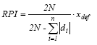
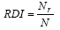
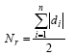
where N is total number of processed cases, di is difference of i-th count from the expected number of cases, n is the number of specific read-out value categories (i.e. 10 for decimal values) and xdef is the pre-defined measurement precision (usually 0.1 for measurement precision of one decimal value)

Relation between the number of redistributed cases (Nr) and the total number of cases (N) is the ReDistribution Index (RDI). The "ideal best case" with the unchanged distribution returns the zero value of RDI, since there are no redistributed cases (0=rN). On the other hand, if all cases are redistributed (), the returned value of RDI is 1.

Peaks of the RDI values indicate possible break points in measurement precision. Higher peaks (over 0.250) indicate drastic changes in precision, while lower peaks (between 0.130 and 0.250) cannot always certainly indicate a break point. RPI values are used for detecting data quality between the break points. For closer looks at the precision problems, a Real Precision Scale or any convenient graphic presentation of distribution of observed specific read-out values is welcome (Petrovic, P. ():DETECTING OF INHOMOGENEITIES IN TIME SERIES USING REAL PRECISION METHOD, WMO … page 81,).

Item Regression Altitude: calculates regression between averages (set reference period) and altitudes. Set Standardize AVG to mean alt option to transform (standardize) averages with regard to mean altitude. Equation used: AVG_standardized=AVG – b1*(Altitude – Mean_Altitude), where b1 is b1 coefficient of regression between all averages and altitudes. See menu Neighbors for regional regressions between averages and altitudes.

Item Frequency distribution: gets frequencies for each month. You can select different rules for defining bins number, width, start … …

Number of days (daily version only)

Item Number of days (6-1): Number of days per each month: done for periods given in Info_file (column begin and end). On the output, you can get Count of the values per each month, percentage of occurrence from available days (without missing values) or effective sum (sum of value-limit if condition contains “more than value”, limit- value otherwise). You can specify allowed maximum number of missing values to get the result (Allow missing values option). Check Individual limit values option for limit values taken individually for each station, limit values to be specified in Anom column of Info_file. Check Add first and last occurrence option to get the first and the last day of occurrence of a given value in the output. Input Begin day (date) with regard to which you want to estimate first and last occurrence; default value is 1 (1st January), for half a year input 183 – suitable for winter characteristics; after semicolon you can define "half year": the day before which you want to find the first occurrence and at the same time the day to start finding the last occurrence (for example 1;152 would start searching the last occurrence after 1st June). Individual begin dates option: each station has its defined begin date with regard to which the first and last occurrence is estimated (specified in Anom_beg column of Info_file). Input the value in a form of order of the day from the 1st January. To record the first and the last occurence according to the given condition with minimum number of consecutive days, set the option Minimum number of days (input negative value for cases you want to record the date of the last date as the first occurance after half year - with opposite condition- occurence, e.g. first span of at least 6 days with daily mean temperature Tmean>5C and first span after July 1st of 6 days with Tmean<5C).
Item Number of days from quantiles: the same as above but the limit values are calculated from the empirical or normal distribution (check the proper option) of the particular month (check the option Months individually) or from all values of the station (unchecked).
Item Number of days – specified daily limits: Limit values for comparison are taken from the input file Statistics (you can create such file in the menu Calculate-Basic Statistics: check the option Each day individually … ). In the settings, option Col. and value for selecting rows specify the name of column (e.g. ID_2) and value by means of which you will select certain rows (e.g. Average, 10th Percentile, …). You can add additional value (option Additional condition) to the daily limit. Option Min. no of consecutive days serves for selecting only such values that fulfill the given condition and are in sequence of the given number of days. Remark: you can further use the Output_days_diffs file as input file in the menu: No_days – Day Periods Statistics.
Examples: 1). in Menu Calculate-Basic Statistics: check the option Each day individually and Moving window, set 2 days (to each side);Calculate – only AVG, STD 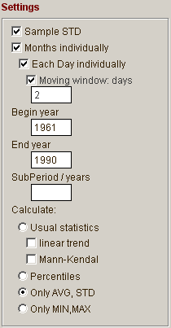
2) Use menu No_days – Number of days- specified daily limits: (Statistics input file is the same as output file from menu Calculate – basic statistics ), set options like in the picture (the limit values are stored in Statistics files column ID_2 – rows with values Average): 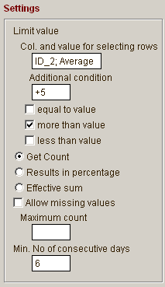
Input file with daily limits (obtained in menu Calculate-Basic Statistics):
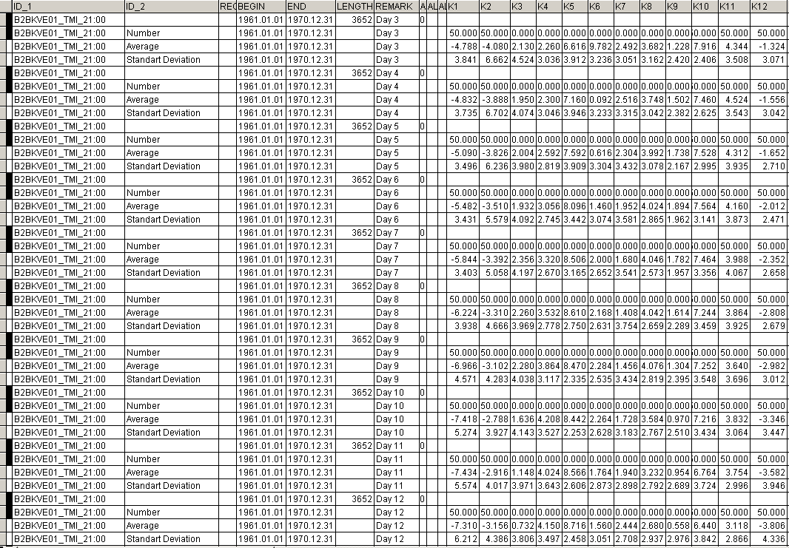

Item Periods (from days, minutes) (6-5): For a given limit value gives a list of days fulfilling the condition (Limit value, <,=,>): date of a beginning and number of successive days and calculates an average, sum and sum of effective values (i.e. values – the limit value) for the successive days. Limit value for ending period can differ from that of begin: after semicolon you can input a Limit value to terminate period together with predicate if needed (e.g. 5; <0). Note: minimum number of consecutive days is not applied for terminating the period with different limit value. Check Individual limit values option for limit values taken individually for each station, limit values to be specified in Anom column of Info_file. If you will specify input file Limits – sums, limit values and sums to be reached are taken from this file and not from the options settings on the form. Check Specified time intervals option for processing only within a given time interval (given in Data_info file, columns begin and end); further, in Remark (or ID_orig) column of Info_file, you can input Julian day (order from 1st January): begin; end or begin;end; step (step - for variations of periods within Begin and End); e.g. 40;90 will create for each year 40th day as begin and 90th day of a year as end limit for calculation. If you want to change limits during the calculation (for all the stations involved), specify them in Input file Limits – sums; column Limit_val in this file should contain limit value, Limit_sum column sum of active temperatures to be reached (or use Lim_sum_ef column to apply effective temperatures – i.e. summing differences from the limit value) (the sums are applied for the period specified in the Info_file, if you want to calculate it each year, you have to create the info_file e.g. in 6-1 function). To get day-weighted output (i.e. replace values with period length) specify Day-weighted output output file (good for later statistics – e.g. average period length to by calculated in Calcualte – Basic statistics menu). If you want to calculate first and last occurrence in each year, specify the output file First&Last occur.. In this case (compared to 6-1 function) it is taken into account heat and cold waves after the first or before the last occurrence so that begin can be shifter forward and end backwards depending upon characters of the waves (“half” year is taken as the half of the longest wave). In Periods – Day output file, in Remark column, information about cold waves is given (number of days, actual and “effective” sum – using also negative values). Only waves fulfilling Min. number of cons. days option are considered.
Remarks: Can be applied either upon daily values or minute data (specified in Time column, e.g. 10:01).
Some tricks: to get summary over found periods (their numbers, count of days etc.), check Specified year time limits option. To get information for days between two periods, put output file for First and last occur. editbox.

Item Day frequencies: Gives frequencies (averages, sums) for day periods (1, 2, …) for individual years and stations. Beware: in case of period lasting to the next year, counting is processed for the year of the begin date!

Output files:…

Item Analyse periods:: evaluates precipitation intensities with regard to Wussv classification.
Output files:the first one (Output_Wussov) gives material used for finding maximum intensitites (maximum sum for each length of duration), the second one gives the maxima for given length, limits (equation: (1+0.5*(m.ii-1))*SQRT(5*D_len), where D_len is length in minutek, ii is 1 for lijavec, 2 for silný lijavec and 3 for katastroficky lijavec – sorry for the Czech) and deviations from those limits.
You can plot a graph using R\Read_DBF\Templates\OPTIONS_R_intensities_WUSSOV.TXT template.

Neighbours menu

Item Compare - use Correlations or Use Distances: Purpose of this function is to give measurements of a base station and neighbours into one line (row) and to perform data quality control. Neighbours can be selected either by means of correlations or by means of distances. Given number of neighbours (option Number of stations) is selected using given limit conditions – e.g. limit distance or limit correlations (you can also input minimum number of station and after semicolon maximum number, in this case, minimum number of stations overrides condition for limit distance or correlation). You can input a limit for correlation coefficients (“Limit - correlation”), the stations with lower correlations won’t be selected. If you want to include condition based on distances at the same time, first put value of limit correlations, then semicolon, after it limit distance in km. Negative distance will mean that only stations above (equal or higher) the given limit will be selected. Maximum Altitude difference: Selects neigbours under given limit of altitude difference. Zero - all neighbors are accepted. Negative - selects stations above the limit (equal or higher). Note that only such neighbours are selected that have some period of common measurements with base stations (so stations measuring in different period are not regarded at all, this make sense only when using distance criterion). If you require that neighbours measure within whole period of measurements of base station, check the Common period option (Selection of the series – if option Common period is not checked, selected stations does need to extend length of the base stations (they can be shorter). But stations measuring outside period of base stations are not selected in any case. If the Common period option is checked, only stations measuring at least the same period as base station are selected). Beware that neighbours are selected only within the same region (defined in column Region in Data_Info_file). Note: If the column Region is empty, it has no effect. But you can define e.g. geographical region, or to put e.g. observation hours or elements (if processing more information at the same time). In this case, if you will not to want to include other elements or observation hours of the same stations (and column Region is empty), just put limit distance - 0.1 (negative), it will take information only from other stations. To process daily data with Time (if you want to process each time individually), you should include Time in the name of ID (Settings – Compose ID from several columns) and to use Region column in Info_file with values of Time (for example if ID=Station_Elem_Time, apply command replace region with strextract(id,'_','',2) all).
"Clever ngb. selection" option: selects neighbours in the way that first 75 percentage of data is taken as it is, but then the software compares base station altitude with the neibhours ones and if coefficient of interquartile range is above 1.5, it searches for another neighbour (just to ensure no problem during 7-3 calcualtion – Standardization to altitude).

After neighbours are selected and put into one row, data quality control is performed. There are calculated either differences between neighbours and base station (if Diffs of transf.Vals option is unchecked) or (if Diffs of transf.Vals option is checked) differences of transformed values (e.g. logarithms – which means using ratios of values, square root, etc.; form of transformation is set in menu Options – Settings – Values, IDs handling, "NO transformation” means 2nd/1st or -1st/2nd series value, the greater value, negative for 2nd/1st, original one (1st or -2nd) if the other is zero, negative values are used to preserve normal distribution for further standardization). These differences are then standardized by difference average and difference standard deviation (parameters are calculated using reference period: options Reference begin and Reference end, for each month).
If reference period is not set, whole period of measurement is used for calculation of AVG and STD. In case of long series (to avoid problems of finding neighbours measuring the same length as candidate series), you can define here (Years per part and Overlap – years options) number of years per one part and overlap period, the candidate series will be divided into several parts then; in this case you can set after semicolon (Refer begin/years per one part option) minimum length of the part to be created: default value is that the minimum length is the same as the given length of period – i.e. for the last part the begin date is moved forward and thus an overlap with previous period happens, in case of individual regression it is better to set it like 20;0 zero e.g. so that no overlap occurs.
After standardization, number of cases exceeding a given confidence limit (Confidence limit option) are calculated and saved into Exc_count column of Output-neighbours file, Exc_perc column contains the same information but in form of percentage of all available neighours (without missing values). CDF_Max_d column in the same file contains the highest value of CDF from all neighbours-base differences, CDF_Med_d contains CDF value (probability, normal distribution) of median of all neighbours – base differences. CDF_b_oMed – difference of Base station value and median calculated from original values of neighbours / STD base station (expressed as probability – normal distribution).
Note: all of these is done for each month individually. Records (base stations) marked for deleting (in Data_info_file) are not processed, but still such stations can appear as neighbours of some (undeleted) base stations (in other words: if you want to process only certain stations, mark (in Info_file) the rest for deleting; in the output Neighbours_info file you will get results only for undeleted stations, but using (as neighbours) all stations listed in Info_file (even if marked for deletion).).
Output file: neighbours.dbf: rows are marked for deleting unless at least one of neigbours-base diffrences exceeds given confidence limit.
Check “Create info File only” option for saving only list of stations used (into Neighbor_Info_file) without neighbours-base differences calculation (much more quicker). Then you can edit the list, adjust it according to your needs and rerun the computation with this adjusted list of stations using Item User defined …. For decision making, a lot information will help you (in Neighbor_info_file) such as correlations, distances, altitudes of selected stations, their difference with tested series, etc.
In menu Options – Settings you can define minimum length of base station for comparing with neighbours (shorter series will not be processed) and minimum length of selected neighbours (shorter series will not be accepted). For zero (or empty) values, no such condition is applied. You can define here also form of transformation (if applied e.g. on precipitation data).

Item User defined – Quality control: the same as above but you can use your pre-defined Neighbour_info file with list of neighbours that are to be used for comparing values. Again, there are calculated differences between neighbours and base station (or, if Diffs of transf.Vals option is checked, differences of transformed values, e.g. logarithms (which lead to using ratios), square root, etc., suitable for precipitations, "NO transformation” means 2nd/1st or -1st/2nd series value, the greater value, negative for 2nd/1st, original one (1st or -2nd) if the other is zero, negative values are used to preserve normal distribution for further standardization). Settings of transformation is made in menu Options - Settings. Then you set confidence limit (probability) for finding significant cases (using normal distribution). By means of Standardize differences option you can either standardize the differences ( (diff-diff_AVG)/diff_STD ) or to leave original differences. For better decision making, you can add columns with neighbours values standardized (option Add standardized values columns): either with respect to
- base station average (AVG) and standard deviation (STD) ( ((neighbour_val - neighbour_avg)/ neighbour _std) * base_std ) + base_avg ) for standardization without STD (i.e. AVG only): neighbour _std=1, base_std=1; STD standardization only: instead of base_avg uses neighbour_avg in the end, (remark: calculation of AVG and STD is done only for non-missing data both in test and reference station, i.e. the test series can have different AVG and STD for individual reference series in case of missing data in them).
or with respect to
- base station altitude (using monthly averages for a whole period and linear regression, see the regression parameters in the output Neighbours_Info_file or in Neighbours file) (neighbour_val - b1*(alt_neighbour – alt_base), or if using STD for standardization as well (not applicable here, but can be run from menu Transf – Calculate grids II): ( (((neighbour_val - neighbour_avg)/ neighbour_std) * stand_STD_altitude ) + stand_AVG_altitude ), where stand_AVG_altitude =( neighbour_AVG - b1*(alt_neighbour – alt_base) ) and stand_STD_altitude =( neighbour_std - b1_STD*(alt_neighbour – alt_base) ) ); Correction coefficient for linear regression (dependance on altitude) can be applied: input (into Regression correction option) 0 for no correction, i.e. the regression is applied regardless strength of relationship between two variables, to 1 for weighting with determ. coeff. between new (from regression) and original value: ( ( ((determination_coeff)^correction)*(new_value) ) + ( ( 1- ((determination_coeff)^correction) )*(original_value) ) ). If the value is more than 0 and determination coefficient (regr_deter column) is less than 0.09, original values are taken into account (no standardization).
check option Transformation of vals to transform values of added columns with values to be standardized (e.g. in case of precipitation, to be set in Settings – tab Values & IDs handling), note: if checked, neighbours with original values equal to zero are not standardized. Check option Stats without suspicious to calculate AVG and STD of base stations and used neighbours without cases found previously as suspicious values (rows unmarked for deleting, both base station and neighbours value NOT used for the calculation). Regression of values and altitudes can be calculated either for monthly averages (Regr. for indiv. cases option is unchecked) or for each row (if checked) individually (for this case and using Stats without suspicious, only suspicious value of Base station is not used) – check option “1 station - apply monhly AVG(+STD)” to get expected value even in case when the only station (neighbour) is available (thus regression cannot be calculated), the value of the neighbour will be standardized with monthly AVG (and possibly STD); Standardized neighbours values can be checked (comparing with original values of all neighbours) if they are not outliers (input the CDF values – option Outliers check), if CDF of (diff. of standardized and original neighbour values / STD orig. values), of a particular neighbours exceeds the limit (is outlier), it is replaced with original – i.e. non standardized value (and Flag_regr column is ‘O’). If the value of Regression coefficient is more than 0 and determination coefficient (regr_deter column) for the individual row is less than 0.09, original values are taken into account (no standardization is carried out), Flag_regr column is ‘o’. If Expected values were calculated from non-standardized values, program checks percentage of such cases. If it exceeds given limit (specified in Settings, tab Params), it erases all the calculated values (otherwise, e.g. if candidate has quite different altitude than ngb. stations, you would get biased value for the altitude).
By means of these standardized values, you can get coefficient (multiply) of interquartile range (q75-q25) above q75 (or below q25), calculated from the standardized values of neighbours, and applied for a value of candidate station (option Add IQR coef. value). Note: the more values of neighbours are similar, the higher is the value of the coefficient. Values below 1.0 (i.e. a value of base station is between q25 and q75) are not given into the output (columns L_q25, L_q75 contain information about lower and upper quartile (from standardized neighbours values), Coef_IQR – coefficient (multiple) of distance of the base station value above (below) q75 (q25) quartile ( (value- q75)/(q075-q025) for valus above media, or (q25-value)/(q075-q025) for values below media, negative values means values between median and a quartile), CDF_b_sMed – difference of Base station and median calculated from standardized neighbours values, expressed as probability: CDF of ( (base station – median_from_standardized_neighbors_values)/STD_base_station ), Check Add expected value option to calculate new (theoretical) value for the candidate station (column Expect_val, column Expect_trf contains detransformed values if any transformation has been applied), from the standardized values of the neighbours, using weighted average of 1/distance weights (or using correlations if available, distances less then 1 are ser to be 1 km to diminish very high weights in the former case, to change this limit, refer to Settings – tab Params, option Minimum distance for weights,), distance with specified power (option Power for weights); after semicolon, you can put function, for example ‘1;log(x)‘ will use weights 1/(log(Distance^{power}) for distances (or log(Correlation^{power}) for correlations) (note that ‘1;sqr(x)t’ is the same as using 0.5). Trimmed mean: you can exclude high/low values from calculation of Expected value (from standardized neighbours values). Check the option if needed and then input lower and upper quantil outside which the values will be replaced with missing values and thus excluded from reference series calculation (0.2; 0.8 will for example exclude the top and bottom 20% of data, i.e. in case of 5 neighbours select only the three central values). CDF_e_oMed – difference of Expected value and median calculated from original values of neighbours / STD base station (expressed as probability – normal distribution) – the value should stay low otherwise it indicates that Expected value calculation could be wrong.
All values are inspected also from time point of view. IQR_time column contains coefficient of IQR – St_base value compared to original neighbours values (calculated from series of the first differences to capture change between individual days; in case of daily values, the higher a value is, the more suspicious value in St_base we have). Software also checks standardized neighbours values (comparing original and standardized value - calculating probability – CDF of normal distribution; to run this, check Outliers check option and as a threshold the specified value is used, if at least in one case it is exceeded, all standardized values are replaced with original ones, Flag_regr column then contains ‘t’ value). IQR_time_E column contains again coeff. of IQR, but for expected values, in this case it indicates a problem in the calculation (if the IQR value is too high, but it should not happen because problems with regression are controlled in comparison of standardized values with its original ones – flag ‘t’).
Check the Only for missing values option, to calculate the quartiles and expected values only for missing values of the base station (saves the time for calculation and can be used for filling missing values). Check the Blank missing values option to blank all the cells (base station, neighbours, differences, etc.) with missing values in the output files. If you check Transformation of vals option, columns are transformed according to selected transformation (menu Options - Settings) before standardization to base station AVG and STD (and interquartile range evaluation and expected value calculation).
Recommended settings (for daily data): temperature (left) and precipitation (right)
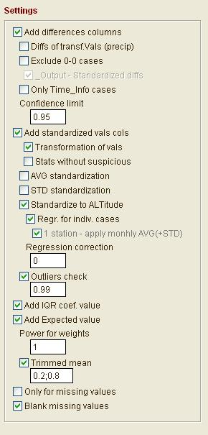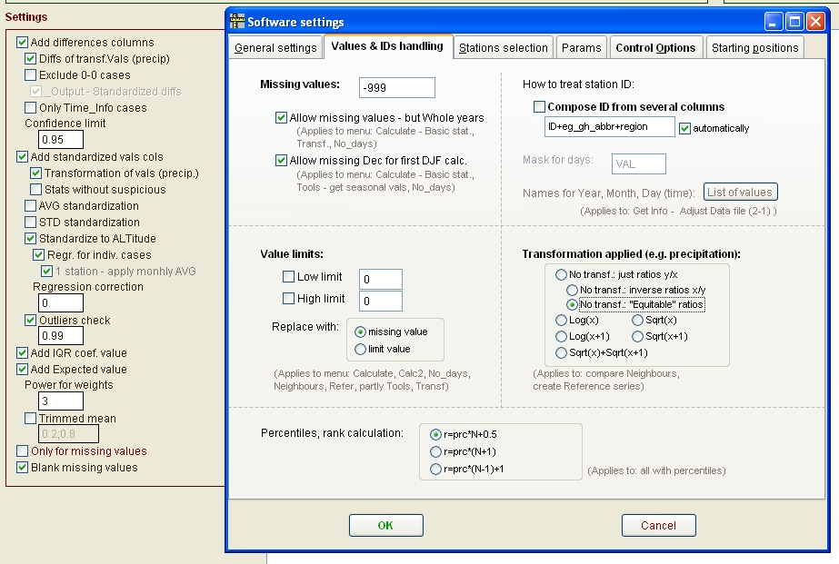

Description of output files: Output-neighbours file contains: columns with values of base and its neighbouring stations (St_X columns), differences of neighbours – base station (DifX_stnd columns). Cases when no neighbour is significantly different from base station are marked for deletion. Number of cases when difference between neighbour and base station exceeds given confidence limit are count into Exc_count column (this counts in percentage - with regard to missing data - are put into Exc_perct column). In case that base station has zero value, Exc_count column contains number of non-zero neighbours, Exc_perct contains percentage with regard to missing data. CDF_Max_d column contains the highest value of CDF from all neighbours-base differences, CDF_Med_d contains CDF value of median of all neighbours-base differences. Missing column contains number of missing neighbours values. Diffs_cnt column contains difference between number of positive values of DifX_stnd and negative ones. Note: In case differences do not have normal distribution (e.g. daily precipitation), the statistics mentioned above are erased in the output file (not to disturb selection of suspicious values in the end).
In case of standardization to altitude, information about the regression is put into these columns: regr_b1 (slope), regr_brs (MSE - mean square error), regr_deter – determination coefficient (of dependence of measured values on altitude) Beginning of every station section contains: in the 1st row – altitudes, follows list of neighbours with distances from a base station. In the end of each station session, p-values of Kolmogorov-Smirnov test (applied on standardized differences) and averages and coefficients of variance (for original values of base and each candidate station) are given Neighbour info output file contains also list of used neighbours together with values used for standardization (differences averages and standard deviations) and number of values used for these calculations. To get easily to suspicious values, you can automatically run the script Settings\run_neighbours_QC_batch.prg – just check the option in Settings – tab Params: Neighbours – QC, here you can also change the limits for selection. “Normal” values are marked for deletion, suspicious are left in the output. Remark: You can easily combine information from neighbours file with e.g. daily version of neighbours file or with outliers detection (by means of Select SQL command using JOIN condition). See Calculate | Outliers & Extremes for more details. Flags: column Flag 'S' stands for using value of the only neighbour station (regression to Altitude could not be calculated), standardized to mean AVG (STD); Flag 'O' stands for using original value of the neighbour station if the standarized value was regarded to be outlier (column CDF_outmax contains maximum - from all neighbours - value of CDF - normal distribution of (neighb_standardized – neighb_original)/STD_month ); Flag 'n' is used if regression to altitude cannot be calculated (e.g. the same alt. values) - NO STANDARDIZATION is performed in such case

Neighbor_Info_file: contains information about neighboring stations. In case you check “Create info File only” option, only information about correlations, altitude, azimuth etc. are stored in the file. In case the option is not checked, this information is rewritten with AVG etc. for individual months. Average, standard deviation and count of used values of differences (of transformed series if applied) are given for each month. Correlation coefficients are calculated for original values of base and neighbor stations, Stand.Vals. Correlation coefficient for standardized values of base and neighbor stations. Distance and azimuth for base station (id_1) mean vector sum of all neighbour positions. K1 column contains- altitude difference, K2 column - sign of the altitude difference, K3 – for base station – gives coefficient of IQR of base station altitude with regard to neithbours altitudes, K4 column - loxodroma/km (note that in column Distance you get ortodroma), K5 column - azimuth, K7 - absolute value of altitude difference, K8 - coeff. of IQR from altitudes, K9 column - length of common period, K11 column - ngb. Order, K12 column - Neighbour Order (selected ngb.)
In the end: Bias (or mean – algebraic – error measure of overall reliability) = forecast - observed; RMSE (Root mean squared error, measure overall accuracy) is a quadratic scoring rule which measures the average magnitude of the error. Since the errors are squared before they are averaged, the RMSE gives a relatively high weight to large errors. This means the RMSE is most useful when large errors are particularly undesirable. The MAE (Mean absolute error) and the RMSE can be used together to diagnose the variation in the errors in a set of forecasts. The RMSE will always be larger or equal to the MAE; the greater difference between them, the greater the variance in the individual errors in the sample. If the RMSE=MAE, then all the errors are of the same magnitude Both the MAE and RMSE can range from 0 to ∞. They are negatively-oriented scores: Lower values are better.

Item User defined – Find problems: aimed to find problems in data, namely cases when neighbour series has the same values as base station series. You can input minimum number of the same values in a line to be recorded (option Minimum number), Tolerance (difference of the neighbour and base station value that is admitted to be regarded as the same value), whether counting of the same values can be interrupted by missing data (check the option Interruption with missvals). Check the Blank missing values option to blank all the cells (base station, neighbours, differences, etc.) with missing values in the output files.

Reconstructing (combining) the series of near stations
Item Get nearest stations: In this first step, neighbours are found and combining stations (reconstruction) is proposed. In Rec.stations file you input stations for which you want to find possible reconstruction. This can be the same file as Data_info file (even the same name). In this case, suggestions for combining near measurement will be done for all stations in the Data_info file, but you will be informed about cases that are more suitable. Limit – Distance option: limit distance to find neighbours for reconstruction. You can input several preferred distances separated with semicolon: the neighbours are then searched for within circles starting from the least distance and ending with the limit distance. This means that neighbours are searched according to: preferred distance, then according to starting or ending points of neighbours, then according to neighbours length and in the end, if still needed, according to distance (within interval of preferred distances). Recon. Min. length option: minimum length for reconstructed series – if this length is shorter, such stations is marked for deleting and not used during reconstruction. Prefer reconstructed option: if not checked, prefers original series even if they are shorter than reconstructed series (but they have to be longer than set minimum length to be used further). If checked, prepares the reconstr_info file in that way that suggests reconstruction of near stations (if possible) even if base station is long enough (length about given limit). Anyway, if you will prefer original series, just blank ID_2 value (name of reconstructed series) – on the first row, then during creating series only original series will be put into output file. Max. gap option – allowed maximum number of years missing between two stations to be combined, otherwise the station is marked for deleting; after semicolon, you can put min. length of a neighbour station, if the threshold is not reached, the name of neighbour is put into parenthesis. Require overlay periods option: if not checked, it can suggests to combine measurements of stations in cases like when one stations ends in one year and the other begin in the next year. If checked, and stations are available, uses fragments of more stations to avoid cases that there will be some missing values when combining stations with begin in following year than end of a station (this option makes difference only in cases there are more neighbours and some have an overlay, the other end one year before the beginning of the station in a question). Merge the same ID option is intended for cases when there are given in Info file several parts of the same station and the parts are adjacent – i.e. no gap occurs between the parts. Check the Prefer the same name option to prefer the same name for reconstructing (in case there are several parts of the same station – name).
Output: In Reconstr_info file you are informed about following (see Ramark column): Suggested name of reconstructed series (with suffix _r in Id_2 column), the name is estimated according to the longest series in the list of used stations, it is not set according to the latest station. List of neighbours> all the neighbouring stations, Correl. of Overlap> correlations in an overlap period, Reconstruction> proposed list of stations to be used for reconstruction, Better to reconstr.> if some of neighbours has longer measurement, it is listed here, then all info for a base station is marked for deleting. Exist before&after> stations that started measurement before and ended after measurement of the base station. Note: if a neighbour has the same maximum length of measurements as a base station, the same list can occur twice (later on during reconstruction for a neighbour as a base station, with the base station as an neighbour).
Remark: you can get different results according to selected distance. The longer the distance is, the more probably a station with long enough measurements will be found (such a neighbour is then preferred for reconstruction) so you get usually less stations for reconstruction in the end. Moreover correlations with more distant stations can be problematic. On the other hand, the shorter the distance is, the less number of neighbours is found. So you have to found a proper distance to balance between these two points.
Possible problem: if length of measurements of two neighbours is the same, you can get suggestion for reconstruction for both of them (otherwise, longer measurement is preferred, the shorter one is marked for deleting and you are informed about “better for reconstruction” ).
Item Reconstruct: In this second step, stations are combined according to given list for reconstruction. Only cases that are not marked for deleting, will be processed. Fill gaps with missvals option: in cases there are no values between two combined series during reconstruction, fills such years with missing data. Add long original series option: beside reconstructed series puts into output also original series (not combined) listed in a Reconstr_info file (cases that are not marked for deleting). Delete overlay periods: If unchecked, leaves an overlay of one year (marked for deleting) in case when combining some months from the first station and the rest from the second station. Then you can verify and follow the process. Later you can delete these cases manually while Viewing a file.

Item Regional regression : evaluates regression for regions using limit distance. Averages that input into calculation are calculated from a given reference period. In case of smaller number of neighbours than a given limit (Min. number of station option), whole output for a given base station is marked for deleting.
In the end, put testing – comparing of averages (by means of t-test) between base stations and its neighbours. One version of t-test for equal variances and the other for different variances (t2). On the output window (Process info) information about statistically significant months is displayed. Set Standardize AVG for t-test option to transform (standardize) averages of neighbours with regard to base station altitude. Equation used: AVG_neighbour_standardized=AVG_neighbour – b1*(Altitude_neighbour – Altitude_Base_station), where b1 is b1 coefficient of regression between averages and altitudes. Remark: see menu Stat2 for regression between averages and altitudes from a whole dataset.
Information in output Reg_info file: All_months column – number of significantly different months (t-test), the last two rows – sums; alt_1 – number of all neighbours, alt_2 – number of significant neighbours (with at least 1 month, t-test). Length – number of all neighbours months.
Item Regional regression – AVG (2): the same as above but averages are taken from a Statistics_AVG file – the first row of a given station. To evaluate t-test, standard deviation value has to present in the Statistics_AVG input file (in column Remark put ‘STD’) as well. Use option Get standardized AVG in Calc2 menu to calculate standardized averages (averages that are comparable with regard to missing data, different length of measurements etc.).
Remark: These Items (regional regressions) serve for assessing methods used for creating maps by means of regional regression between values to be shown and altitudes.

Anomalies menu (monthly version only)

This function serves for creating anomalies (each month individually) by converting data to deviations from average of reference period (e.g. 1961-1990).
In the first step (Item “1961-1990”) the series that measured within the given period (set Reference begin and Reference end options) are converted into series with zero mean in this period (for each month).
In the second step (Item “Outside 1961-1990”) the software takes series with the ends of measurement from present further and further into the past and converts the series into anomalies by means of series already converted into anomalies. There is calculated an average both for the station in question and for all its reference stations together. These two averages are then compared using either Differences or Ratios (for differences check the Differences(Ratios) option) and an adjustment factor is estimated for the series to be converted. The reference series is calculated from a given number of stations (“Number of stations” option). These stations are selected according to the highest correlation coefficients (stored in Correlations file). You can input a limit for correlation coefficients (“Limit - correlation” option), the stations with lower correlation coefficients won’t be selected. The averages are calculated for the period ending with the last year of measurement of the station in question and with begin year according to a length indicated in a “Length of period” option.
Remarks:
Converting to anomalies is carried out for stations given in Data_Info_file, source data are in Data_file. Suitable for temperatures, in case of precipitation this is not the best function.
Correlations file: there is taken one value for all the months or seasons – in column K13 (it as an average of monthly correlations).
Description of a output Info_file: columns Begin,End –the series are converted with regard to this period. PBegin, PEnd columns – whole period of measurement of a given station. Correl – correlation coefficient between the two stations (for creating anomalies outside 1961-1990 only), Remark column: value avg : an average for a station being converted (Id_1), avg_ref : an average for a reference station (Id_2), diffs : differences (ratios) for 1 and 2 (1-2, 1/2 resp.)), No_miss : number of missing values (for Id_2). ADJ= : adjustment for converting to anomalies; for series outside 1961-1990 it is an average of all differences/ratios between candidate and reference series (an average of rows with Distance=3). In the end there are listed stations that could not be converted into anomalies (Remark=nil).
Into Data_info_file, there are saved information about converting as well. For series converted into anomalies 1961-1990: value for column Anom=1, for other series (outside 1961-1990): Anom>1. Stations with short period of measurement (not converted into anomalies): Anom=-1. Anom_beg, Anom_end – period used for converting, Anom_cnt – number of stations used for averaging (reference stations).

Fig. 1. Converting series to anomalies for the period 1961-1990 and outside 1961-1990.

Reference menu

Creates reference series. There are three possibilities how to do it.
The first Item – Simple average. Takes all available series included in Data_info_file for a given year and computes average values. The data should be converted into anomalies (in Data_info_file column Anom is greater or equal to 1, see above), otherwise you can get problematic results (values are not comparable). To calculated regional averages, check Within region only option. Regions are given in Data_info_file . You can specify minimum length of series to be accepted for average calculation in Min. series length option.
The second Item – From Correlations. The resulting reference series is created from a given number of stations (“Number of stations” option, you can also input minimum number of station and after semicolon maximum number, in this case, minimum number of stations overrides condition for limit distance or correlation) according to correlation coefficients between a station in question and a reference station (stations with the highest correlation coefficients are selected). You can input a limit for correlation coefficients (“Limit - correlation”), the stations with lower correlations won’t be selected. If you want to include condition based on distances at the same time, first put value of limit correlations, then semicolon, after it limit distance in km. Negative distance will mean that only stations above (equal or higher) the given limit will be selected. Maximum Altitude difference: Selects neigbours under given limit of altitude difference. Zero - all neighbors are accepted. Negative - selects stations above the limit (equal or higher). The calculated average can be either simple or weighted (option “Weighted average”). As weights, squares of correlation coefficients are taken. Option “Years per one part” specifies the length of created reference series. In case this length is shorter than a length of whole series – there are created more reference series for one station with a suffix indicating the order of series. Specify length of overlapping period (“Overlap-years”) for these series. If the “Years per one part” is empty or zero, stations are selected regardless of common period, otherwise selected stations has to cover at least the period of tested series. In other words: when I work with long series, I usually create several reference series, each one with e.g. 40years, overlap 10 years. Then, reference series are calculated e.g. 1900-1940, 1930-1970, 1960-2000. In each period, another selection of neighboring stations is performed. Otherwise, it would not be possible to calculate reference series for the longest series. In case I work with short series (e.g. 1961-2000), I leave the option “Years per one part” empty, and then neighbors for calculating reference series are selected regardless period of measurements. Allow lenght +/- overlay: if checked, for short series allows maximum length as length for a part of a series +plus overlay, in case there are more parts of the same station - the last part can have a length of a part –minus overlay. Maximum altitude difference option: on the output marks for deleting neighbours above given limit of altitude difference. Given Number of stations is selected out of double this number (e.g. 5 stations out of 10). If zero, all neighbours are accepted. Correlations column: in which column to take correlations (column k13 contains an average of monthly correlations). Beware that neighbours are selected only within the same region (defined in column Region in Data_Info_file). If the column Region is empty, it has no effect. But you can define e.g. geographical region, or to put e.g. observation hours or elements (if processing more information at the same time). In this case, if you will not to want to include other elements or observation hours of the same stations (and column Region is empty), just put limit distance - 0.1 (negative), it will take information only from other stations.
The third Item – From Distances. Similar to a previous case, but the stations are selected according to a distance from a given station. You can specify a limit for the distances (“Limit – Distance/km”), the stations with greater distances won’t be selected. Negative distance will mean that only stations above (equal or higher) the given limit will be selected. As weights, reciprocal values of a squares of distances are taken.
Check “Create info File only” option for saving list of stations used for calculating reference series (into Ref_Info_file) without calculating these reference series (much more quicker). Then you can edit the list, adjust it according to your needs and rerun the computation with this adjusted list of stations. For decision making, a lot information will help you (in Ref_info_file) such as correlations, distances, altitudes of selected stations, their difference with tested series, etc.
In the menu Options – Settings you can define minimum length of base station for creating reference series (shorter series will not be processed) and minimum length of selected neighbours (shorter series will not be accepted). For zero (or empty) values, no such condition is applied.
Item User Defined: reference series calculation is performed according to given list of stations in Ref_info_file. Column Id_1 in this file stores names of stations for which reference series are calculated. Column Id_2 stores list of stations by means of which the reference series (average) are calculated. First row of this list (Id_2 column) is a name of a part of the created reference series. For weighting values (using either correlations if available or distances - distances less then 1 are set to be 1 km to diminish very high weights in the former case, to change this limit, refer to Settings – tab Params, option Minimum distance for weights, the weights are as mentioned above) set option Power for weights different from 0; after semicolon, you can put function, for example ‘1;log(x)‘ will use weights 1/(log(Distance^{power}) for distances (or log(Correlation^{power}) for correlations) (note that ‘1;sqr(x)t’ is the same as using 0.5). Reccomended: 0.5 for temperature, 1 for precipitation. Trimmed mean: you can exclude high/low values from calculation of reference series. Check the option if needed and then input lower and upper quantil outside which the values will be replaced with missing values and thus excluded from reference series calculation (0.2; 0.8 will for example exclude the top and bottom 20% of data, i.e. in case of 5 neighbours select only the three central values). Check Vals. Transformation (precip.) to transform the values before standardization (form of transformation is set in menu Options – Settings – Values, IDs handling). Check AVG and/or STD standardization option to standardize series before averaging – to have the same mean and/or standard deviation as tested series. Then there will not be problems with various number of stations used in different periods, missing data etc. Check Differences/Ratios option to use differences for AVG standardization, uncheck for ratios. First, STD standardization is applied: ( ( ((&mes_vyb-avg_refpom)/std_refpom) *std_test ) + avg_refpom ), then AVG standardization: resultvalue + avg_test-avg_refpom, or resultvalue * avg_test/avg_refpom (remark: calculation of AVG and STD is done only for non-missing data both in test and reference station, i.e. the test series can have different AVG and STD for individual reference series in case of missing data in them). Information about used adjustment factor is saved into Output_Stand_info file. Option Output – correction factor: if checked, displays in Process info window information about used correction factor. This can slow down a process. Check option Extrapolate option to calculate reference series for the longest possible period – i.e. as long as data of used stations exist, unchecked - creates ref. series only for a period given in Ref_info_file. Sometimes calculated value drop below physically meaningful limit, e.g. 0 for precipitation; to treat such cases, i.e. to replace the cases with limit value, check Apply limit value option and set Lower limit value. Check option Export into TXT files to create TXT files from Reference series file and Test series files (output is given in TXT subfolder of Test series file). Check Launch AnClim option (or run straight function Reference series – Launch AnClim) to launch AnClim software. You can specify tests that will be automatically run in AnClim, menu Tools – Automation; specifiacion should be given in this form: items (numbers) "for Series1" ; and items for "for Merged", e.g.: 10 ; 1,6 will run t-test (tests for one series) and Alexandersson SNHT and Bivariate test (tests for Merged series) (to run only relative tests, you can omit the semicolon, e.g. 11 will create plots of differences in .bmp files). If reference series are already calculated and you just want to re-run statistical tests in AnClim (from existing output files), check Just export and AnClim option. See section in the end of this chapter for the AnClim items number.

Stations marked for deleting (in Ref_info_file) are not taken into account – neither base stations nor neighbours.

Data: Reference series are created for stations given in Data_Info_file, source data are in Data_file.
Description of output files: Refer_series: stores created reference series. In Column “Rem” there is a number of stations used in individual months of a given year, in column “Remark” is a total number of missing months in a given year.
Ref_Info_file contains information about stations from which the reference series are calculated. In Id_2 column: first row of each station segment is a name of a part of created reference series, follows list of stations selected for creating appropriate reference series. Remark column – number of selected stations or length of common period. K1 column – altitude difference, K2 column – sign of the altitude difference, K3 – for base station – gives coefficient of IQR of base station altitude with regard to neithbours altitudes, K4 column – loxodroma/km, K5 column – azimuth, K7 - absolute value of altitude difference, K8 - coeff. of IQR from altitudes, K9 column - length of common period, K11 column - ngb. Order, K12 column - Neighbour Order (selected ngb.). Distance and azimuth columns: for neighbours contain distances and azimuth from the base station, for base station contain mean vector sum of all neighbour positions.
Standardization_Info_file: contains information about standardization. Columns Alt_1,Alt_2 - number of values, K1,K2 - AVG of tested and reference series, K4 - correction, K7,K8 - STD, K10 - STD correction .'
Remarks: a length of a reference series is recommended not to exceed about 40 years because of homogeneity tests for one shift (such as SNHT of Alexandersson). Overlap 10 years is sufficient.
If you want to get reference series calculated from standardized data, you can use only User defined option (create Ref_info_file first using distances or correlations).
We recommend to standardize with regard to AVG and STD (because of possible gaps in neighbour stations), Power for weights could be set 0.5 for temperature and 1.0 for precipitation, not to give too much weight for the nearest station (and thus to propagate its inhomogeneity into final reference series)

Item User Defined – indiv. ngbs: prepares output for pair-wise comparison with all neighbours (given in ref_info_file).

AnClim items numbers:
Tests for one series (if you send also reference series from ProClimDB, then differences – ratios are used):
1. Averages
2. Standard Deviations
3. Maximal values
4. Minimal values
5. Trend
6. Spearman rank statistic
7. Outliers
8. Extremes
9. Normal Distribution
10. T-test (10)
11. SNHT - single series (shift)
12. Mann-Whitney-Pettit test
13. All the Statistics
14. Graph - Plot series

Tests for two series (relative testing):
1. SNHT (Alexandersson test) (1)
2. SNHT II
3. SNHT - Two Standard Deviations
4. SNHT - Trend
5. SNHT - Double Shift
6. Bivariate Test (6)
7. Easterling & Peterson
8. Vincent Method (Step)
9. Vincent Method (all models)
10. All the Statistics
11. Graph - Diffs/Ratios (11)

Homog menu

Processes output from AnClim software homogenization routines. In AnClim: use menu Tools|(Multi)Open Files for opening files for homogenization testing. Select menu Tools|Automatize, switch “Merge files” option (define mask for finding reference series, suffix, different directory). Switch Calculate statistics for Merged option and select a proper test.
Creating test_results.dbf file for further processing in ProCliMDB: there are two ways: 1) Copy output of the AnClim testing into MS-Excel (test_results.xls template file), use menu Data|Text into Columns, choose Separator, then Select Tab, Semicolon, Comma and Other = “:” . Save the output as DBF4 file - use File|Save as, select DBF4. Test_results.xls in a root directory contains a template (various sheets for individual tests) for input for ProcData software. Replace the cells by your data, except of the first two rows – they are needed for a proper format of the created DBF file. Drag “x”s in the first column to the position where is the end of your data (needed for saving all your data correctly into DBF file). Save the file as DBF (e.g. test_results.dbf). Then you should merge all the files into one file. For merging several test_results.dbf files into one, use this command (while viewing a file in this software): append from filename. 2) The other way is to: copy GetStations_xls.xls file into folder with TXT files, run it and allow macros. In the form that appears after lunching the xls file, set files like *.txt, Separate column: in ComboBox select the last option: “Delimit with tab, semicolon, comma, char ‘:’ ”, and pres “Read All Files”. To save individual sheets into DBF files, Right Click upon “Save as DBF” button, with “Adjust” option checked. DBF files will be created. Then in ProClimDB: run menu Tools-Export from TXT/DBF files, check Import DBF files option, and you will finally get the test_results.dbf file that can be used further. 3) another way of creating test_results.dbf file from TXT AnClim output files with test results: in ProClimDB: use function Tools – Import from TXT/DBF files: check the Import TXT files option, set Delimited with: ’,;:’. You have to proceed each test output individually, e.g. Alexandersson test: set Files (filter) option: Saveresults_A*.txt, destination file (Import file): test_results_A.dbf. (find proper test_results_*.dbf file for each particular test in folder Data\Test_results).
After you create proper dbf files for each particular test (monthly and seasonal results are saved in one dbf file) ), you can merge all the test_results dbf files: you will use the same function (Import from TXT/DBF files), but now check the Import DBF files option. Note: keep only test_results*.dbf files in the proper “import file” folder, do not mix with e.g. hom_results file).
4) the easiest way is to run 8-4 function (menu Refer – Reference Sereis – User Defined) with checked Export into TXT files and Launch AnClim options. Input TXT files for AnClim are created automatically, AnClim software is launched and selected tests are run (either automatically, if you specify the items in Tests to run option, or manually (leave the option empty) – with selecting proper items in AnClim). Results from AnClim are automatically taken back into ProClimDB and converted into DBF files with required file structure (suitable for 9-1 function).
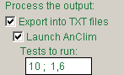

Homogenization results processing Item. Distributes AnClim software output (years) (TestResults file) for every station tested into one line - row (HomResults file). Check “Only significant” option for putting “x” instead of years not significant according to a test. When not-switched – no years are replaced (note: mark “<” is used to mark significant years (see output in AnClim for further details). Check "Include Adjust" option for adding amount of change in brackets after a year of inhomogeneity. Check "Delete subperiod info " option to remove rows with info about testing subperiods in case of Alexandersson’s SNHT and Bivariate tests. Output column is usually set to ‘change’, but you may want to retrieve also correlations in some cases. …
Hom proc1 Item. Calculates some characteristics for detected inhomogeneous years (from HomResults file), such as quartiles, minimum and maximum year, numbers … - NOT available at the moment
Homogenization results processing II Item. For all stations given in HomResults file calculates some characteristics. For each year of inhomogeneity (Year_inhom column) or some period given in Begin and End columns, gives number of occurrence (Year_count column), express this numbers of occurrence relatively to all detected years – both homogeneous and inhomogeneous - (into Y_portion column, note: that some series were divided into subperiods during testing), further expresses number of inhomogeneity occurrence relatively to number of all theoretically possible detections (into Y_possible column, base is 13– i.e. months and a year). Year_end column gives a number of years from the begin or end of the series (for less then 5 years only). Missvals column informs about number of missing months around a given year. Remark column contains information about month in which an inhomogeneity probably started (in brackets: number of detections of following year in a month previous to that of indicated and - number of detections of a given year in the month indicated); after semicolon: month with first occurrence of a given year and – last month with occurrence of following year. If you want to give a different weight to annual or seasonal values, check Weight Year and Seasons option and specify e.g. 5;2 (i.e. Months (N1-N12) weight 1, Year (N13) weight 5, Seasons (N14-N17) weight 2). Rem_cor column contains information about values in brackets in HomResults file after a year of change (e.g. correlation), it gives minimum value, median and maximum value.
Homogenization - Find in metadata Item: attaches information from metadata (geography, observers) to the testing results (hom_results_p2.dbf file) and deletes breaks with lower probability. Highly recommended. You can also combine information from metadata 1 (e.g. change of geography position) with second metadata file: e.g. output of 7-6 – reconstruction – function:
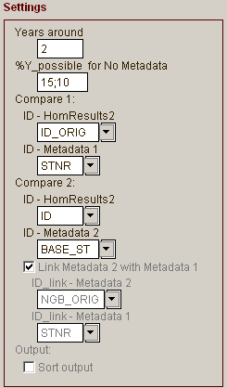

Y_possible: setting limits for assignment years for homogenization. Reccomended: 20,10 for air temperature (first number is given for case no metadata are found, the second one the break is found in metadata), 10,5 for precipitation (both for individual neighbours and reference file testing).
You can process the resulting e.g. in Excel – using Data – Filters. For final decision about inhomogeneities, see also plots of differences (rations) in AnClim. From such results, you can create inhomogeneities.dbf file (in Excel e.g. and save it as DBF file) that will be used for data adjustment (see next chapter).
Remark: please contact distributor of this software for routines (in MS-Excel) for further processing of the results.
Note: for homogeneity testing, use AnClim software. For getting results (in AnClim):
- Open all tested series (menu Tools – (Multi)Open Files
- Use menu Tool – Automatization. Define mask for finding reference series (suffix, different directory), select a test and run for all the tested series.
- Use test_results.xls template file and load your TXT data into it (see above), save as DBF and open in ProClimDB.
Or run AnClim straight from ProClimDB (e.g. in 8-4 function)

Adjust menu

Adjusts series for inhomogeneities according to reference series. Adjusting is made by comparing averages of differences (or ratios) before and after year of inhomogeneity being adjusted. The adjustment is done before the year of inhomogeneity. You need to create inhomogeneities.dbf file with defined inhomogeneities in advance (see previous chapter).
From correlations Item: the reference series are calculated "in-situ" by means of correlations. The reference series are created from a given number of stations (“Number of stations” option) according to correlation coefficients between a station in question and a reference station (stations with the highest correlation coefficients are selected). Values of correlation coefficients are taken from K13 column of Correlation file (average of monthly correlations). You can input a limit for correlation coefficients (“Limit - correlation” option), the stations with lower correlations won’t be selected. Switch option “First Differences” for calculating characteristics with correlation coefficients (given in output Adjust_info_file) from the first-difference series (good for time series with inhomogeneities). Note that this does not refer to correlations according to which the reference series are selected - these correlations are already calculated in Correlations file. Option “No. of years around” means a number of years to be taken before and the same number after a year of inhomogeneity being adjusted for adjusting (correcting) data. Near ends of series there are taken only values that are available. You can confine adjusting series to certain period from the end of series (“Min. years from end “ option). Note that near the ends the adjusting is problematic because of uncertain estimate of an average. Check One decimal place if you want to get results for adjustments rounded to one decimal place. Note that in this case some characteristics can be less accurate. On the output you are also given smoothed adjustments (with weights 1-2-1).
From existing reference series Item: there are used already created reference series for adjustment. Options “No. of years around” and “Min. years from end “ are the same as in previous option. On the output you are also given smoothed adjustments (smoothed by Gauss low-pass filter): using Smooth monthly ADJ option put number of neighboring months to be taken (to each side) for smoothing monthly adjustments (0 – no smoothing, 2 – recommended = period of 5 values, similar results as for 1-2-1 weights). One decimal place option should not be checked in this case, otherwise you can get curious results. Note: for adjustments, row 'ADJust' is used (not 'ADJ_sm'), smoothes monthly adjustments are only saves into Adjusted_info file! Use “User defined” option to get different adjustments (here you can select a row with adjustments to be applied).
Smoothed adjustments (low-pass filter) are estimated using all months of previous and following year.
Option Delete ADJ below Corr+: deletes smoothed adjustments in cases Corr+ (correlation improvement after carrying out the adjustments) drops below specified value (Corr+ value). After semicolon you can specify minimum number of values that has to be below the limit, to discard the adjustment for the particular year
Daily version only:
From existing reference series: you can select whether you get adjustments based on montly averages (calculated from daily values) (check Months based adjustment option), or directly from individual daily values (check Days based adjustment option). In the former case (months based adjustments), results are saved into Adj_Info file (both original and smoothed adjustments). In the latter case, daily adjustments are saved into Output Daily ADJ file and smoothed (if Smooth daily ADJ option is defined).
Smoothed adjustments (low-pass filter) are estimated using all days of previous and following year.

User defined Item: adjustment is proceeded according to information in Adjust_info file. Row with adjustments option: specify row with adjustments (name in Remark column of Adjust_info file). Select either unsmoothed (''ADJust ') or smoothed ('ADJ_sm') version of adjustments. Add original series option: adds original (unadjusted) series to the end of the output file, i.e. series present in Data file and not being adjusted (not present in Adjust_info file). This will help you to create new data set with both original and adjusted series.
Daily version only:
Check the Daily offset option to calculate offset of adjustment for each day, i.e. in case there are different adjustments in adjacent months, the adjustment changes continually with days (increment is calculated from values of the adjacent monthly adjustments). The day 16 of the month has adjustment for a given month, from day 15 before and day 17 after the adjustment continually changes towards a value of adjacent month. Note: it is advisable to smooth monthly adjustments (using low-pass filter) before applying the Daily offset option.
In case you have got adjustments from monthly data and want to adjust daily values (using the User defined menu option), it is easy to import adjustments from monthly Adjust_info file to daily Adjust_info file. The only difference is Day column for daily version of this file. How to do this: open Adjust_info file (daily version) using View command (after right mouse click). Click Edit, then Command button. Type this commands into appeared window: 1.: delete all, 2. (second command): pack, 3.: append from <filename>, where <filename> is a name of the monthly Adjust_info file, use relative path name (e.g. Data\Adjust_info.dbf), so in the end you write e.g. append from Data\Adjust_info.dbf.

Data:
Inhomogeneities file: here are specified years and months for which data are adjusted (can be created e.g. in MS-Excel).
Ref_info serves for assigning reference series to each candidate. These reference series are seeked for in Refer_series.
Adjusted_Data file: a file with adjusted series.
Adjusted_Info_File: a file containing information about adjusting data. K1-K12 are values for individual months. These values for Remark column equal to: DIFF1 means differences before a break, DIFF2 after a break, ADJ - final adjustments applied to series, Corr means correlations before adjustments (can be used correlations from the first difference series according to a proper option - see above, but this makes no sense), Corr+ - differences between correlations before and after adjustments. Student t-test results (for testing a differences between averages before and after a change, before adjusting data): T_ - critical value for t-test, Tcrit_ - test criterion of the t-test, p=0.05,. T2_, Tcrit2 - values for significantly different variances of the parts before and after a change (note that there is not included F-test yet in the software). Std_1,Std_2 – standard deviations of parts before and after a change (it is a sample standard deviation because of input into t-test), No_1,No_2 – length of parts of series before and after a change. b1_1, b1_2 – coefficients of linear regression for differences (ratios) taken before and after the shift. To see if assumption of applying averages for adjusting a single shift is correct (i.e. if there is no other type of inhomogeneity). In the end, smoothed monthly adjustments are given. In case of “From correlations” menu, smoothing with weights 1-2-1 is applied. In case of “From existing reference series” menu, Gaussian low-pass filter is applied for given number of neighbours. Recommended number of neighbours is 2 (to each side from a given month). Adj_sm: smoothed adjustments according to weights given in id_2 column (displayed only for one side) (k13 column contains number of missing values - no correction for 12 months), follows again correlations coefficients and difference of correlation coefficients after adjustments using these smoothed weights (for these correlations, an average of all months is given into k13 column).
AdjustCompare file: this file contains candidate and reference series used for individual adjustments. By means of this you can verify and follow the computation by yourself.
Remark
When inhomogeneity starts within a year (month in inhomogeneity file is greater than zero), previous months are adjusted for one year later. In that case a period taken for adjustment is shifted (the beginning and end are taken also one year later). See number of used values in Adjusted_Info_File.
The period to be taken for calculation is shortened in case of another inhomogeneity within this period.
To see adjustments, use AnClim software, menu Homog2 – User Defined Homogenization and plot graphs.

Adjust q-q – from Reference Series: finds correction using percentiles and Reference series.
This metod is an adaptation of a method for the correction of regional climate model outputs by Déqué (2007), itself based on assumptions similar to those implicit in methods described by Trewin and Trevitt (1996) and Della-Marta (2006), which apply variable correction according to individual percentiles (or deciles). Our process is based on comparison of percentiles (empirical distribution) of differences (or ratios) between candidate and reference series before and after a break. Percentiles are estimated from candidate series and values for differences of candidate and references series are taken from the same time (date). Each month is processed individually, but also taking into account the values of adjacent months before and after it to ensure smoother passage from one month to another. Candidate – reference differences for individual percentiles are then differenced before and after a break and smoothed by low-pass filter to obtain a final adjustment based on a given percentile (see Fig. below for illustration). Values (before a break) are then adjusted in such a way that we find a value for the candidate series before a break (interpolating between two percentile values if needed) and the corresponding correction factor, which is then applied to the value to be adjusted. Special treatment is needed for outlier values at the ends of distributions. No Adj. below Corr+ option: if, for a given month, correlation after correction does not improve above given limit, correction is not performed and original data are preserved.
Fig. x. Deriving corrections for individual percentiles from differences between candidate and reference series before and after a break.

In other words, it finds CDF before the break, calculates differences, then after break, gets differences for each percentile and uses this as a offset (values for correction are found in values of Candidate before the break …). Recommended: create Refer_info file in menu Homog – Reference Info_file, then Refer - Reference series – User defined calculate reference series, and finally get corrections in menu Adjust …
Empirical CDF – number of values has to be the same before and after a break, so it is diminished on a side if needed – in the way that the same months are used.

Output file:
Corrections q-q: corrections
Q_diff_be = (Q_Cand_be-Q_Ref_be)
Q_diff_af = (Q_Cand_af-Q_Ref_af)
With regard to the past, since the past is later corrected:
Q_diff = (Q_diff_af-Q_diff_be)
Multiplicative model:
Q_diff_be = (Q_Cand_be/Q_Ref_be)
Q_diff_af = (Q_Cand_af/Q_Ref_af)
And with regard to the past:
Q_diff =(Q_diff_af/Q_diff_be)
Q_diff_sm - smoothed corrections by low-pass filter - these are the final corrections …
Output correction summary: gives various statistics (correlation, Corr+ = increase of correlation after correction )
For individual neighbours (pair-wise comparison): run 8-7 function before, then 10-6. In case more inhomogeneities happens for the base station, the same order of neighbour is used for correction of the (for previous inhomogeneity) corrected series (being K12 column in input ref info file). ID_indiv distuingish among stations and inhomogeneities, while ID_indiv2 marks order of the neighbours.
Correlation: is given for the period in which adjustment is estimated.

Fill Missing menu

This serves for replacing missing values with interpolated ones.
Simple Average Item. Interpolation by means of simple arithmetic mean. There are taken either differences or ratios (check the Differences(Ratios) option for using differences) between candidate and reference station (using Cand-Ref, Cand/Ref resp.). For an option Ratios there is used ratio of averages (not an average of ratios – note that results are different for these two cases!). Option “No. of years around” means number of years to be taken before and the same number after a missing value. Near the ends of series there are taken only values available. You can confine filling missing values to certain distance from the end of series (“Min. years from end “ option); it can happened that you need to fill longer period with missing value, than a problem can arise if this option is set too low. If you input negative value, it will behave like the option is set to zero, but in case that period with missing values occur in the series, the nearest period with real value will be found (searched to both sides – i.e. before and after the value to be filled); example: -40, in Data_file 1961-1980 are only missing values, from 1981 start real data, in this case values starting from 1981 will be used for calculating new values (if you set -20, it will not be already used). Include missing periods option: in case that according to Info_file station begins or ends measurements outside period of values in Data file, missing values are added before (or after) the measurements; later during filling missing values - for these missing data - new values will be calculated (extrapolation). Fill all gaps serves for checking possible gaps in data – in case a gap is found, it is filled with missing values and then new values can be calculated. Sometimes calculated value drop below physically meaningful limit, e.g. 0 for precipitation; to treat such cases, i.e. to replace the cases with limit value, check Apply limit value option and set Lower limit value.
Remarks: Computation is done only for cases (years) when there are not missing data neither in candidate nor in reference series. At least 5 non-missing values have to be present for calculation of differences or linear regression, otherwise missing values will not be replaces by a new value.
Linear Regression Item. Missing values are interpolated by means of linear regression between candidate (dependent) and reference station (independent variable).
There are two versions of these two options. In the first version the reference series are calculated "in-situ" by means of correlations. In the second version there are used already created reference series. The first version seems to be better because here the reference series are selected extra for every missing value (the reference series being more adequate for a filled series).
Data:
Missing values to be replaced are taken from Data_file.
Correlations file contains correlations between all the stations used for calculating reference series "in-situ". There is taken one value for all the months or seasons – in column K13 (it as an average of monthly correlations).
Ref_info serves for assigning reference series to each candidate. These reference series are seeked for in Refer_series.
Filled_data file contains all the series with filled missing values. In case you interrupt a computation before the end, the rest of missing values is not replaced.
Fill_Info_file contains information about a process of interpolating missing values. Begin and End are beginning and end of a period used for interpolating of filled values. Year and Month is a position of the missing value. Diff_avg (for “Simple average” option only) is an difference (ratio) of averages between candidate and reference station, Year_avg is a value (of a given year and month to be interpolated) corresponding to a reference series, New_val is the interpolated value. For Linear regression: columns B0_ and B1_ contain regression coefficients b0 and b1, Brs_ contains a mean error. Correl_: correlation between reference and candidate series for a given period. Further info: Avg_ – an average for a series specified in column Remark (Ref = reference series, Can = candidate series, Diff = differences or ratios; number after the name means part of a series before {1} or after {2} the missing value, Val means values of series), Std_ – standard deviation (for parts {1,2} of a series it is sample standard deviation because of input into t-test), No_ – length of a series (or a part). Student t-test results (for testing parts before and after the missing value): T_ - critical value for t-test, Tcrit_ - test criterion of the t-test, p=0.05, Sign_ = 1 for significant t-test. T2_, Tcrit2 - values for significantly different variances of the part before and after the missing value (note that there is not included F-test yet in the software). The t-test serves for finding possible shifts in the series; in that case the interpolating missing value could be erroneous!.
FillCompare file: this file contains candidate and reference series used for interpolating each missing values. By means of this you can verify the computation by yourself.

Examples of Visual FoxPro commands (that can be used during file viewing/editing)

replace region with substr(id,10,100) all for len(alltrim(id))>0

replace ID with alltrim(STRTRAN(ID,'B2','')) all

replace Value with 9997 all for (Flag='T')and(Value=0)

replace id with alltrim(id)+'_w' all for (substr(id,1,2)<>upper('b1'))and(substr(id,1,2)<>upper('b2'))

delete all for length<10

delete rest

dele next 20

recall all

copy to 15m_2001 all for year=2001 type foxplus as 1250

sort on id,year,month,day to table_sorted.dbf

locate for (id='0158O')and(year=1950)
continue

append from table_A for year>1900
(for blank spaces in the path: append from ‘long space path\table_A’ )

blank fields correl all

blank fields value2b all for value2b=0

Select * from thisfile where length>30

Select distinct id from DBF() into table uniq_id.dbf

Select id,name,min(begin_date),max(end_date) from data.dbf group by id,name into table seznam_3b

SELECT * FROM table_A a
LEFT OUTER JOIN table_B b
ON a.id = b.id and a.year=b.year AND a.month=b.month AND a.day=b.day
into table OUTPUT_TABLE.dbf

add column: ALTER TABLE DBF() ADD COLUMN XXX N(10,1)
change column: ALTER TABLE DBF()ALTER COLUMN XXX C(10)
rename column: ALTER TABLE DBF() RENAME COLUMN XXX TO YYY

Useful functions for strings processing:

SUBSTR(cExpression, nStartPosition [, nCharactersReturned]) - Returns a character string from the given character expression or memo field, starting at a specified position in the character expression or memo field and continuing for a specified number of characters.
ALLTRIM(Expression [, nFlags] [, cParseChar [, cParseChar2 [, ...]]]) - Removes all leading and trailing spaces or parsing characters from the specified character expression, or all leading and trailing zero (0) bytes from the specified binary expression.
UPPER(cExpression) - Returns the specified character expression in uppercase. Similarly LOWER(cExpression)
AT(cSearchExpression, cExpressionSearched [, nOccurrence]) - Searches a character expression for the occurrence of another character expression. Note The search performed by AT( ) is case-sensitive. To perform a search that is not case-sensitive, use ATC( ). For more information, see ATC( ) Function.
RAT(cSearchExpression, cExpressionSearched [, nOccurrence]) - Returns the numeric position of the last (rightmost) occurrence of a character string within another character string.
OCCURS(cSearchExpression, cExpressionSearched) - Returns the number of times a character expression occurs within another character expression.
LEFT(cExpression, nExpression) - Returns a specified number of characters from a character expression, starting with the leftmost character. Similarly RIGHT(cExpression, nCharacters)
STRTRAN(cSearched, cExpressionSought [, cReplacement][, nStartOccurrence] [, nNumberOfOccurrences] [, nFlags]) - Searches a character expression or memo field for a second character expression or memo field and replaces each occurrence with a third character expression or memo field. You can specify where the replacement begins and how many replacements are made.
STREXTRACT(cSearchExpression, cBeginDelim [, cEndDelim [, nOccurrence[, nFlag]]]]) - Retrieves a string between two delimiters.

Batch mode

You can run the LoadData.exe or ProClimDB from command line with parameter specifying profile to be used. Then, commands in Settings\ld_batch_own.dbf will be processed (for a given profile and for “Active” column equal to 1, rows not marked for deletion).

Required fields: Page (page - tab), Option, Cname (name of a proper control), Value (character type, e.g. filename for Editbox), Value2b (numeric type – e.g. 1 for Checkbox or Optionbutton to be checked)

Field Action: list of possible values:
Do - serves for running a command (Visual FoxPro):
further required fields: Value
- you can input either command of Visual FoxPro, e.g. MessageBox('Hello world'),
- or program (with commands) to be run - *.prg
You can input several commands separated by semicolon. You can also use functions of ProClimDB like: ChangeDataFormatProcessing_batch ( {0 for monthly, 1 for daily version} ), …
Run - servers for clicking a specified button:
further required fields: page, option and cname
Set Option - setting a value for editbox or checkbox:
editbox: further required fields: page, option and cname (name of a proper editbox), value (name of a file).
checkbox: further required fields: page, option and cname, value2b –1 for checked, 0 for unchecked
Optionbutton, Optionbutton2 – option button
Open Table – fills filename of a proper Editbox (specified in column Edit – 1-8)

Field Action , special values:
ModiStru, - modify structure
OpeninExcel – open the file in Excel
SaveAsDBFIV – save the file as DBF IV,
LoadTemplate – loads template for a proper Editbo x (specified in column Edit – 1-8)
SaveAs
Templ_SaveAs – loads template and save the file as …
LostFocus
Run_another_Batch – runs another batch job file and then follows processing the rest of rows in original file
Command_Edit – runs command upon given Editbox (filename) (with open table in the active work area). You can also use functions of ProClimDB like:
Change_columns_order({Column_to_move}, order_new_pozition }), e.g. Change_columns_order('Year', Column_exist2('Time')) - changes column order – puts the given column (first parameter) into the given position – you can use Column_exist2 function to find the position the given column
Adjust_col_size('Region', 't_sun' ,RECNO()) - adjusts column Region size – taken the length of the second parameter
Exclude_empty_columns(DBF(),"") - removes columns with all blank values
Exclude_empty_columns(dbf(),"",1,.T.,.T.) - excludes given columns (second parameter) with unique value
Split_into_more_Columns('Column', '_') - splits the column values into individual columns according to given delimiter (the second parametr)
SaveAsDBFIVversion(dbf(),.T.) - saves into DBFIV format (the same as SaveAsDBFIV action)´
Plot_graphs_R(dbf(), graph_template , .F.) – creates plot under R, Rterm
Load_Data_into_Excel('','',file_in,'',.F.,.T.,.F.,0,"A",1) – saves as Excel
Or you can launch a script: e.g. do data\Cecilia\Run_commands_prepareoutput.prg with 0
ChangeProfile – change to profile named specified in Cname (or Value) column.
Set Var - setting variable:
further required fields: VariableIn (name of destination variable), value to be assigned: Value2n (or Value2b) for numeric variables (or logical ones), Value for character variables
Variables to be set: few examples:
Missval – code for missing value
k_id_combine_names, k_auto_multi_ID: ID of data file is in several columns;
k_apply_limit_low, k_apply_limit_high – whether to apply limit values, val_apply_limit_low, val_apply_limit_high – limit values, val_apply_replace – 1 or 2 for replacing missing or limit value;
n_transformation – 1-5 transformation log() – sqrt(…), -1 x/y, 0 – no transformation (see Settings\o_Transformation.txt)
k_allow_mv_OnlyAllYears – allow missing values but not if the whole year is missing
k_allow_mv_firstyear – allow missing December for the first DJF season
k_backupOutputFiles no backup of output files (faster)
k_save_output_DBFIV - saves the output file in format of DBF IV
Remark: ChangeDataFormatProcessing_batch() function may change the value back, so use Set Var only after it. Or save the setting, like: Do: get_put_do_TXT(1,'o_Transformation',n_transformation,1,.T.)
Own variables to be used later: Action: OpenTable (SaveAs), or Set Option - Editbox,
Action: Set Var, VariableIn: …, Value: …,
later use: Value: "myvar:$s_output_type"
ReadTXT – reading variable settings from a TXT file:
further required fields: Cname (TXT file to be read - the first row), VariableIn (name of destination variable), Value2b – put 1 for destination variable to be number, character otherwise
if - condition to be fulfilled:
further required fields: VariableIn (name of variable to be compared), value to be compared: Value2b for numeric variables or Value for character variables.
lines after ‘if’ condition are run only if the expression in ‘if’ is true
if: - you can put as many ‘if’ as you want
endif: end of ‘if’ sequence
Abort: – exiting batch mode
Quit_PD: quits the whole application (without asking), Quit_PD_ask - the same but you will be asked
launch: launches an application specified in cname, parameters in VariableIn

Notes:
* Batchjob file is to be specified in Settings – Control options, Batchjob processing section. If you need to save main variables (e.g. transformation, missval, …), use “Save global vars” button on the Settings form.
* You can save settings of files and options of a current function by Right click upon Run button on the main form
* only specified profile will be processed ….
* to check, if Options are consistent with the current version and input files do exist, run menu Options – Check batchfile options

You can launch ProClimDB with batchjob file automatically from command line, example: …
Better to use Profile “Default” in the batchjob file, thus all the rows will be processed.

Connection with R software

This part is being Under construction …

You can download the software from this site:
http://cran.r-project.org/bin/windows/base/

Some additional packages may be required:
On Windows install.packages can also install a binary package from a local zip file by setting argument repos to NULL. Rgui.exe has a menu Packages with a GUI interface to install.packages, update.packages and library.

Example (R code):
install.packages("D:/dokumenty/progr/R/Gstat/gstat_0.9-37.zip", dependencies = TRUE, repos=NULL)
install.packages("sp", dependencies = TRUE)

finding PATH to R in Windows registry:
HKEY_LOCAL_MACHINE\Software\R-core\R\InstallPath

Final remarks

Recently, settings described in following 4 remarks can be done very easily right in the software - through “Settings” button upon the main form.
* Batch file mode: put 1 in the first row of the file Settings\go_batch.txt. Set Settings\batchfile.dbf (batchfile_day.dbf) files with tasks to perform. Run command (in cmd): ProClimDB.exe 'ahoj' to run command for the profile ‘ahoj’, put ‘*’ for arbitrary profile (all market with 1 in the Active column). Put ProClimDB.exe '/1',*' to run daily version of the software and all profiles.
* Suppress error messages: set 1 in the first row of the file Settings\no_stop.txt. All errors are logged in any case into Controls\errors_log.dbf file.
* Starting performance from a middle of the file: set a given row from which you want to begin in a settings\start_*.txt (name according to a function to be performed).
* If you want to run a long command (or more lines of commands), put it into Settings\Run_commands.prg file and then use right click upon Command button while Viewing a file.

* As default setting, some template files are set (in edit boxes). You should proceed like this: you replace input files by your files (on the left site), and copy (“Save as”) the template (output) files to some new files which you name as you want (thus you preserve template files for future). After you run a function, you get the results into your output files. If you have lost the template files (e.g. you have empty edit boxes), find it in Data directory (the name is e.g. data_info.dbf) or use right click button upon an edit box and use “Load template” command.
* Structure of menu and functions is open. You can change appearance and/or functionality by changing these files: Settings\menu_items.dbf, Settings\submenu_items.dbf and Settings\options_items.dbf . You can program your own functions (prg files). Changing functionality of the software is conditioned by sharing new functions with the author and other users.

Troubleshootings when working with DBF files in Excel

1. Created DBF file (in Excel) causes problems in ProcData.
Possible cause: if columns in your created DBF file are blank (no data) when saving as DBF file in Excel - the format of the column is "Character" by default .
Solution: put zeros into the second row (first row of data) for columns where there are no data and these data are expected to be numbers.
2. After adding new rows in existing DBF file open in Excel - the number of rows remains the same - added rows are not accepted.
Solution: when adding new rows - insert rows and then replace blank spaces with your data. Similarly: when deleting rows - remove the rows otherwise there will be blank spaces.
3 Rows marked for deleting are not displayed in MS- Excel.
Solution: open the file in this software (right click and select View/Edit file), then right click the Delete button (to run recall all function), or input this function manually using Command button.
4. Not all records are displayed in Excel.
Solution: In Excel you can display only first 65.536 records (rows) (beware that also records marked for deleting counts even if they are not displayed in Excel – that means if you have e.g. 100000 rows, 50000 marked for deleting, you may not see all of those undeleted rows in Excel!). The only solution is to split the file into more parts and open them in Excel separately.

