The last update of the document:29.3. 2007

How to import data from TXT files
and insert them into Database (using LoadData software)

Structure of input TXT files (delimited with comma)
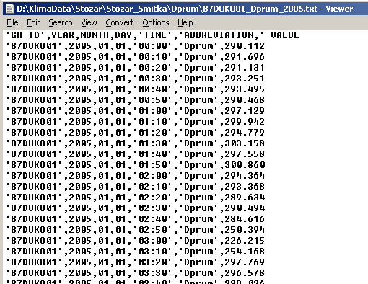

Import data from TXT files to DBF file in LoadData:
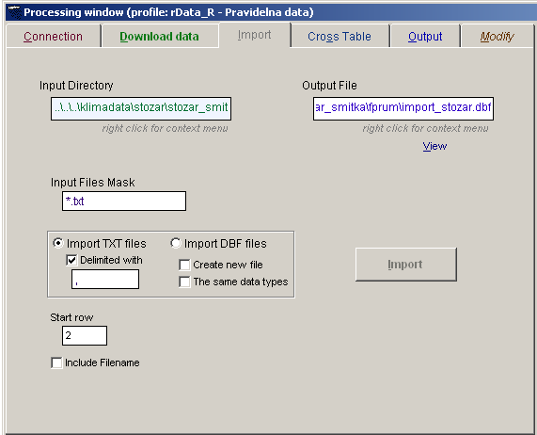

Output DBF file:
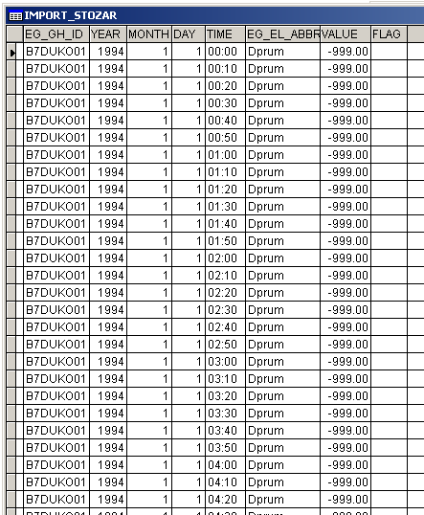
Adjust the output DBF file: View the table: press button Command:
dele all for value=-999
dele all for year=0

Adjust DBF file:
Create cross table:
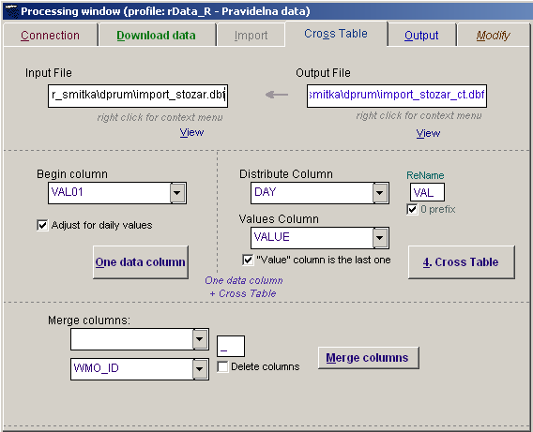
Output cross table file:
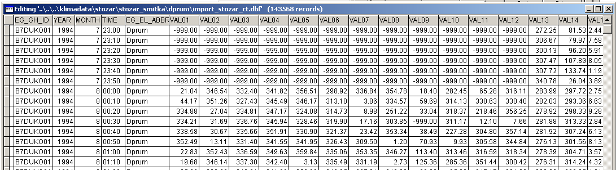

Insert values into database:

Adjust DBF file: View the file:
Change table structure (Year and Month to character type, to suit structure of RDARA_R table):
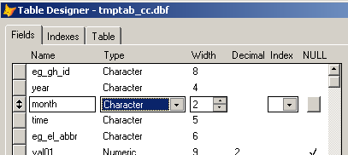
Replace ‘ ‘ in Month column with ‘0’ (right click in the Month column during Viewing the file and select Replace strings)
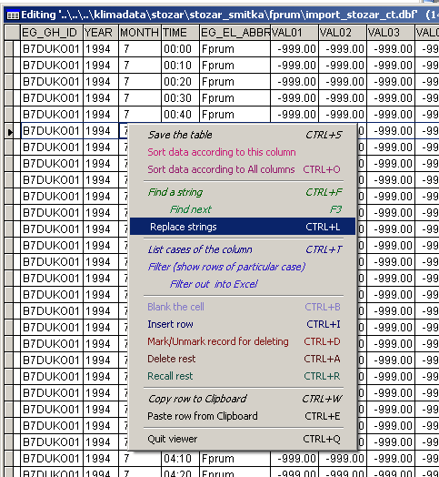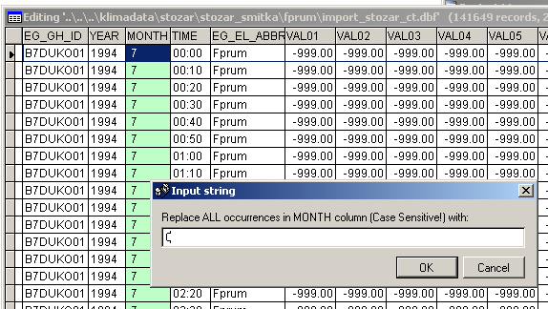

Insert values into database (use the created cross-table DBF file):
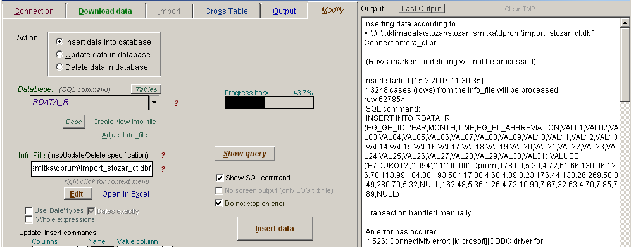

Example of data in the database (table RDATA_R):
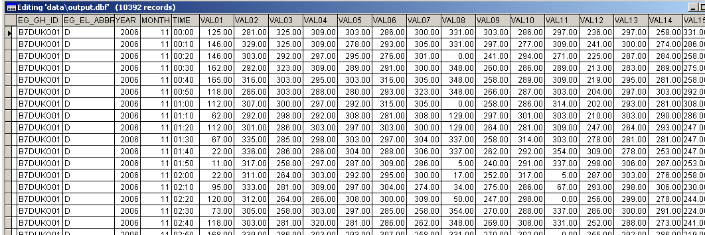

If you need to update data in database (use original DBF file – all values in one column):
Input file:
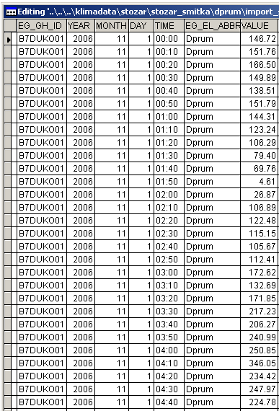
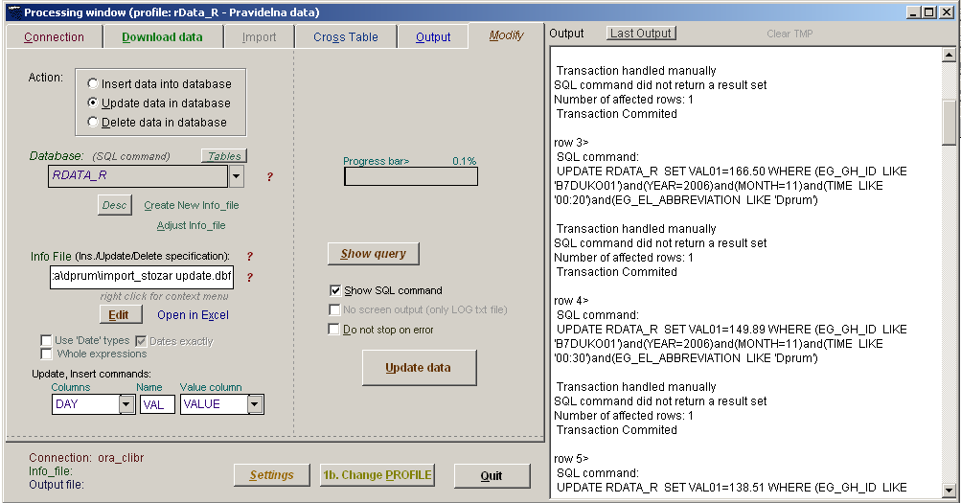

Example, how to update flags (e.g. for precipitation):
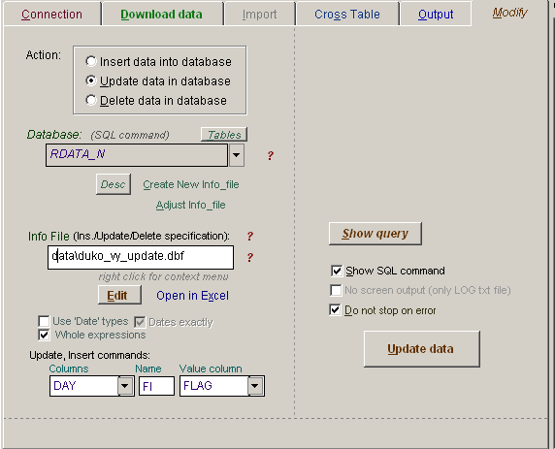

Petr Štěpánek, II, 2007
more details about the software available at:
www.climahom.eu

