The last update of the document:23.5. 2007

Example how to proceed during data processing
target: getting outputs for maps creation

- In ProClimDB: “sophisticated way” – in case of missing data, the values used for maps calculation are not biased.
  - Take all the steps described for “Example - target: homogenization” (previous document how_to_proceed.doc)
  - Run User – defined creation of reference series (menu Reference / User defined), check Standardize used series and mainly the Extrapolate option. Thus you will create reference series for long enough period (even beyond period of original base station).
  - Use menu Calc2 -/ Get standardized AVG to calculate averages for a specified period (Begin_year and End_year options). In case a station has shorter measurements or/and has missing data, a final value will be adjusted so that it is comparable with the rest of dataset.
  - Maps are sometimes creating using regressions for individual regions (surrounding of stations), e.g. dependence on altitude. For this case you can try menu Neighbours / Regional regression - … to find optimal distances, number of stations etc.

- In LoadData: quick way – download data, press buttons and you have the results …
  - Go to Download tab and set the Output file (you can possible download data using the software)
  - If you need to group values over certain period, press Group records button to group the records (to calculate average and other statistical characteristics over the whole period). For this, the initial file with data should contain monthly (daily) values in one column (you can convert data by means of tab Cross table – button One data column: e.g. from 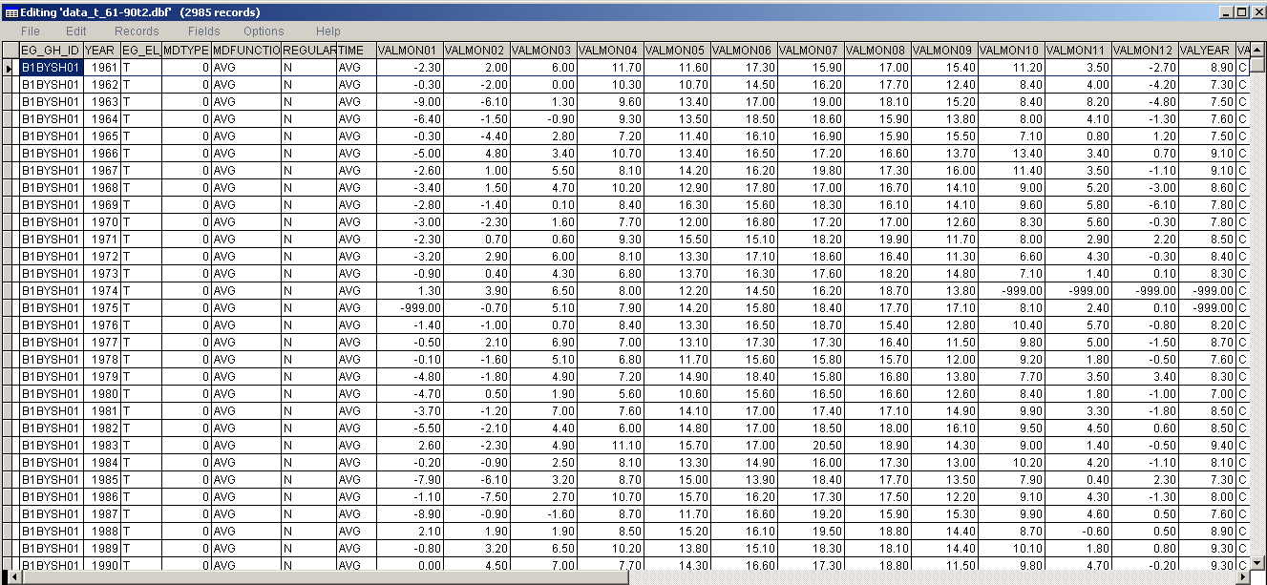 to 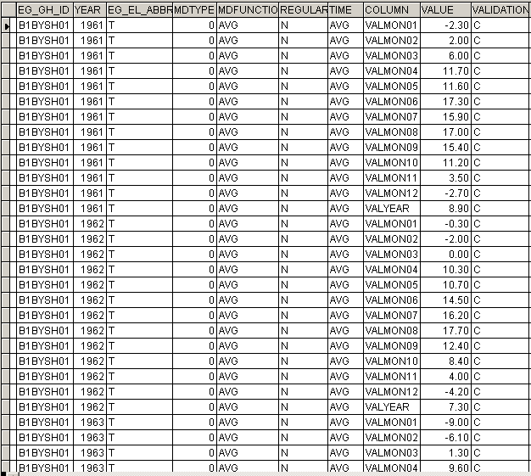

  - press Add geography button to link station data with station geography (coordinates and altitudes), using the geography file

  - Alternative way(s): right click - View the file and use proper SQL command to connect table with data and geography or in ProClimDB try menu Get Info – Import geography.

Further processing of prepared data file: e.g. in ArcView:
- Project window – Tables – Add: select the DBF table with your data
- Menu View – Add event theme: select the DBF file, set coordinates
- Menu Theme – Convert to Shapefile
- Interpolate values (by means of krigging for instance)
- To obtain area average: select shape file with borders: menu Analysis – Summarize zones.

Remark (made on 23.9. 2009): current version of ProClimDB makes it possible to run calculation in ArcView straight from ProClimDB software (on the background), automatically for selected time frames and periods.

www.climahom.eu

